Table of Contents

Appendix A – Bridge 041 Performance Evaluation and Load Rating Analysis A-1

Experimental Evaluation Summary A-2

Load Rating Analysis Summary A-3

Appendix A-1 – Bridge Description A-4

Appendix A-2 – Experimental Evaluation A-5

Description of Test Equipment - THMPR System A-5

Instrumentation A-6

Test Execution A-7

Data Quality A-7

Modal Parameter Identification A-8

Appendix A-3 – Model Updating A-12

Appendix A-4 – Updated Model Ratings A-18

Span 1 A-18

Span 2 A-20

Appendix B – Bridge 063 Performance Evaluation and Load Rating Analysis B-1

Experimental Evaluation Summary B-2

Load Rating Analysis Summary B-3

Appendix B-1 – Bridge Description B-4

Appendix B-2 – Bridge 063 Experimental Evaluation B-5

Description of Test Equipment - THMPR System B-5

Instrumentation B-6

Test Execution B-7

Data Quality B-7

Modal Parameter Identification B-8

Appendix B-3 – Model Updating B-12

Appendix B-4 – Bridge 063 Updated Model Ratings B-14

Span 1 B-14

Span 2 B-16

Span 3 B-18

Appendix C – Bridge 076 Performance Evaluation and Load Rating Analysis C-1

Experimental Evaluation Summary C-2

Load Rating Analysis Summary C-3

Appendix C-1 – Bridge Description C-4

Appendix C-2 – Experimental Evaluation C-5

Description of Test Equipment - THMPR System C-5

Instrumentation C-6

Test Execution C-7

Data Quality C-7

Modal Parameter Identification C-8

Appendix D – Bridge 138 Performance Evaluation and Load Rating Analysis D-1

Appendix D-1 Bridge Description D-3

Appendix D-2 Experimental Evaluation D-5

Instrumentation D-6

Test Execution D-7

Data Quality D-8

Modal Parameter Identification D-9

Appendix D-3 - Finite Element (FE) Model Development and Rating D-12

FE Model Creation D-12

Error Screening for *A Priori* Model D-15

*A Priori* FE Model Rating D-17

Unknown Parameter Selection D-17

Initial Natural Frequency Analysis Comparison D-18

*A Priori* FE Model Load Rating D-21

Appendix D-4 - Model Experiment Correlation and Updated Model Rating D-23

Initial Values D-23

Updating Process D-24

Final Values D-25

Updated Model Fitness D-25

Rating D-30

Appendix E – Bridge 200 Performance Evaluation and Load Rating Analysis E-1

Experimental Evaluation Summary E-2

Load Rating Analysis Summary E-3

Appendix E-1 – Bridge Description E-4

Appendix E-2 – Experimental Evaluation E-5

Description of Test Equipment - THMPR System E-5

Instrumentation E-6

Test Execution E-7

Data Quality E-7

Modal Parameter Identification E-8

Appendix E-3 – Model Updating E-10

Appendix E-4 – Updated Model Ratings E-15

**PAGE INTENTIONALLY LEFT BLANK**

# Appendix A – Bridge 041 Performance Evaluation and Load Rating Analysis

**Northampton County Bridge 041**

|  |  |
| --- | --- |
| **BMS No:** | 48 7208 0684 9041 |
| **Feature Carried:** | Little Creek Road |
| **Feature Intersected:** | Little Martins Creek |
| **Structure Type:** | Two Span, Simply Supported Concrete Encased Steel I-Beam |
|  |  |
| **Test Date:** | 11/05/2014 |
| **Test Type:** | Dynamic Test |
| **Analysis and Rating Method:** | AASHTO LRFR |

|  |  |  |  |  |  |  |  |  |  |  |
| --- | --- | --- | --- | --- | --- | --- | --- | --- | --- | --- |
|  | **Strength I** | **Inventory** | **Tons** | **Operating** | **Tons** | **Service II** | **Inventory** | **Tons** | **Operating** | **Tons** |
| ***Pre-Test Rating*** |  |  |  |  |  |  |  |  |
| Single Line* | 0.6 | 22 | 1.0 | 37 | - | - | - | - |
| *A Priori* Model | 1.5 | 56 | 2.0 | 72 | 0.6 | 22 | 0.8 | 29 |
| ***Post-Test Conservative Model Rating*** |  |  |  |  |  |  |  |  |
| **Span 1** | **4.2** | **150** | **5.4** | **195** | **1.1** | **40** | **1.4** | **51** |
| **Span 2** | **4. 8** | **172** | **6.2** | **68** | **1.1** | **39** | **1.4** | **51** |

Table 1. Single Line, *A Priori*, and Final Calibrated Models for both spans of Bridge 041.   
*Single line rating for ML80 loading, from 2012 report provided by STV Inc.

Design drawings for this bridge were not available at the time of testing; however, STV Inc. produced a Load Rating Summary performed in 2012 that detailed the structure’s cross section. The geometry of the bridge and its components was verified via field measurements on the day of the test. The structure was evaluated using forced vibration testing methods and the dynamic properties (natural frequencies and mode shapes) were extracted for finite element model calibration.

Strand7 FE Modelling Software was used in conjunction with computational software to perform a live load rating analysis for both spans of the bridge. An initial finite element (FE) model was created in Strand7 for all three spans of the bridge. Conservative material properties, section properties, continuity conditions and boundary conditions were assumed for an initial model. The initial model was rated for AASHTO Load and Resistance Factor Strength I and Service II limit states for an HL-93 truck. The initial model was then calibrated to the natural frequencies and mode shapes developed through experimentation. A set of calibrated models were used to perform live load ratings for each span with and without concrete encasement stiffness contribution. Controlling ratings for the initial and calibrated models are summarized in the above table.

## Experimental Evaluation Summary

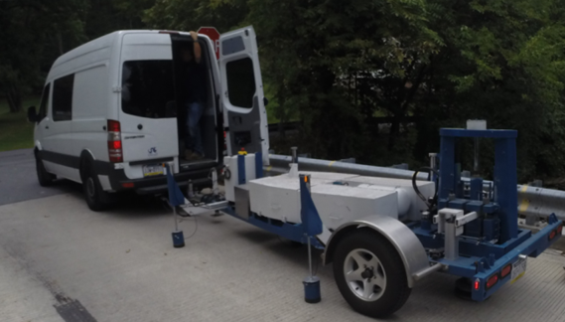The structure was evaluated on November 5, 2014 using forced vibration testing methods and the dynamic properties (natural frequencies and mode shapes) were extracted for finite element model calibration.

Figure 1. THMPR System

A self-contained modal impact trailer equipped with a falling mass impact system and local sensor array was used to execute the vibration tests. The superstructure was excited via a 25 kip impulse force at multiple, spatially distributed locations which resulted in up to 3 g’s of bridge deck acceleration. Acceleration responses were measured via a local sensor array of six accelerometers and multiple spatially distributed stationary global references secured to the bridge deck via glue adhesive prior to testing. Local modal parameter estimation was performed utilizing the Complex Mode Indicator Function (CMIF) and integrated into a final global modal parameter set. Six natural frequencies and mode shapes were identified for span 1 and five natural frequencies and mode shapes were identified for span 2 in the frequency band of 0-65 Hz (Figure 2 & Table 2).

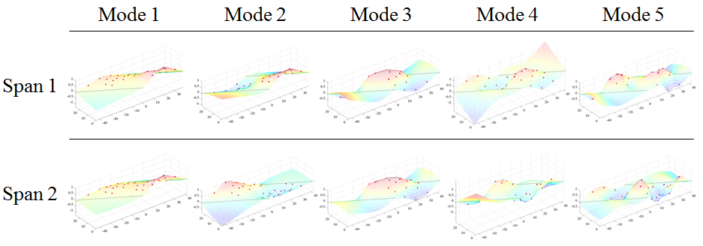

Figure 2. THMPR Results – Overview of Global Mode Shapes

Table 2. THMPR Results – Identified Natural Frequencies

|  |  |  |
| --- | --- | --- |
| **Mode** | **Span 1**  **Frequency [Hz]** | **Span 2**  **Frequency [Hz]** |
| 1 | 21.29 | 21.39 |
| 2 | 23.05 | 23.93 |
| 3 | 27.93 | 29.3 |
| 4 | 35.94 | 37.3 |
| 5 | 48.73 | 48.24 |
| 6 | 61.33 | - |

## Load Rating Analysis Summary

The structure was modeled using finite element analysis and computational software. An initial finite element (FE) model was created in Strand7 for both spans of Northampton County Bridge 041 using the RAMPS software package developed at Drexel University as part of a National Institute of Standards and Technology Innovation Program (NIST-TIP) and the National Cooperative Highway Research Program Project 12-103 (NCHRP 12-103).Conservative material properties, section properties, continuity conditions and boundary conditions were assumed for an initial model. The 3D geometric model (Figure 3) utilizes beam elements for the steel I-section and concrete encasement. Shell elements are used to model the deck and concrete curb. Rigid links as well as beam elements with variable stiffness are used to enforce compatibility of the displacements between the various structural elements.

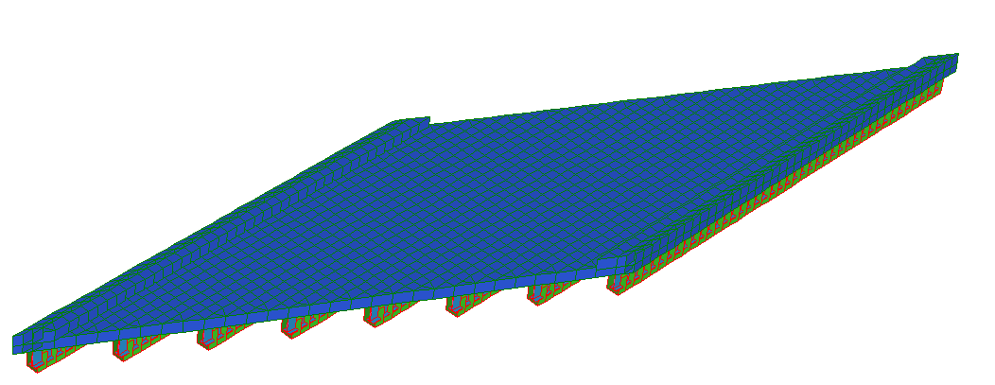

Y

X

Z

Figure 3. *A Priori* FE Model of single span of Bridge 041.

The initial model was rated for AASHTO Load and Resistance Factor Strength I and Service II limit states for an HL-93 truck. It was then calibrated to the natural frequencies and mode shapes developed through experimentation. A set of calibrated models were used to perform live load ratings. The six calibrated models with strong objective function and final parameter agreement were rated using the RAMPs software. In order to assure the most conservative load rating estimate while utilizing an updated FE model, stiffness contributions from the concrete encasement were ignored in a second set of ratings for the same six updated models. It was necessary to allow the updating algorithm to increase encasement stiffness in the model in response to differences between frequencies and mode shapes. Conservatively, we neglected the stiffness contribution of the concrete encasement after updating. The final reported ratings are based on the updated models without stiffness contribution of the concrete encasement. All other parameters from the updated models were carried over into this rating.

**The controlling Strength I and Service II limit state rating factors for the model with and without concrete encasement stiffness contribution is summarized for all three spans in the following table.**

Table 3. Controlling Strength I and Service II Limit state rating factors.

|  |  |  |  |  |
| --- | --- | --- | --- | --- |
| **(Inventory/Operating)** | **Strength I** | | **Service II** | |
| **Span 1** | **Span 2** | **Span 1** | **Span 2** |
| **With Concrete Encasement** | **17.3/22.5** | **22.3/28.9** | **3.5/4.5** | **3.6/4.7** |
| **Concrete Encasement Neglected** | **4.2/5.4** | **4.8/6.2** | **1.1/1.4** | **1.1/1.4** |

## Appendix A-1 – Bridge Description

Northampton County Bridge 041 is a two span, simply supported, concrete encased steel I-Beam structure with a 60⁰ skew. The bridge carries Little Creek Road over Little Martin’s Creekhad an ADT of 200 and has a current posted weight limit of 20 tons. With a sufficiency rating of 46.0, the bridge is evaluated as “Not Deficient.” Both spans were measured as 41’-6” span length and a roadway width of 22’-6”. Each span carries Type-2 strong post guide rails over a curb measuring 6.5”x14” on either side of the roadway (Figure 4). The overall deck thickness was measured to be approximately 16” with a 2.75” overlay, implying the deck is 13.25”. Each span has six (8) concrete encased steel I-beams spaced at 3’-3” with overall dimensions of 22”x12”. Each girder has what appears to be 1-2” of shotcrete applied to the surface of the original concrete encasement at a time unknown to the engineer. Cracking of the shotcrete was more apparent in this structure than in others tested. The presence of shotcrete over the original concrete encasement may imply that some deterioration of the encasement was present.

No original plans exist for the bridge; however STV Inc. produced a Load Rating Summary performed in 2012 that details the structure cross-section. In their load rating, STV noted that Northampton County produced approximate beam dimensions after taking cores of the structure. Measurements taken in the field agreed with those reported by STV Inc.

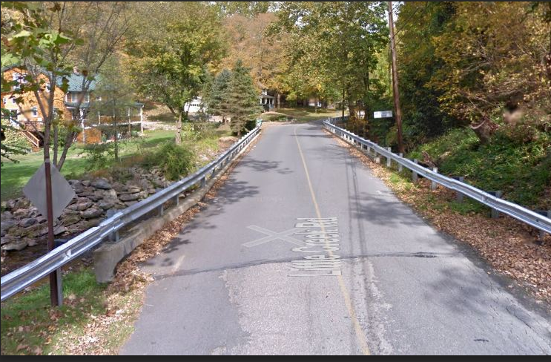

Figure 4. Northampton County Bridge 041

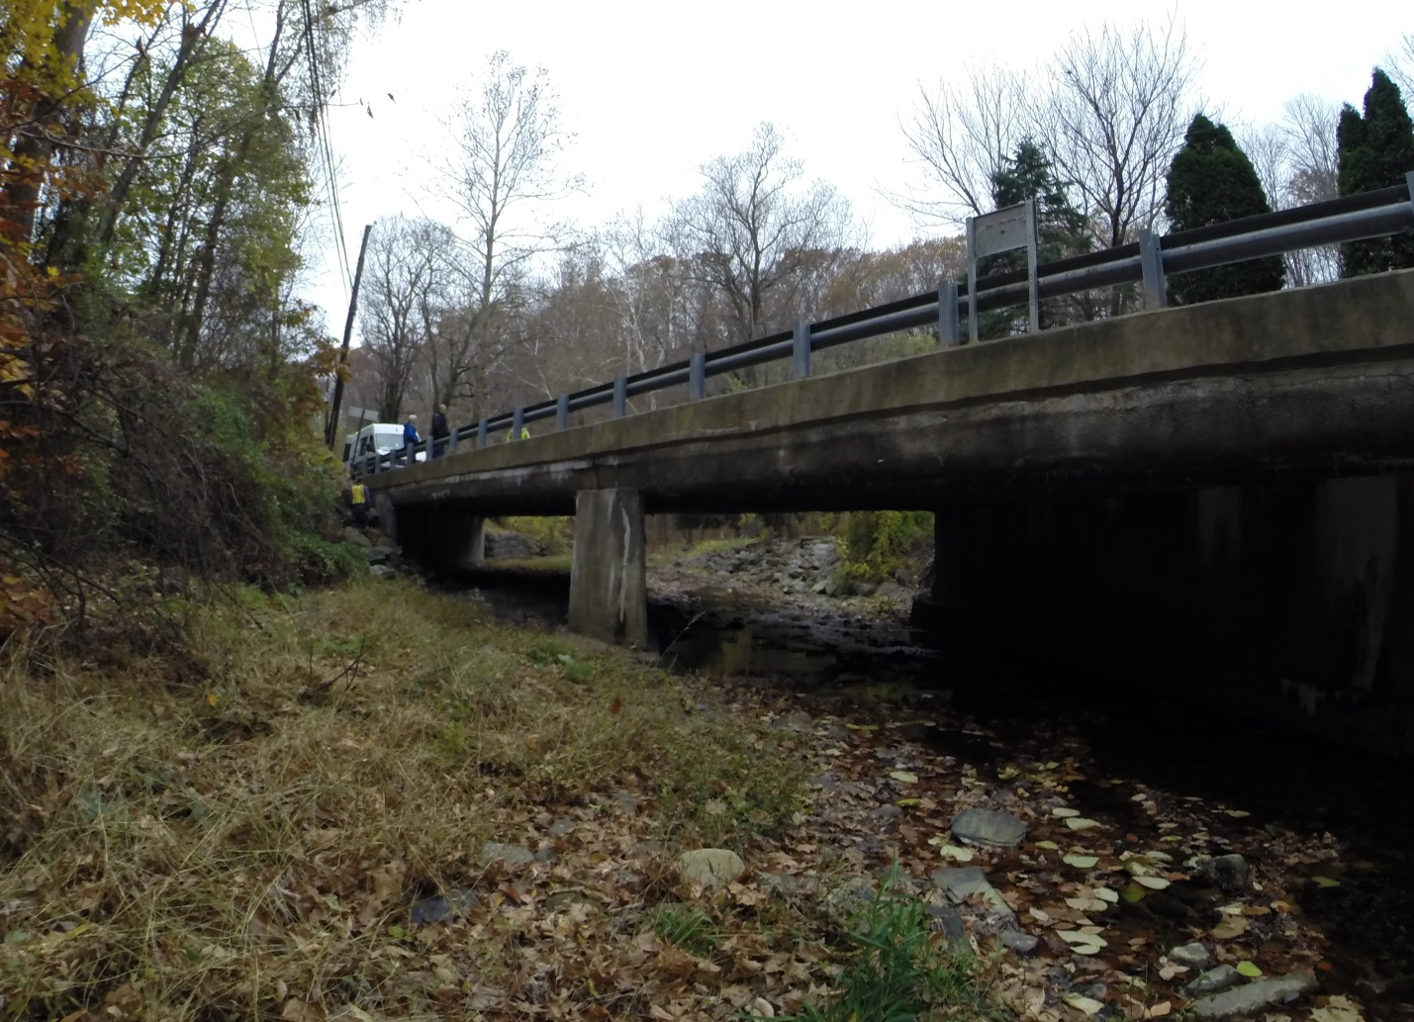

Figure 5. Elevation view of Northampton County Bridge 041

## Appendix A-2 – Experimental Evaluation

Northampton County Bridge 041 was evaluated using vibration testing methods. The bridge was dynamically excited at several locations on the deck surface using a broad band impact force, and its corresponding vibration responses were measured using accelerometers that were also located on the deck. The combined input-output vibration measurements were subsequently analyzed to extract the dynamic properties of the structure which were then used to calibrate a finite element model of the bridge. Details of the experimental setup, the test execution and the data analysis methods employed for the bridge are provided in the following sections.

### Description of Test Equipment - THMPR System

The Targeted Hits to Measure Performance Responses (THMPR) system is a self-contained rapid modal testing trailer and streamlined data processing software which extracts modal parameters, such as frequencies and mode shapes, of a structure. The extracted modal parameters may then be used to determine anomalous behavior as well as provide experimental data for finite element model calibration. The system, shown in Figure 6, is comprised of a physical test device which utilizes a significantly reconfigured Falling Weight Deflectometer trailer with modifications to (1) provide a single, large (~30 kip) broadband impact source, and (2) collect the resulting free-decay response of the bridge’s surface in a spatially distributed manner (and in-turn be able to capture local mode shapes). The local sensor array is shown in Figure 7. The trailer is towed along the bridge deck and single-input-multiple-output (SIMO) impact testing is performed at targeted locations. The data is wirelessly acquired at each location and passed to semi-automated modal processing software which performs (1) data quality checks, (2) frequency response function development and (3) modal parameter estimation. The local mode shapes are then linearly combined into a final global modal parameter set utilizing selected stationary references previously secured along an available sidewalk and cabled to an independent, GPS synchronized data acquisition.

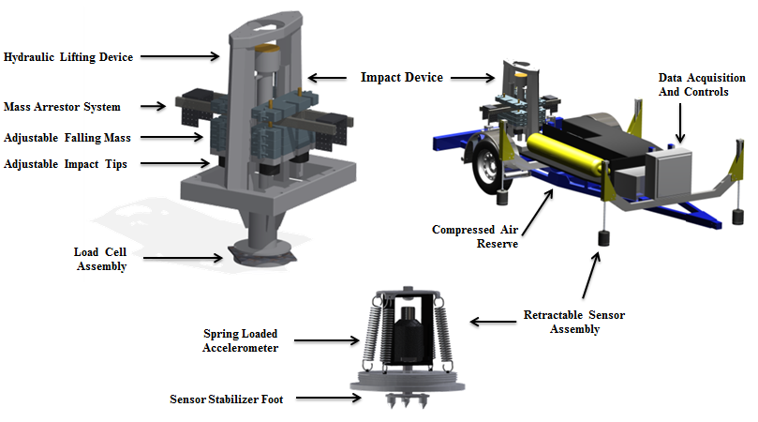

Figure 6. THMPR System - Primary Components

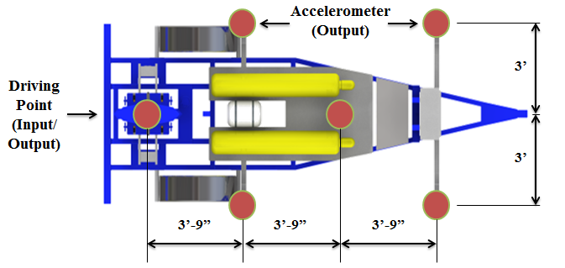

Figure 7. THMPR Local Sensor Array

### Instrumentation

The typical instrumentation plan for a single span is shown in Figure 8. A total of six stationary reference accelerometers were used for each of the two spans. The references were temporarily attached to the bridge deck using glue adhesive at the quarter span, mid span, and three-quarter span locations along each lane. The reference accelerometers remained at the same locations on the deck throughout the vibration testing and were used to link together the vibrations measured by THMPR’s local sensor array of six accelerometers (Figure 7). The reference accelerometers were cabled to GPS synchronized data acquisition systems along each shoulder and out of the way of traffic.

A total of six impact locations were selected for the test: (1) at quarter span in the right lane, (2) at mid span in the right lane, (3) at three-quarter span in the right lane, (4) at quarter span in the left lane, (5) at mid span in the left lane, and (6) at three-quarter span in the left lane. The impact locations were chosen so that the measured vibration responses would have a dense spatial resolution and to vary the spatial characteristics of the input excitation. The former consideration is important for resolving different mode shapes from the vibration measurements, while the latter is important for exciting different vibration modes. Note, only three of the six local output sensors were required for data analysis.

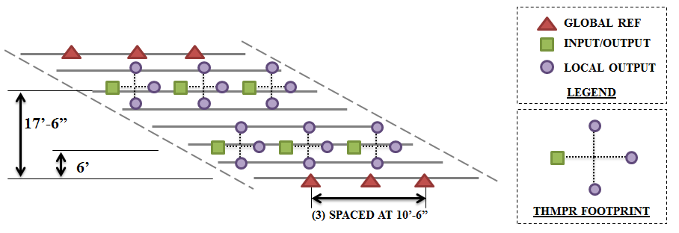

Figure 8. Typical Instrumentation Plan

### Test Execution

THMPR system testing was conducted on November 5, 2014. THMPR’s impact head was centered above a selected impact location on the deck and the GPS synchronized accelerometer array attached to THMPR was remotely deployed. This lowered the six accelerometer housings onto the bridge deck and compressed them against the surface (Figure 9). The impact force and bridge vibration measurements were recorded at a rate of 3,200 samples per second (Hz) for each span in order to precisely define the shape of the impulse signal and for a duration of 10 seconds to ensure the complete capture of the structure’s post-impact free vibration decay response. A total of three separate impacts were recorded for averaging and noise reduction purposes at each of the six locations for each of the three spans.

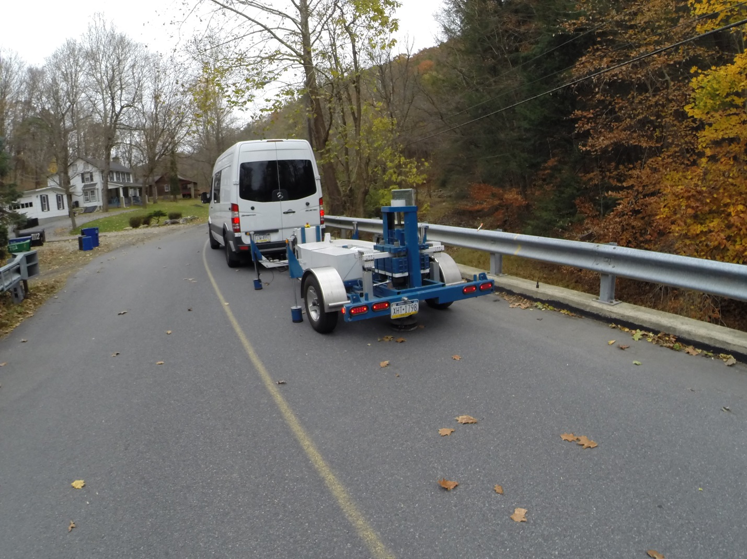

SENSOR HOUSING

Figure 9. THMPR System Test Execution

### Data Quality

Typical impact forces of up to 25,000 lbs. were observed (Figure 10A) with an approximate usable frequency range of 0-65 Hz (Figure 10B). The impact forces produced by THMPR also resulted in bridge acceleration magnitudes of up to 3 g’s (Figure 11A). Frequency content of the structural response (Figure 11B) shows clearly defined, smooth peaks of resonance which indicates linearity, adequate frequency resolution, and good excitation of all fundamental modes of interest. The relatively large structural response and the acquisition of ten second time windows provided a frequency resolution of 0.09 Hz which resulted in good characterization of closely spaced modes.

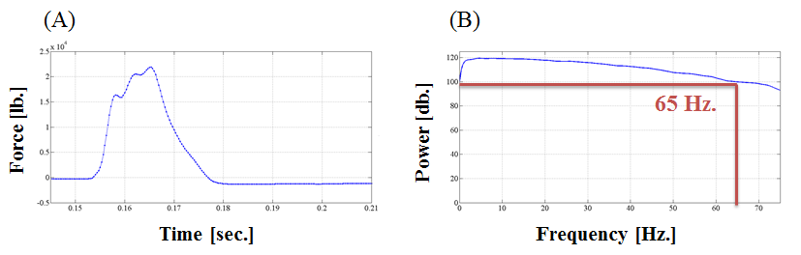

Figure 10. (A) Typical Force Time History & (B) Typical Force Frequency Content

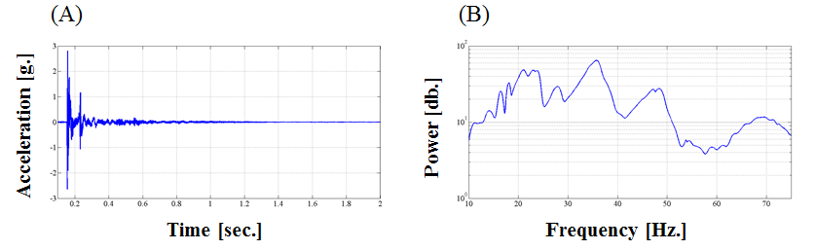

Figure 11. (A) Typical Response Time History & (B) Typical Response Frequency Content

### Modal Parameter Identification

The modal parameters for the structure were identified from the vibration measurements onsite after completion of the testing to provide immediate feedback on the data quality, structural response of the bridge, and operating condition of the test equipment to the on-site engineers. The modal parameters include the natural frequencies and the modal vectors (mode shapes) for each mode. These parameters are directly related to the in-situ mass and stiffness characteristics of the bridge, and are used for calibrating the FE model of the structure.

The modal parameter identification process starts with the computation of frequency response functions for each input-output measurement pair. A frequency response function is essentially the frequency domain transform of measured acceleration response at each sensor location divided by the measured impact force for each test location. The Complex Mode Indicator Function (CMIF) was then calculated for each test location (Figure 12 and Figure 13) using the frequency response functions created in the previous step. The CMIF is computed by singular value decomposition of the matrix of frequency response functions for each test location. The largest singular values are plotted against frequency to create the CMIF plot. Each peak in the CMIF plot represents a location of a vibration mode for the structure and the amplitude of the singular value is directly related to the dominance of the corresponding modal vector at that test location. The singular values for each independent impact location are super imposed to compare areas of resonance and ultimately select global modal parameters. A total of six global vibration modes (global poles) for span 1 and five global vibration modes for span 2 were identified from the CMIF plots as shown in Figure 12 and Figure 13.

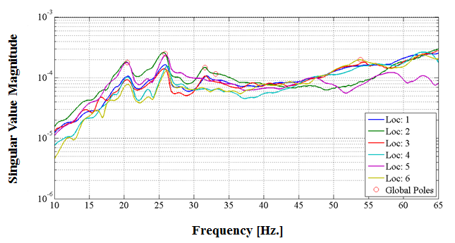

Figure 12. Span 1 – Complex Mode Indicator Function (CMIF)

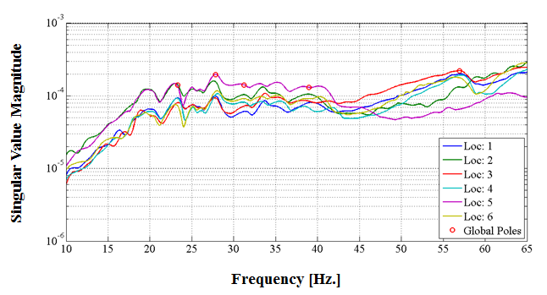

Figure 13. Span 2 – Complex Mode Indicator Function (CMIF)

For each of the spans, local mode shapes for each impact location were extracted at each global pole and combined into a global parameter set. Master mode shapes were selected for each mode based on the relative amplitude of the CMIF singular value for each impact location. The impact location associated with the largest CMIF amplitude for a specific vibration mode contains the highest signal to noise ratio and the corresponding mode shape was designated the master shape for that vibration mode. For each global pole, the modal amplitudes of the stationary references were compared between the local master mode shape and the remaining local mode shapes. A scaling coefficient was developed via a least squares approximation and used to linearly integrate the independent local mode shapes into the local master mode shape and form a global parameter set. Local mode shapes extracted from impact locations which coincided with a point of zero displacement (nodal point) for a particular mode were discarded and not included within the global modal parameter set. Additionally, a combination of the stationary references for each master local mode shape was chosen on an individual mode basis to avoid using reference sensors in locations of low modal amplitude for a particular mode. Span 1 global mode shapes and frequencies are shown in Figure 14 and Table 4, respectively. Span 2 global mode shapes and frequencies are shown in Figure 15 and Table 5, respectively. It should be noted that the interstitial areas between the discrete experimental degrees-of-freedom for the mode shapes were interpolated using a fourth order equation to aid in the visualization of these shapes.

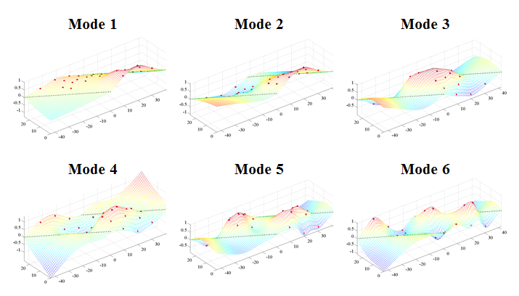

Figure 14. Span 1 – THMPR Results - Global Mode Shapes

Table 4. Span 1 – THMPR Results – Identified Natural Frequencies

|  |  |  |  |
| --- | --- | --- | --- |
| **Mode** | **Frequency [Hz]** | **Master**  **Location** | **Included Locations** |
| 1 | 21.29 | 2 | 2 3 4 5 6 |
| 2 | 23.05 | 2 | 1 2 3 4 5 |
| 3 | 27.93 | 2 | 1 2 5 6 |
| 4 | 35.94 | 2 | 1 2 3 4 5 6 |
| 5 | 48.73 | 2 | 2 3 4 5 |
| 6 | 61.33 | 1 | 1 3 4 6 |

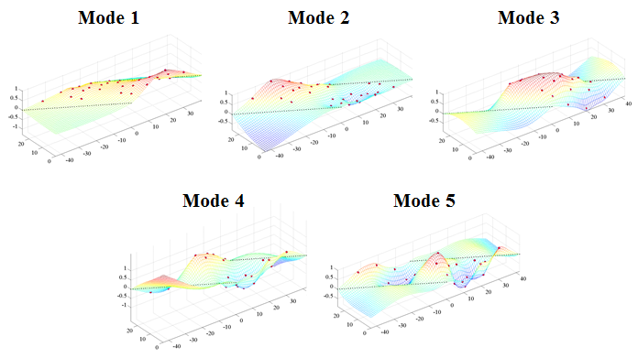

Figure 15. Span 2 – THMPR Results – Global Mode Shapes

Table 5. Span 2 – THMPR Results – Identified Natural Frequencies

|  |  |  |  |
| --- | --- | --- | --- |
| **Mode** | **Frequency [Hz]** | **Master**  **Location** | **Included Locations** |
| 1 | 21.39 | 2 | 1 2 3 4 5 6 |
| 2 | 23.93 | 5 | 1 2 3 4 5 6 |
| 3 | 29.3 | 2 | 1 2 3 5 6 |
| 4 | 37.3 | 5 | 1 2 3 5 6 |
| 5 | 48.24 | 5 | 1 2 3 4 5 |

## Appendix A-3 – Model Updating

The *a priori* model was updated for each span using a multi-start method with 6 updating trials starting from different combinations of initial parameter values:

|  |  |  |  |  |
| --- | --- | --- | --- | --- |
|  | **Start Point** | | | |
| **Update** | *Deck* | *Encasement* | *Composite Action* | *R2* |
| *1* | Min | Min | Min | Min |
| *2* | Max | Min | Min | Min |
| *3* | Min | Max | Min | Min |
| *4* | Min | Min | Max | Min |
| *5* | Min | Min | Min | Max |
| *6* | Max | Max | Max | Max |

Presented in the table are the analytical mode shapes paired with the experimental results. Updated model modes shapes are typical for both spans of the structure. The *a priori* model from each span exhibited natural frequencies lower than that of the actual structure, indicating a lack of global stiffness. All updated models for both spans showed negligible differences in frequency from the experiment (+/- 5%). Mode shapes developed with THMPR were judges to be insufficient for model updating, therefore only frequency values were used in the objective function. Despite neglecting mode shapes for updating purposes, the updated models showed similar or better agreement with the experimental mode shapes than the *a priori* models. The updating results indicate that the updated models are accurate indicators of global stiffness.

Table 6. Typical Mode Shapes

|  |  |  |  |
| --- | --- | --- | --- |
| A-Priori Shapes | Mode Number | Typical Updated Model Shaped | Mode Number |
|  | **1** |  | **1** |
|  | **2** |  | **2** |
|  | **3** |  | **3** |
|  | **5** |  | **4** |
|  | **8** |  | **5** |
|  | **9** |  | **9** |

Table 7. Comparison of *A Priori* and Experimental Mode Frequencies for Span 1

|  |  |  |  |  |
| --- | --- | --- | --- | --- |
| **MAC** | **Natural Frequency** | | | **Analytical Mode** |
| *Experimental [Hz]* | *Analytical [Hz]* | *% Difference* |
| 0.8813 | 21.2891 | 11.7443 | -44.834 | 1 |
| 0.8523 | 23.0469 | 12.5899 | -45.3728 | 2 |
| 0.9445 | 27.9297 | 19.0544 | -31.7771 | 3 |
| 0.8658 | 35.9375 | 26.4372 | -26.4355 | 5 |
| 0.4339 | 48.7305 | 40.0885 | -17.7343 | 8 |
| 0.6477 | 61.3281 | 44.7317 | -27.0617 | 9 |

Table 8. Comparison of Update 1 and Experimental Mode Frequencies for Span 1

|  |  |  |  |  |
| --- | --- | --- | --- | --- |
| **MAC** | **Natural Frequency** | | | **Analytical Mode** |
| *Experimental [Hz]* | *Analytical [Hz]* | *% Difference* |
| 0.9552 | 21.2891 | 21.7215 | 2.0311 | 1 |
| 0.7458 | 23.0469 | 22.4636 | -2.5307 | 2 |
| 0.9539 | 27.9297 | 27.5927 | -1.2067 | 3 |
| 0.9636 | 35.9375 | 36.4214 | 1.3466 | 4 |
| 0.8747 | 48.7305 | 48.1366 | -1.2188 | 5 |
| 0.729 | 61.3281 | 62.0981 | 1.2555 | 9 |

Table 9. Comparison of Update 2 and Experimental Mode Frequencies for Span 1

|  |  |  |  |  |
| --- | --- | --- | --- | --- |
| **MAC** | **Natural Frequency** | | | **Analytical Mode** |
| *Experimental [Hz]* | *Analytical [Hz]* | *% Difference* |
| 0.9555 | 21.2891 | 21.708 | 1.968 | 1 |
| 0.7454 | 23.0469 | 22.4102 | -2.7625 | 2 |
| 0.9557 | 27.9297 | 27.5516 | -1.3538 | 3 |
| 0.9641 | 35.9375 | 36.3906 | 1.2608 | 4 |
| 0.8735 | 48.7305 | 48.0751 | -1.3449 | 5 |
| 0.7325 | 61.3281 | 61.9579 | 1.0269 | 9 |

Table 10. Comparison of Update 3 and Experimental Mode Frequencies for Span 1

|  |  |  |  |  |
| --- | --- | --- | --- | --- |
| **MAC** | **Natural Frequency** | | | **Analytical Mode** |
| *Experimental [Hz]* | *Analytical [Hz]* | *% Difference* |
| 0.9425 | 21.2891 | 21.6746 | 1.8107 | 1 |
| 0.7733 | 23.0469 | 22.5021 | -2.3636 | 2 |
| 0.9494 | 27.9297 | 27.6417 | -1.031 | 3 |
| 0.9629 | 35.9375 | 36.3608 | 1.1779 | 4 |
| 0.8782 | 48.7305 | 48.038 | -1.421 | 5 |
| 0.7113 | 61.3281 | 62.2931 | 1.5735 | 9 |

Table 11. Comparison of Update 4 and Experimental Mode Frequencies for Span 1

|  |  |  |  |  |
| --- | --- | --- | --- | --- |
| **MAC** | **Natural Frequency** | | | **Analytical Mode** |
| *Experimental [Hz]* | *Analytical [Hz]* | *% Difference* |
| 0.9543 | 21.2891 | 21.7826 | 2.3182 | 1 |
| 0.7508 | 23.0469 | 22.4708 | -2.4997 | 2 |
| 0.9552 | 27.9297 | 27.5469 | -1.3707 | 3 |
| 0.9644 | 35.9375 | 36.4083 | 1.3099 | 4 |
| 0.8764 | 48.7305 | 48.1483 | -1.1947 | 5 |
| 0.7322 | 61.3281 | 61.9288 | 0.9795 | 9 |

Table 12. Comparison of Update 5 and Experimental Mode Frequencies for Span 1

|  |  |  |  |  |
| --- | --- | --- | --- | --- |
| **MAC** | **Natural Frequency** | | | **Analytical Mode** |
| *Experimental [Hz]* | *Analytical [Hz]* | *% Difference* |
| 0.8776 | 21.2891 | 21.5732 | 1.3346 | 1 |
| 0.8606 | 23.0469 | 22.2423 | -3.4912 | 2 |
| 0.956 | 27.9297 | 27.6003 | -1.1792 | 3 |
| 0.9681 | 35.9375 | 36.5244 | 1.633 | 4 |
| 0.8814 | 48.7305 | 48.2685 | -0.9479 | 5 |
| 0.7444 | 61.3281 | 62.4461 | 1.8229 | 9 |

Table 13. Comparison of Update 6 and Experimental Mode Frequencies for Span 1

|  |  |  |  |  |
| --- | --- | --- | --- | --- |
| **MAC** | **Natural Frequency** | | | **Analytical Mode** |
| *Experimental [Hz]* | *Analytical [Hz]* | *% Difference* |
| 0.8772 | 21.2891 | 21.5653 | 1.2976 | 1 |
| 0.861 | 23.0469 | 22.2363 | -3.517 | 2 |
| 0.956 | 27.9297 | 27.5998 | -1.1811 | 3 |
| 0.9681 | 35.9375 | 36.5303 | 1.6496 | 4 |
| 0.8811 | 48.7305 | 48.2769 | -0.9307 | 5 |
| 0.7446 | 61.3281 | 62.4529 | 1.834 | 9 |

Table 14. Comparison of *A Priori* Model and Experimental Modal Frequencies for Span 2

|  |  |  |  |  |
| --- | --- | --- | --- | --- |
| **MAC** | **Natural Frequency** | | | **Analytical Mode** |
| *Experimental [Hz]* | *Analytical [Hz]* | *% Difference* |
| 0.8387 | 21.3867 | 11.7443 | -45.0859 | 1 |
| 0.6801 | 23.9258 | 12.5899 | -47.3795 | 2 |
| 0.8319 | 29.2969 | 19.0544 | -34.9608 | 3 |
| 0.7513 | 37.3047 | 26.4372 | -29.1316 | 5 |
| 0.342 | 48.2422 | 40.0885 | -16.9017 | 8 |

Table 15. Comparison of Update 1 and Experimental Modal Frequencies for Span 2

|  |  |  |  |  |
| --- | --- | --- | --- | --- |
| **MAC** | **Natural Frequency** | | | **Analytical Mode** |
| *Experimental [Hz]* | *Analytical [Hz]* | *% Difference* |
| 0.9418 | 21.3867 | 21.7614 | 1.7522 | 1 |
| 0.7808 | 23.9258 | 22.9391 | -4.1238 | 2 |
| 0.8586 | 29.2969 | 28.4937 | -2.7415 | 3 |
| 0.8736 | 37.3047 | 37.6947 | 1.0456 | 4 |
| 0.5959 | 48.2422 | 49.7117 | 3.0461 | 5 |

Table 16. Comparison of Update 2 and Experimental Modal Frequencies for Span 2

|  |  |  |  |  |
| --- | --- | --- | --- | --- |
| **MAC** | **Natural Frequency** | | | **Analytical Mode** |
| *Experimental [Hz]* | *Analytical [Hz]* | *% Difference* |
| 0.9596 | 21.3867 | 22.1237 | 3.4462 | 1 |
| 0.8238 | 23.9258 | 22.8931 | -4.3162 | 2 |
| 0.8637 | 29.2969 | 28.4316 | -2.9536 | 3 |
| 0.8569 | 37.3047 | 37.5435 | 0.64 | 4 |
| 0.561 | 48.2422 | 49.341 | 2.2776 | 5 |

Table 17. Comparison of Update 3 and Experimental Modal Frequencies for Span 2

|  |  |  |  |  |
| --- | --- | --- | --- | --- |
| **MAC** | **Natural Frequency** | | | **Analytical Mode** |
| *Experimental [Hz]* | *Analytical [Hz]* | *% Difference* |
| 0.9453 | 21.3867 | 21.7853 | 1.8639 | 1 |
| 0.7865 | 23.9258 | 22.9246 | -4.1845 | 2 |
| 0.8585 | 29.2969 | 28.4815 | -2.7831 | 3 |
| 0.8715 | 37.3047 | 37.6912 | 1.0361 | 4 |
| 0.5921 | 48.2422 | 49.7106 | 3.0438 | 5 |

Table 18. Comparison of Update 4 and Experimental Modal Frequencies for Span 2

|  |  |  |  |  |
| --- | --- | --- | --- | --- |
| **MAC** | **Natural Frequency** | | | **Analytical Mode** |
| *Experimental [Hz]* | *Analytical [Hz]* | *% Difference* |
| 0.9597 | 21.3867 | 22.0482 | 3.093 | 1 |
| 0.8365 | 23.9258 | 22.9876 | -3.9214 | 2 |
| 0.849 | 29.2969 | 28.3102 | -3.368 | 3 |
| 0.8428 | 37.3047 | 37.5254 | 0.5916 | 4 |
| 0.5404 | 48.2422 | 49.617 | 2.8498 | 5 |

Table 19. Comparison of Update 5 and Experimental Modal Frequencies for Span 2

|  |  |  |  |  |
| --- | --- | --- | --- | --- |
| **MAC** | **Natural Frequency** | | | **Analytical Mode** |
| *Experimental [Hz]* | *Analytical [Hz]* | *% Difference* |
| 0.9606 | 21.3867 | 22.106 | 3.3633 | 1 |
| 0.8279 | 23.9258 | 22.8902 | -4.3283 | 2 |
| 0.8628 | 29.2969 | 28.4447 | -2.9088 | 3 |
| 0.8548 | 37.3047 | 37.5894 | 0.7631 | 4 |
| 0.5564 | 48.2422 | 49.4113 | 2.4234 | 5 |

Table 20. Comparison of Update 6 and Experimental Modal Frequencies for Span 2

|  |  |  |  |  |
| --- | --- | --- | --- | --- |
| **MAC** | **Natural Frequency** | | | **Analytical Mode** |
| *Experimental [Hz]* | *Analytical [Hz]* | *% Difference* |
| 0.9591 | 21.3867 | 22.0786 | 3.235 | 1 |
| 0.8369 | 23.9258 | 22.8976 | -4.2975 | 2 |
| 0.8591 | 29.2969 | 28.4262 | -2.972 | 3 |
| 0.8466 | 37.3047 | 37.609 | 0.8156 | 4 |
| 0.5409 | 48.2422 | 49.48 | 2.5658 | 5 |

## Appendix A-4 – Updated Model Ratings

### Span 1

Table 21. Updated models with concrete encasement contribution.

|  |  |  |  |  |  |  |  |  |  |
| --- | --- | --- | --- | --- | --- | --- | --- | --- | --- |
|  |  | **Updated Models With Concrete Encasement Contribution** | | | | | | | |
|  |  | ***Strength I*** | | | | ***Service II*** | | | |
|  |  | *Inv* | *Ctrl. Gir.* | *Op* | *Ctrl. Gir.* | *Inv* | *Ctrl. Gir.* | *Op* | *Ctrl. Gir.* |
| ***A Priori*** | **RF** | 1.54 | 5 | 2.00 | 5 | 0.62 | 2 | 0.80 | 2 |
| **Tons** | 55.47 | 71.90 | 22.22 | 28.88 |
| **Update 1** | **RF** | 18.36 | 5 | 23.80 | 5 | 3.52 | 2 | 4.58 | 2 |
| **Tons** | 661.03 | 856.89 | 126.73 | 164.74 |
| **% Δ** | 91.61 | 91.61 | 82.47 | 82.47 |
| **Update 2** | **RF** | 17.99 | 5 | 23.32 | 5 | 3.50 | 2 | 4.54 | 2 |
| **Tons** | 647.50 | 839.36 | 125.83 | 163.58 |
| **% Δ** | 91.43 | 91.43 | 82.34 | 82.34 |
| **Update 3** | **RF** | 19.88 | 5 | 25.77 | 5 | 3.65 | 2 | 4.75 | 2 |
| **Tons** | 715.72 | 927.79 | 131.48 | 170.92 |
| **% Δ** | 92.25 | 92.25 | 83.10 | 83.10 |
| **Update 4** | **RF** | 17.33 | 5 | 22.47 | 5 | 3.45 | 2 | 4.49 | 2 |
| **Tons** | 624.00 | 808.90 | 124.23 | 161.50 |
| **% Δ** | 91.11 | 91.11 | 82.12 | 82.12 |
| **Update 5** | **RF** | 20.58 | 5 | 26.68 | 5 | 3.63 | 2 | 4.72 | 2 |
| **Tons** | 740.86 | 960.37 | 130.68 | 169.88 |
| **% Δ** | 92.51 | 92.51 | 83.00 | 83.00 |
| **Update 6** | **RF** | 20.55 | 5 | 26.64 | 5 | 3.62 | 2 | 4.71 | 2 |
| **Tons** | 739.81 | 959.01 | 130.50 | 169.65 |
| **% Δ** | 92.50 | 92.50 | 82.97 | 82.97 |

Table 22. Updated models without concrete encasement contribution.

|  |  |  |  |  |  |  |  |  |  |
| --- | --- | --- | --- | --- | --- | --- | --- | --- | --- |
|  | | **Updated Model Without Concrete Encasement Contribution** | | | | | | | |
| ***Strength I*** | | | | ***Service II*** | | | |
| Inv | Ctrl. Gir. | Op | Ctrl. Gir. | Inv | Ctrl. Gir. | Op | Ctrl. Gir. |
| ***A Priori*** | **RF** | 1.54 | 5 | 2.00 | 5 | 0.62 | 2 | 0.80 | 2 |
| **Tons** | 55.47 | 71.90 | 22.22 | 28.88 |
| **Update 1** | **RF** | 4.54 | 5 | 5.88 | 5 | 1.10 | 2 | 1.44 | 2 |
| **Tons** | 163.27 | 211.64 | 39.75 | 51.68 |
| **% Δ** | 66.03 | 66.03 | 44.11 | 44.11 |
| **Update 2** | **RF** | 4.60 | 5 | 5.97 | 5 | 1.11 | 2 | 1.44 | 2 |
| **Tons** | 165.69 | 214.78 | 39.81 | 51.75 |
| **% Δ** | 66.52 | 66.52 | 44.18 | 44.18 |
| **Update 3** | **RF** | 4.18 | 5 | 5.41 | 5 | 1.10 | 2 | 1.43 | 2 |
| **Tons** | 150.35 | 194.90 | 39.56 | 51.42 |
| **% Δ** | 63.11 | 63.11 | 43.83 | 43.83 |
| **Update 4** | **RF** | 4.68 | 5 | 6.06 | 5 | 1.11 | 2 | 1.44 | 2 |
| **Tons** | 168.42 | 218.32 | 39.86 | 51.82 |
| **% Δ** | 67.07 | 67.07 | 44.26 | 44.26 |
| **Update 5** | **RF** | 4.39 | 5 | 5.69 | 5 | 1.10 | 2 | 1.43 | 2 |
| **Tons** | 158.07 | 204.90 | 39.49 | 51.34 |
| **% Δ** | 64.91 | 64.91 | 43.74 | 43.74 |
| **Update 6** | **RF** | 4.40 | 5 | 5.70 | 5 | 1.10 | 2 | 1.43 | 2 |
| **Tons** | 158.44 | 205.38 | 39.49 | 51.33 |
| **% Δ** | 64.99 | 64.99 | 43.73 | 43.73 |

### Span 2

Table 23. Updated models with concrete encasement contribution.

|  |  |  |  |  |  |  |  |  |  |
| --- | --- | --- | --- | --- | --- | --- | --- | --- | --- |
|  |  | **Updated Models With Concrete Encasement Contribution** | | | | | | | |
|  |  | ***Strength I*** | | | | ***Service II*** | | | |
|  |  | *Inv* | *Ctrl. Gir.* | *Op* | *Ctrl. Gir.* | *Inv* | *Ctrl. Gir.* | *Op* | *Ctrl. Gir.* |
| ***A Priori*** | **RF** | 1.54 | 5 | 2.00 | 5 | 0.62 | 2 | 0.80 | 2 |
| **Tons** | 55.47 | 71.90 | 22.22 | 28.88 |
| **Update 1** | **RF** | 22.67 | 5 | 29.39 | 5 | 3.59 | 2 | 4.66 | 2 |
| **Tons** | 816.20 | 1058.03 | 129.09 | 167.82 |
| **% Δ** | 93.20 | 93.20 | 82.79 | 82.79 |
| **Update 2** | **RF** | 23.54 | 5 | 30.51 | 5 | 3.72 | 2 | 4.84 | 2 |
| **Tons** | 847.40 | 1098.48 | 134.08 | 174.31 |
| **% Δ** | 93.45 | 93.45 | 83.43 | 83.43 |
| **Update 3** | **RF** | 22.77 | 5 | 29.52 | 5 | 3.60 | 2 | 4.68 | 2 |
| **Tons** | 819.75 | 1062.64 | 129.53 | 168.39 |
| **% Δ** | 93.23 | 93.23 | 82.85 | 82.85 |
| **Update 4** | **RF** | 22.30 | 5 | 28.91 | 5 | 3.63 | 2 | 4.72 | 2 |
| **Tons** | 802.75 | 1040.60 | 130.79 | 170.02 |
| **% Δ** | 93.09 | 93.09 | 83.01 | 83.01 |
| **Update 5** | **RF** | 23.63 | 5 | 30.63 | 5 | 3.72 | 2 | 4.83 | 2 |
| **Tons** | 850.59 | 1102.62 | 133.86 | 174.01 |
| **% Δ** | 93.48 | 93.48 | 83.40 | 83.40 |
| **Update 6** | **RF** | 23.65 | 5 | 30.66 | 5 | 3.71 | 2 | 4.82 | 2 |
| **Tons** | 851.39 | 1103.66 | 133.59 | 173.67 |
| **% Δ** | 93.49 | 93.49 | 83.37 | 83.37 |

Table 24. Updated models without concrete encasement contribution.

|  |  |  |  |  |  |  |  |  |  |
| --- | --- | --- | --- | --- | --- | --- | --- | --- | --- |
|  | | **Updated Model Without Concrete Encasement Contribution** | | | | | | | |
| ***Strength I*** | | | | ***Service II*** | | | |
| Inv | Ctrl. Gir. | Op | Ctrl. Gir. | Inv | Ctrl. Gir. | Op | Ctrl. Gir. |
| ***A Priori*** | **RF** | 1.54 | 5 | 2.00 | 5 | 0.62 | 2 | 0.80 | 2 |
| **Tons** | 55.47 | 71.90 | 22.22 | 28.88 |
| **Update 1** | **RF** | 4.78 | 5 | 6.20 | 5 | 1.09 | 2 | 1.41 | 2 |
| **Tons** | 172.15 | 223.16 | 39.12 | 50.85 |
| **% Δ** | 67.78 | 67.78 | 43.20 | 43.20 |
| **Update 2** | **RF** | 4.91 | 5 | 6.37 | 5 | 1.10 | 2 | 1.44 | 2 |
| **Tons** | 176.86 | 229.27 | 39.75 | 51.67 |
| **% Δ** | 68.64 | 68.64 | 44.10 | 44.10 |
| **Update 3** | **RF** | 4.80 | 5 | 6.22 | 5 | 1.09 | 2 | 1.42 | 2 |
| **Tons** | 172.79 | 223.99 | 39.18 | 50.94 |
| **% Δ** | 67.90 | 67.90 | 43.30 | 43.30 |
| **Update 4** | **RF** | 4.85 | 5 | 6.29 | 5 | 1.10 | 2 | 1.43 | 2 |
| **Tons** | 174.56 | 226.28 | 39.63 | 51.52 |
| **% Δ** | 68.22 | 68.22 | 43.93 | 43.93 |
| **Update 5** | **RF** | 4.94 | 5 | 6.40 | 5 | 1.10 | 2 | 1.43 | 2 |
| **Tons** | 177.71 | 230.37 | 39.74 | 51.66 |
| **% Δ** | 68.79 | 68.79 | 44.08 | 44.08 |
| **Update 6** | **RF** | 4.95 | 5 | 6.41 | 5 | 1.10 | 2 | 1.44 | 2 |
| **Tons** | 178.06 | 230.82 | 39.74 | 51.66 |
| **% Δ** | 68.85 | 68.85 | 44.09 | 44.09 |

**PAGE INTENTIONALLY LEFT BLANK**

# Appendix B – Bridge 063 Performance Evaluation and Load Rating Analysis

**Northampton County Bridge 063**

|  |  |
| --- | --- |
| **BMS No:** | 48 7415 0000 9063 |
| **Feature Carried:** | Bushkill Road |
| **Feature Intersected:** | Bushkill Creek |
| **Structure Type:** | Three Span, Simply Supported Concrete Encased Steel I-Beam |
|  |  |
| **Test Date:** | 11/04/2014 |
| **Test Type:** | Dynamic Test |
| **Analysis and Rating Method:** | AASHTO LRFR |

|  |  |  |  |  |  |  |  |  |  |  |
| --- | --- | --- | --- | --- | --- | --- | --- | --- | --- | --- |
|  | **Strength I** | **Inventory** | **Tons** | **Operating** | **Tons** | **Service II** | **Inventory** | **Tons** | **Operating** | **Tons** |
| ***Pre-Test*** |  |  |  |  |  |  |  |  |
| Single Line* | 0.6 | 21 | 0.9 | 35 | - | - | - | - |
| *A Priori* Model | 3.2 | 116 | 4.2 | 150 | 2.4 | 856 | 3.1 | 112 |
| ***Post-Test Conservative Model*** |  |  |  |  |  |  |  |  |
| Span 1 | **5.2** | **187** | **6.7** | **242** | **2.0** | **72** | **2.6** | **93** |
| Span 2 | **6.8** | **244** | **8.8** | **316** | **2.0** | **72** | **2.6** | **94** |
| Span 3 | **5.7** | **205** | **7.4** | **266** | **1.7** | **60** | **2.2** | **78** |

Table 1. Single Line, *A Priori*, and Final Calibrated Models for all three spans of Bridge 063.   
*Single line rating for ML80 loading, from 2012 report provided by STV Inc.

Design drawings for this bridge were not available at the time of testing; however, STV Inc. produced a Load Rating Summary performed in 2012 that detailed the structure’s cross section. The geometry of the bridge and its components was verified via field measurements on the day of the test. The structure was evaluated using forced vibration testing methods and the dynamic properties (natural frequencies and mode shapes) were extracted for finite element model calibration.

Strand7 FE Modelling Software was used in conjunction with computational software to perform a live load rating analysis for all three spans of the bridge. An initial finite element (FE) model was created in Strand7 for all three spans of the bridge. Conservative material properties, section properties, continuity conditions and boundary conditions were assumed for an initial model. The initial model was rated for AASHTO Load and Resistance Factor Strength I and Service II limit states for an HL-93 truck. The initial model was then calibrated to the natural frequencies and mode shapes developed through experimentation. A set of calibrated models were used to perform live load ratings for each span with and without concrete encasement stiffness contribution. Controlling ratings for the initial and calibrated models are summarized in the above table.

## Experimental Evaluation Summary

Bridge 063 was evaluated on November 4, 2014 using forced vibration testing methods and the dynamic properties (natural frequencies and mode shapes) were extracted for finite element model calibration.

Figure 1. THMPR System

A self-contained modal impact trailer equipped with a falling mass impact system and local sensor array was used to execute the vibration tests. The superstructure was excited via a 25 kip impulse force at multiple, spatially distributed locations which resulted in up to 4 g’s of bridge deck acceleration. Acceleration responses were measured via a local sensor array of six accelerometers and multiple spatially distributed stationary global references secured to the bridge deck via glue adhesive prior to testing. Local modal parameter estimation was performed utilizing the Complex Mode Indicator Function (CMIF) and integrated into a final global modal parameter set. The structure's first five natural frequencies and mode shapes were identified for each of the three spans in the frequency band of 0-60 Hz (Figure 2 & Table 2).

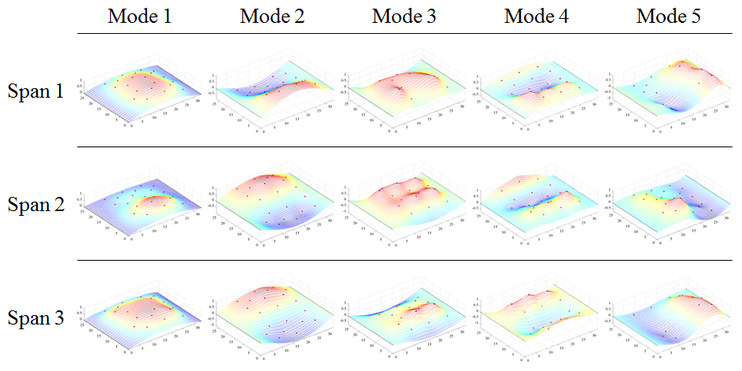

Figure 2. THMPR Results – Overview of Global Mode Shapes

Table 2. THMPR Results – Identified Natural Frequencies

|  |  |  |  |
| --- | --- | --- | --- |
| **Mode** | **Span 1**  **Frequency [Hz]** | **Span 2**  **Frequency [Hz]** | **Span 3**  **Frequency [Hz]** |
| 1 | 20.41 | 23.34 | 18.95 |
| 2 | 25.88 | 27.83 | 24.9 |
| 3 | 31.54 | 31.25 | 30.57 |
| 4 | 33.11 | 38.96 | 36.91 |
| 5 | 53.81 | 56.93 | 46.58 |

## Load Rating Analysis Summary

The structure was modeled using finite element analysis and computational software. An initial finite element (FE) model was created in Strand7 for all three spans of Northampton County Bridge 063 using the RAMPS software package developed at Drexel University as part of a National Institute of Standards and Technology Innovation Program (NIST-TIP) and the National Cooperative Highway Research Program Project 12-103 (NCHRP 12-103). Conservative material properties, section properties, continuity conditions and boundary conditions were assumed for an initial model. The 3D geometric model (Figure 3) utilizes beam elements for the steel I-section and concrete encasement. Shell elements are used to model the deck and concrete curb. Rigid links as well as beam elements with variable stiffness are used to enforce compatibility of the displacements between the various structural elements.

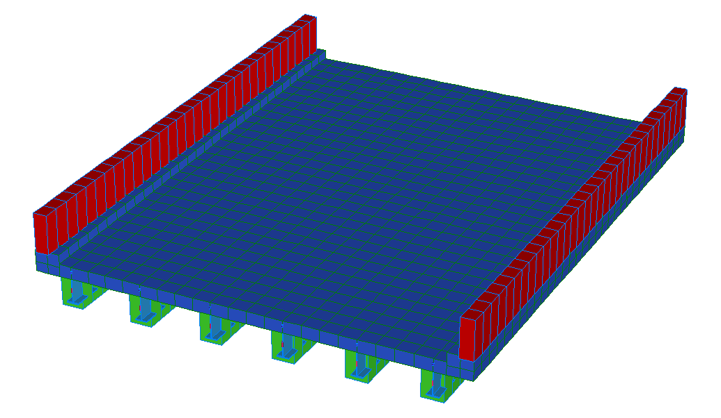

Y

X

Z

Figure 3. *A Priori* FE Model of single span of Bridge 063.

The initial model was rated for AASHTO Load and Resistance Factor Strength I and Service II limit states for an HL-93 truck. It was then calibrated to the natural frequencies and mode shapes developed through experimentation. A set of calibrated models were used to perform live load ratings. The six calibrated models with strong objective function and final parameter agreement were rated using the RAMPs software. In order to assure the most conservative load rating estimate while utilizing an updated FE model, stiffness contributions from the concrete encasement were ignored in a second set of ratings for the same six updated models. It was necessary to allow the updating algorithm to increase encasement stiffness in the model in response to differences between frequencies. Conservatively, we neglected the stiffness contribution of the concrete encasement after updating. The final reported ratings are based on the updated models without stiffness contribution of the concrete encasement. All other parameters from the updated models were carried over into this rating.

**The controlling Strength I and Service II limit state rating factors for the model with and without concrete encasement stiffness contribution is summarized for all three spans in the following table.**

Table 3. Controlling Strength I and Service II Limit state rating factors.

|  |  |  |  |  |  |  |
| --- | --- | --- | --- | --- | --- | --- |
| **(Inventory/Operating)** | **Strength I** | | | **Service II** | | |
| **Span 1** | **Span 2** | **Span 3** | **Span 1** | **Span 2** | **Span 3** |
| **With Concrete Encasement** | **18.8/24.4** | **24.6/31.9** | **19.7/25.6** | **5.0/6.5** | **4.3/5.5** | **4.0/5.2** |
| **Concrete Encasement Neglected** | **5.2/6.7** | **6.8/7.8** | **5.7/7.4** | **2.0/2.6** | **2.0/2.6** | **1.7/2.2** |

## Appendix B-1 – Bridge Description

Northampton County Bridge 063 is a three span, simply supported, concrete encased steel I-Beam structure. The bridge carries Bushkill Road over Bushkill Creek and has a current posted weight limit of 16 tons. All three spans were measured as 33’-6” span length and a roadway width of 23’-5”. Each span carries a curb measuring 4.75”x6.5” with a monolithic barrier of 29”x10” on either side of the roadway (Figure 4). The overall deck thickness was measured to be approximately 14” with a 4.75” overlay, implying the deck is 9”. Each span has six (6) concrete encased steel I-beams spaced at 4’-4” (Figure 5) with overall dimensions of 14.5”x21.5”. Each girder has what appears to be 1-2” of shotcrete applied to the surface of the original concrete encasement at a time unknown to the engineer. No apparent cracks were observed in the shotcrete cover for any of the girders. The presence of shotcrete over the original concrete encasement may imply that some deterioration of the encasement was present. This bridge has no skew.

No original plans exist for the bridge; however STV Inc. produced a Load Rating Summary performed in 2012 that details the structure cross-section. In their load rating, STV noted that Northampton County produced approximate beam dimensions after taking cores of the structure. Measurements taken in the field agreed with those reported by STV Inc.

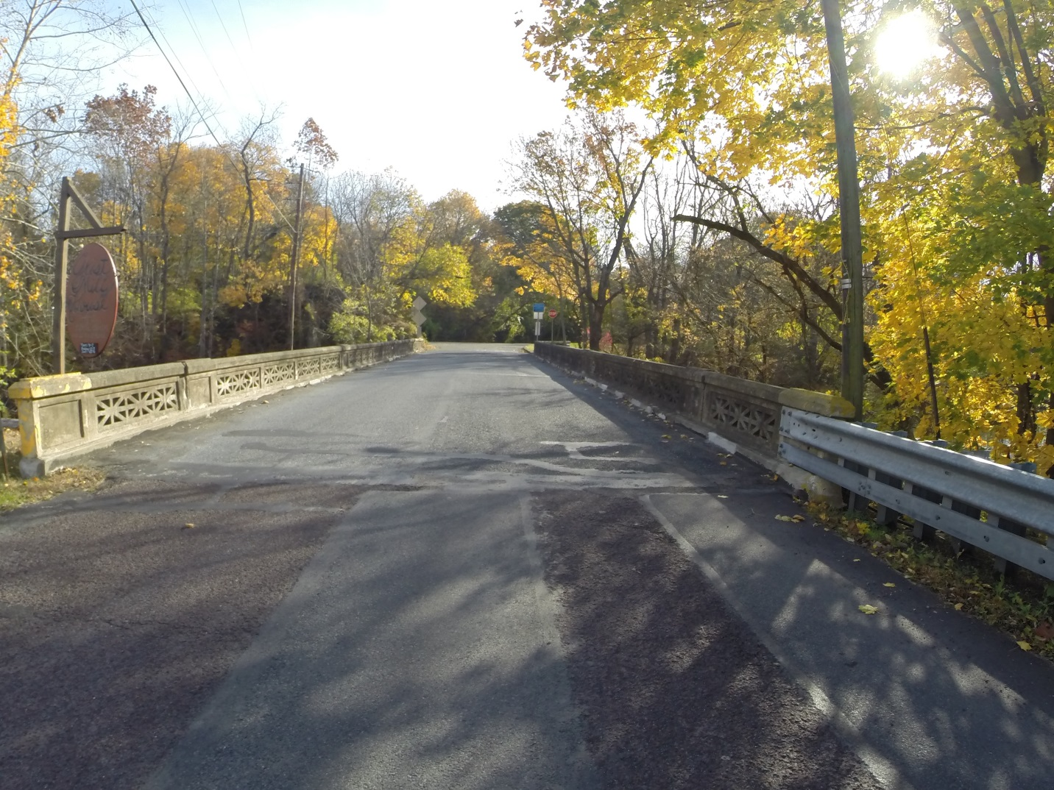

Figure 4. Northampton County Bridge 063

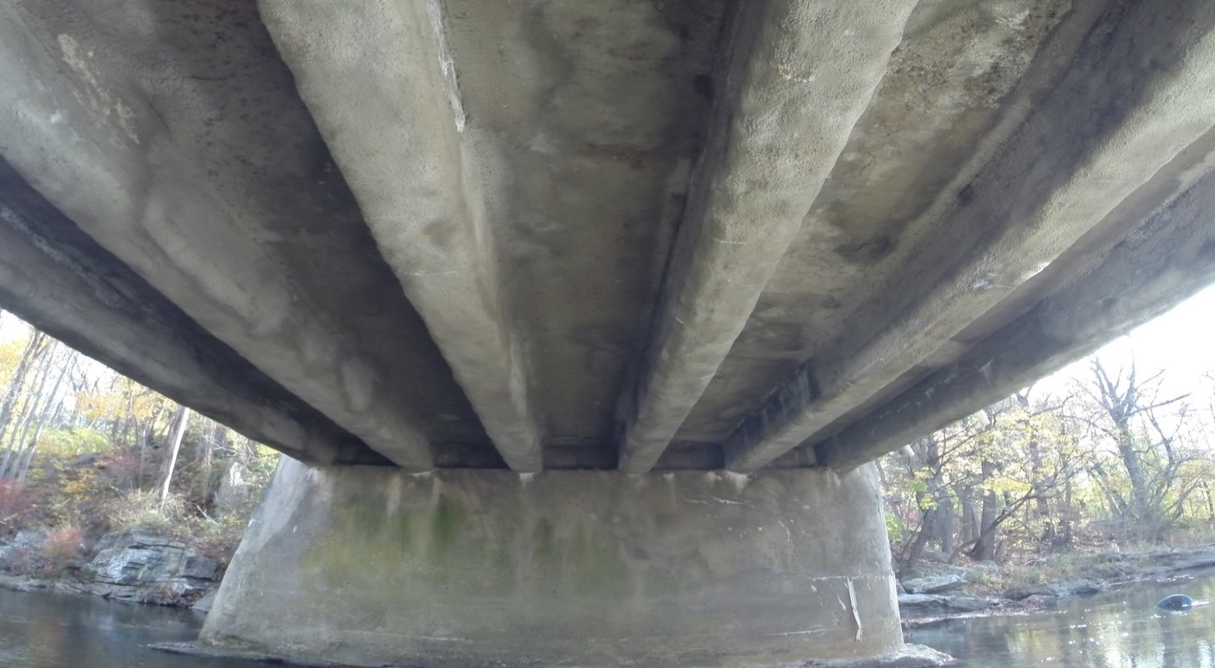

Figure 5. Underside view of Northampton County Bridge 063

## Appendix B-2 – Bridge 063 Experimental Evaluation

Northampton County Bridge 063 was evaluated using vibration testing methods. The bridge was dynamically excited at several locations on the deck surface using a broad band impact force, and its corresponding vibration responses were measured using accelerometers that were also located on the deck. The combined input-output vibration measurements were subsequently analyzed to extract the dynamic properties of the structure which were then used to calibrate a finite element model of the bridge. Details of the experimental setup, the test execution and the data analysis methods employed for the bridge are provided in the following sections.

### Description of Test Equipment - THMPR System

The Targeted Hits to Measure Performance Responses (THMPR) system is a self-contained rapid modal testing trailer and streamlined data processing software which extracts modal parameters, such as frequencies and mode shapes, of a structure. The extracted modal parameters may then be used to determine anomalous behavior as well as provide experimental data for finite element model calibration. The system, shown in Figure 6, is comprised of a physical test device which utilizes a significantly reconfigured Falling Weight Deflectometer trailer with modifications to (1) provide a single, large (~30 kip) broadband impact source, and (2) collect the resulting free-decay response of the bridge’s surface in a spatially distributed manner (and in-turn be able to capture local mode shapes). The local sensor array is shown in Figure 7. The trailer is towed along the bridge deck and single-input-multiple-output (SIMO) impact testing is performed at targeted locations. The data is wirelessly acquired at each location and passed to semi-automated modal processing software which performs (1) data quality checks, (2) frequency response function development and (3) modal parameter estimation. The local mode shapes are then linearly combined into a final global modal parameter set utilizing selected stationary references previously secured along an available sidewalk and cabled to an independent, GPS synchronized data acquisition.



Figure 6. THMPR System - Primary Components



Figure 7. THMPR Local Sensor Array

### Instrumentation

The typical instrumentation plan for a single span is shown in Figure 8. A total of three stationary reference accelerometers were used for each of the three spans. The references were temporarily attached to the bridge deck using glue adhesive at the quarter span, mid span, and three-quarter span locations. The reference accelerometers remained at the same locations on the deck throughout the vibration testing and were used to link together the vibrations measured by THMPR’s local sensor array of six accelerometers (Figure 7). The reference accelerometers were cabled to a local GPS synchronized data acquisition system along the shoulder and out of the way of traffic.

A total of six impact locations were selected for the test: (1) at quarter span in the right lane, (2) at mid span in the right lane, (3) at three-quarter span in the right lane, (4) at quarter span in the left lane, (5) at mid span in the left lane, and (6) at three-quarter span in the left lane. The impact locations were chosen so that the measured vibration responses would have a dense spatial resolution and to vary the spatial characteristics of the input excitation. The former consideration is important for resolving different mode shapes from the vibration measurements, while the latter is important for exciting different vibration modes. Note, only three of the six local output sensors were required for data analysis.

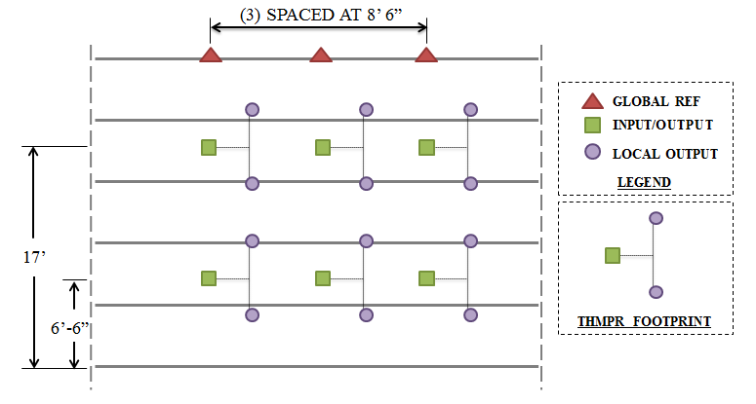

Figure 8. Typical Instrumentation Plan

### Test Execution

THMPR system testing was conducted on November 4, 2014. THMPR’s impact head was centered above a selected impact location on the deck and the GPS synchronized accelerometer array attached to THMPR was remotely deployed. This lowered the six accelerometer housings onto the bridge deck and compressed them against the surface (Figure 9). The impact force and bridge vibration measurements were recorded at a rate of 3,200 samples per second (Hz) for each span in order to precisely define the shape of the impulse signal and for a duration of 10 seconds to ensure the complete capture of the structure’s post-impact free vibration decay response. A total of three separate impacts were recorded for averaging and noise reduction purposes at each of the six locations for each of the three spans.

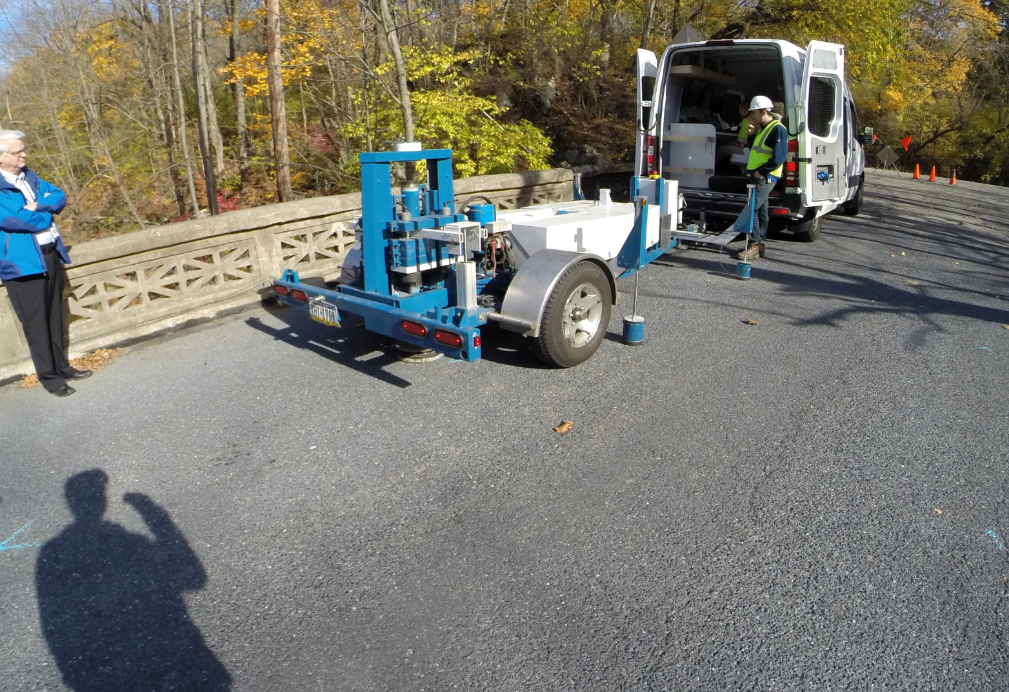

SENSOR HOUSING

Figure 9. THMPR System Test Execution

### Data Quality

Typical impact forces of up to 25,000 lbs. were observed (Figure 10A) with an approximate usable frequency range of 0-60 Hz (Figure 10B). The impact forces produced by THMPR also resulted in bridge acceleration magnitudes of up to 4 g’s (Figure 11A). Frequency content of the structural response (Figure 11B) shows clearly defined, smooth peaks of resonance which indicates linearity, adequate frequency resolution, and good excitation of all fundamental modes of interest. The relatively large structural response and the acquisition of ten second time windows provided a frequency resolution of 0.09 Hz which resulted in good characterization of closely spaced modes.

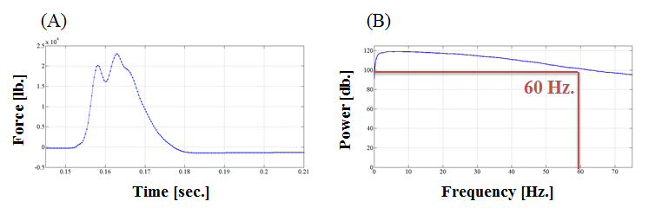

Figure 10. (A) Typical Force Time History & (B) Typical Force Frequency Content

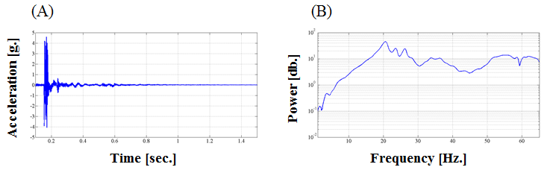

Figure 11. (A) Typical Response Time History & (B) Typical Response Frequency Content

### Modal Parameter Identification

The modal parameters for the structure were identified from the vibration measurements onsite after completion of the testing to provide immediate feedback on the data quality, structural response of the bridge, and operating condition of the test equipment to the on-site engineers. The modal parameters include the natural frequencies and the modal vectors (mode shapes) for each mode. These parameters are directly related to the in-situ mass and stiffness characteristics of the bridge, and are used for calibrating the FE model of the structure.

The modal parameter identification process starts with the computation of frequency response functions for each input-output measurement pair. A frequency response function is essentially the frequency domain transform of measured acceleration response at each sensor location divided by the measured impact force for each test location. The Complex Mode Indicator Function (CMIF) was then calculated for each test location (Figure ) using the frequency response functions created in the previous step. The CMIF is computed by singular value decomposition of the matrix of frequency response functions for each test location. The largest singular values are plotted against frequency to create the CMIF plot. Each peak in the CMIF plot represents a location of a vibration mode for the structure and the amplitude of the singular value is directly related to the dominance of the corresponding modal vector at that test location. The singular values for each independent impact location are super imposed to compare areas of resonance and ultimately select global modal parameters. A total of five global vibration modes for span 1, span 2, and span 3 (global poles) were identified from the CMIF plots as shown in Figure 12, Figure 13, and Figure 14.



Figure 12. Span 1 – Complex Mode Indicator Function (CMIF)



Figure 13. Span 2 – Complex Mode Indicator Function (CMIF)

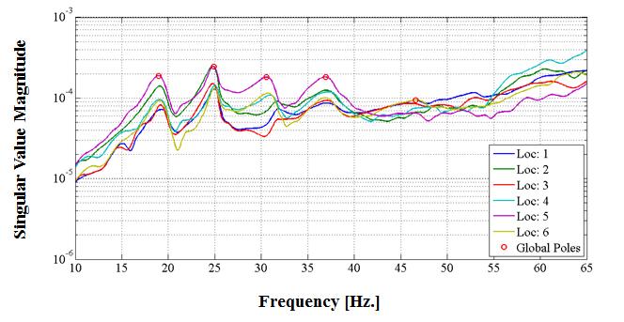

Figure 14. Span 3 – Complex Mode Indicator Function (CMIF)

For each of the spans, local mode shapes for each impact location were extracted at each global pole and combined into a global parameter set. Master mode shapes were selected for each mode based on the relative amplitude of the CMIF singular value for each impact location. The impact location associated with the largest CMIF amplitude for a specific vibration mode contains the highest signal to noise ratio and the corresponding mode shape was designated the master shape for that vibration mode. For each global pole, the modal amplitudes of the stationary references were compared between the local master mode shape and the remaining local mode shapes. A scaling coefficient was developed via a least squares approximation and used to linearly integrate the independent local mode shapes into the local master mode shape and form a global parameter set. Local mode shapes extracted from impact locations which coincided with a point of zero displacement (nodal point) for a particular mode were discarded and not included within the global modal parameter set. Additionally, a combination of the stationary references for each master local mode shape was chosen on an individual mode basis to avoid using reference sensors in locations of low modal amplitude for a particular mode. The first five fundamental global mode shapes and corresponding frequencies for each of the three spans occur within the frequency band of 0-60 Hz. Span 1 global mode shapes and frequencies are shown in Figure 15 and Table 4, respectively. Span 2 global mode shapes and frequencies are shown in Figure 16 and Table 5, respectively. Span 3 global mode shapes and frequencies are shown in Figure 17 and

Table 6, respectively. It should be noted that the interstitial areas between the discrete experimental degrees-of-freedom for the mode shapes were interpolated using a fourth order equation to aid in the visualization of these shapes.

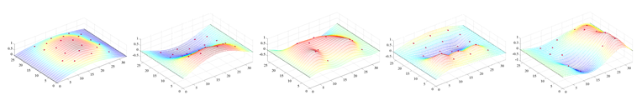

Figure 15. Span 1 – THMPR Results - Global Mode Shapes

Table 4. Span 1 – THMPR Results – Identified Natural Frequencies

|  |  |  |  |
| --- | --- | --- | --- |
| **Mode** | **Frequency [Hz]** | **Master**  **Location** | **Included Locations** |
| 1 | 20.41 | 5 | 1 2 3 4 5 6 |
| 2 | 25.88 | 2 | 1 2 3 4 5 6 |
| 3 | 31.54 | 1 | 1 3 4 5 |
| 4 | 33.11 | 2 | 1 2 3 4 5 6 |
| 5 | 53.81 | 6 | 1 3 4 6 |

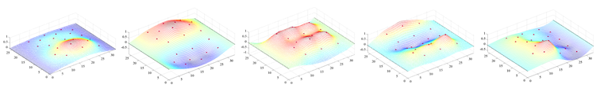

Figure 16. Span 2 – THMPR Results – Global Mode Shapes

Table 5. Span 2 – THMPR Results – Identified Natural Frequencies

|  |  |  |  |
| --- | --- | --- | --- |
| **Mode** | **Frequency [Hz]** | **Master**  **Location** | **Included Locations** |
| 1 | 23.34 | 2 | 1 2 3 4 5 6 |
| 2 | 27.83 | 5 | 1 2 3 4 5 6 |
| 3 | 31.25 | 5 | 1 2 3 4 5 6 |
| 4 | 38.96 | 5 | 1 2 3 4 5 6 |
| 5 | 56.93 | 3 | 1 2 3 4 5 6 |

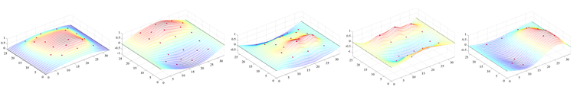

Figure 17. Span 3 – THMPR Results – Global Mode Shapes

Table 6. Span 3 – THMPR Results – Identified Natural Frequencies

|  |  |  |  |
| --- | --- | --- | --- |
| **Mode** | **Frequency [Hz]** | **Master**  **Location** | **Included Locations** |
| 1 | 18.95 | 2 | 1 2 3 4 6 |
| 2 | 24.9 | 5 | 1 2 3 4 5 6 |
| 3 | 30.57 | 5 | 1 2 3 4 5 6 |
| 4 | 36.91 | 5 | 1 2 3 4 5 6 |
| 5 | 46.58 | 1 | 1 3 6 |

## Appendix B-3 – Model Updating

Five modes from the model were paired with the experiment. The table below shows the paired analytical shapes from the *a priori* and updated models for Span 1. Spans 2 and 3 have similar modal properties. Frequency differences between experiment and *a priori* model were in the range of -30 to -60 percent, indicating that the *a priori* model had lower global stiffness than the *in situ* structure. The mode shapes developed through the THMPR system were determined to be unsuitable for updating, therefore a general improvement in natural frequencies will be used as the criteria for updated model fitness. Due to this, the updated model will be significantly altered to ensure that a conservative estimate of load rating is still produced.

The updated Span 1 model exhibited resultant frequencies that were anywhere from 40 percent lower to 20 percent higher than the experiment. The longitudinally dominated mode shapes had higher-than-experimental frequencies while the transverse dominated modes had the lower-than-experimental frequencies. This indicates that overall global stiffness in the model along the main load path is not conservative while load distribution in the model among girders is conservative. As a result, the stiffness contribution from the concrete encasement in the model was neglected during rating to maintain a conservative estimate.

The updated Span 2 and Span 3 models exhibited lower frequencies than the experiment for the majority of modes, with higher-than-experiment frequencies having a small error value. The frequencies were closer to the experiment for both Span 2 and 3 updated models than the *a priori* model. The concrete encasement was neglected during rating for Spans 2 and 3 to ensure a conservative estimate.

The objective function values from the updating algorithm for all three spans showed an improvement over the *a priori* model, indicating that the accuracy of the final updated models were higher than that of the *a priori* model.

Table 7. Typical Mode Shapes

|  |  |  |  |
| --- | --- | --- | --- |
| A-Priori Shapes | Mode Number | Typical Updated Model Shapes | Mode Number |
|  | **1** |  | **1** |
|  | **2** |  | **2** |
|  | **4** |  | **5** |
|  | **3** |  | **4** |
|  | **5** |  | **10** |

## Appendix B-4 – Bridge 063 Updated Model Ratings

### Span 1

Table 8. Updated models with concrete encasement contribution.

|  |  |  |  |  |  |  |  |  |  |
| --- | --- | --- | --- | --- | --- | --- | --- | --- | --- |
|  |  | **Updated Models With Concrete Encasement Contribution** | | | | | | | |
|  |  | ***Strength I*** | | | | ***Service II*** | | | |
|  |  | *Inv* | *Ctrl. Gir.* | *Op* | *Ctrl. Gir.* | *Inv* | *Ctrl. Gir.* | *Op* | *Ctrl. Gir.* |
| ***A Priori*** | **RF** | 3.22 | 3 | 4.18 | 3 | 2.38 | 1 | 3.10 | 1 |
| **Tons** | 116.03 | 150.41 | 85.84 | 111.59 |
| **Update 1** | **RF** | 18.81 | 3 | 24.38 | 3 | 4.99 | 1 | 6.49 | 1 |
| **Tons** | 677.12 | 877.75 | 179.74 | 233.66 |
| **% Δ** | 82.86 | 82.86 | 52.24 | 52.24 |
| **Update 2** | **RF** | 18.82 | 3 | 24.40 | 3 | 4.99 | 1 | 6.49 | 1 |
| **Tons** | 677.63 | 878.42 | 179.68 | 233.58 |
| **% Δ** | 82.88 | 82.88 | 52.23 | 52.23 |
| **Update 3** | **RF** | 18.83 | 3 | 24.41 | 3 | 4.99 | 1 | 6.49 | 1 |
| **Tons** | 678.02 | 878.91 | 179.63 | 233.52 |
| **% Δ** | 82.89 | 82.89 | 52.21 | 52.21 |
| **Update 4** | **RF** | 18.83 | 3 | 24.41 | 3 | 4.99 | 1 | 6.49 | 1 |
| **Tons** | 678.01 | 878.91 | 179.61 | 233.50 |
| **% Δ** | 82.89 | 82.89 | 52.21 | 52.21 |
| **Update 5** | **RF** | 18.82 | 3 | 24.40 | 3 | 4.99 | 1 | 6.49 | 1 |
| **Tons** | 677.62 | 878.40 | 179.70 | 233.61 |
| **% Δ** | 82.88 | 82.88 | 52.23 | 52.23 |
| **Update 6** | **RF** | 18.83 | 3 | 24.41 | 3 | 4.99 | 1 | 6.49 | 1 |
| **Tons** | 677.81 | 878.64 | 179.60 | 233.48 |
| **% Δ** | 82.88 | 82.88 | 52.21 | 52.21 |

Table 9. Updated models without concrete encasement contribution.

|  |  |  |  |  |  |  |  |  |  |
| --- | --- | --- | --- | --- | --- | --- | --- | --- | --- |
|  | | **Updated Model Without Concrete Encasement Contribution** | | | | | | | |
| ***Strength I*** | | | | ***Service II*** | | | |
| Inv | Ctrl. Gir. | Op | Ctrl. Gir. | Inv | Ctrl. Gir. | Op | Ctrl. Gir. |
| ***A Priori*** | **RF** | 3.22 | 3 | 4.18 | 3 | 2.38 | 1 | 3.10 | 1 |
| **Tons** | 116.03 | 150.41 | 85.84 | 111.59 |
| **Update 1** | **RF** | 5.18 | 3 | 6.72 | 3 | 1.99 | 1 | 2.59 | 1 |
| **Tons** | 186.50 | 241.76 | 71.78 | 93.32 |
| **% Δ** | 37.78 | 37.78 | -19.58 | -19.58 |
| **Update 2** | **RF** | 5.18 | 3 | 6.72 | 3 | 1.99 | 1 | 2.59 | 1 |
| **Tons** | 186.64 | 241.94 | 71.75 | 93.28 |
| **% Δ** | 37.83 | 37.83 | -19.63 | -19.63 |
| **Update 3** | **RF** | 5.19 | 3 | 6.73 | 3 | 1.99 | 1 | 2.59 | 1 |
| **Tons** | 186.79 | 242.14 | 71.75 | 93.28 |
| **% Δ** | 37.88 | 37.88 | -19.63 | -19.63 |
| **Update 4** | **RF** | 5.19 | 3 | 6.73 | 3 | 1.99 | 1 | 2.59 | 1 |
| **Tons** | 186.80 | 242.15 | 71.75 | 93.27 |
| **% Δ** | 37.88 | 37.88 | -19.64 | -19.64 |
| **Update 5** | **RF** | 5.18 | 3 | 6.72 | 3 | 1.99 | 1 | 2.59 | 1 |
| **Tons** | 186.65 | 241.95 | 71.77 | 93.30 |
| **% Δ** | 37.83 | 37.83 | -19.60 | -19.60 |
| **Update 6** | **RF** | 5.19 | 3 | 6.73 | 3 | 1.99 | 1 | 2.59 | 1 |
| **Tons** | 186.80 | 242.14 | 71.75 | 93.28 |
| **% Δ** | 37.88 | 37.88 | -19.63 | -19.63 |

### Span 2

Table 10. Updated models with concrete encasement contribution.

|  |  |  |  |  |  |  |  |  |  |
| --- | --- | --- | --- | --- | --- | --- | --- | --- | --- |
|  |  | **Updated Models With Concrete Encasement Contribution** | | | | | | | |
|  |  | ***Strength I*** | | | | ***Service II*** | | | |
|  |  | *Inv* | *Ctrl. Gir.* | *Op* | *Ctrl. Gir.* | *Inv* | *Ctrl. Gir.* | *Op* | *Ctrl. Gir.* |
| ***A Priori*** | **RF** | 3.22 | 3 | 4.18 | 3 | 2.38 | 1 | 3.10 | 1 |
| **Tons** | 116.03 | 150.41 | 85.84 | 111.59 |
| **Update 1** | **RF** | 24.60 | 3 | 31.89 | 3 | 4.26 | 1 | 5.54 | 1 |
| **Tons** | 885.53 | 1147.91 | 153.30 | 199.30 |
| **% Δ** | 86.90 | 86.90 | 44.01 | 44.01 |
| **Update 2** | **RF** | 24.58 | 3 | 31.86 | 3 | 4.26 | 1 | 5.53 | 1 |
| **Tons** | 884.86 | 1147.04 | 153.24 | 199.21 |
| **% Δ** | 86.89 | 86.89 | 43.98 | 43.98 |
| **Update 3** | **RF** | 24.60 | 3 | 31.89 | 3 | 4.26 | 1 | 5.54 | 1 |
| **Tons** | 885.49 | 1147.86 | 153.31 | 199.30 |
| **% Δ** | 86.90 | 86.90 | 44.01 | 44.01 |
| **Update 4** | **RF** | 24.59 | 3 | 31.87 | 3 | 4.26 | 1 | 5.53 | 1 |
| **Tons** | 885.21 | 1147.50 | 153.27 | 199.26 |
| **% Δ** | 86.89 | 86.89 | 44.00 | 44.00 |
| **Update 5** | **RF** | 24.60 | 3 | 31.89 | 3 | 5.06 | 1 | 6.57 | 1 |
| **Tons** | 885.54 | 1147.92 | 182.06 | 236.67 |
| **% Δ** | 86.90 | 86.90 | 52.85 | 52.85 |
| **Update 6** | **RF** | 24.60 | 3 | 31.89 | 3 | 5.06 | 1 | 6.57 | 1 |
| **Tons** | 885.57 | 1147.95 | 182.06 | 236.68 |
| **% Δ** | 86.90 | 86.90 | 52.85 | 52.85 |

Table 11. Updated models without concrete encasement contribution.

|  |  |  |  |  |  |  |  |  |  |
| --- | --- | --- | --- | --- | --- | --- | --- | --- | --- |
|  | | **Updated Model Without Concrete Encasement Contribution** | | | | | | | |
| ***Strength I*** | | | | ***Service II*** | | | |
| Inv | Ctrl. Gir. | Op | Ctrl. Gir. | Inv | Ctrl. Gir. | Op | Ctrl. Gir. |
| ***A Priori*** | **RF** | 3.22 | 3 | 4.18 | 3 | 2.38 | 1 | 3.10 | 1 |
| **Tons** | 116.03 | 150.41 | 85.84 | 111.59 |
| **Update 1** | **RF** | 6.76 | 3 | 8.77 | 3 | 2.01 | 1 | 2.61 | 1 |
| **Tons** | 243.48 | 315.62 | 72.39 | 94.10 |
| **% Δ** | 52.34 | 52.34 | -18.58 | -18.58 |
| **Update 2** | **RF** | 6.76 | 3 | 8.77 | 3 | 2.01 | 1 | 2.61 | 1 |
| **Tons** | 243.48 | 315.62 | 72.39 | 94.10 |
| **% Δ** | 52.34 | 52.34 | -18.58 | -18.58 |
| **Update 3** | **RF** | 6.76 | 3 | 8.77 | 3 | 2.01 | 1 | 2.61 | 1 |
| **Tons** | 243.46 | 315.59 | 72.39 | 94.10 |
| **% Δ** | 52.34 | 52.34 | -18.58 | -18.58 |
| **Update 4** | **RF** | 6.76 | 3 | 8.77 | 3 | 2.01 | 1 | 2.61 | 1 |
| **Tons** | 243.48 | 315.62 | 72.39 | 94.10 |
| **% Δ** | 52.34 | 52.34 | -18.59 | -18.59 |
| **Update 5** | **RF** | 6.76 | 3 | 8.77 | 3 | 2.01 | 1 | 2.61 | 1 |
| **Tons** | 243.48 | 315.62 | 72.39 | 94.10 |
| **% Δ** | 52.34 | 52.34 | -18.58 | -18.58 |
| **Update 6** | **RF** | 6.76 | 3 | 8.77 | 3 | 2.01 | 1 | 2.61 | 1 |
| **Tons** | 243.48 | 315.62 | 72.39 | 94.10 |
| **% Δ** | 52.34 | 52.34 | -18.58 | -18.58 |

### Span 3

Table 12. Updated models with concrete encasement contribution.

|  |  |  |  |  |  |  |  |  |  |
| --- | --- | --- | --- | --- | --- | --- | --- | --- | --- |
|  |  | ***Strength I*** | | | | ***Service II*** | | | |
|  |  | *Inv* | *Ctrl. Gir.* | *Op* | *Ctrl. Gir.* | *Inv* | *Ctrl. Gir.* | *Op* | *Ctrl. Gir.* |
| ***A Priori*** | **RF** | 3.22 | 3 | 4.18 | 3 | 2.38 | 1 | 3.10 | 1 |
| **Tons** | 116.03 | 150.41 | 85.84 | 111.59 |
| **Update 1** | **RF** | 19.74 | 3 | 25.59 | 3 | 3.97 | 1 | 5.16 | 1 |
| **Tons** | 710.57 | 921.11 | 142.79 | 185.63 |
| **% Δ** | 83.67 | 83.67 | 39.89 | 39.89 |
| **Update 2** | **RF** | 19.73 | 3 | 25.58 | 3 | 3.96 | 1 | 5.15 | 1 |
| **Tons** | 710.42 | 920.92 | 142.70 | 185.51 |
| **% Δ** | 83.67 | 83.67 | 39.84 | 39.84 |
| **Update 3** | **RF** | 19.74 | 3 | 25.59 | 3 | 3.96 | 1 | 5.15 | 1 |
| **Tons** | 710.58 | 921.13 | 142.74 | 185.56 |
| **% Δ** | 83.67 | 83.67 | 39.86 | 39.86 |
| **Update 4** | **RF** | 19.73 | 3 | 25.57 | 3 | 3.96 | 1 | 5.15 | 1 |
| **Tons** | 710.25 | 920.70 | 142.68 | 185.49 |
| **% Δ** | 83.66 | 83.66 | 39.84 | 39.84 |
| **Update 5** | **RF** | 19.74 | 3 | 25.59 | 3 | 3.96 | 1 | 5.15 | 1 |
| **Tons** | 710.57 | 921.11 | 142.73 | 185.55 |
| **% Δ** | 83.67 | 83.67 | 39.86 | 39.86 |
| **Update 6** | **RF** | 19.73 | 3 | 25.58 | 3 | 3.96 | 1 | 5.15 | 1 |
| **Tons** | 710.34 | 920.81 | 142.68 | 185.48 |
| **% Δ** | 83.67 | 83.67 | 39.84 | 39.84 |

Table 13. Updated models without concrete encasement contribution.

|  |  |  |  |  |  |  |  |  |  |
| --- | --- | --- | --- | --- | --- | --- | --- | --- | --- |
|  | | **Updated Model Without Concrete Encasement Contribution** | | | | | | | |
| ***Strength I*** | | | | ***Service II*** | | | |
| Inv | Ctrl. Gir. | Op | Ctrl. Gir. | Inv | Ctrl. Gir. | Op | Ctrl. Gir. |
| ***A Priori*** | **RF** | 3.22 | 3 | 4.18 | 3 | 2.38 | 1 | 3.10 | 1 |
| **Tons** | 116.03 | 150.41 | 85.84 | 111.59 |
| **Update 1** | **RF** | 5.70 | 3 | 7.39 | 3 | 1.66 | 1 | 2.16 | 1 |
| **Tons** | 205.31 | 266.14 | 59.87 | 77.83 |
| **% Δ** | 43.48 | 43.48 | -43.38 | -43.38 |
| **Update 2** | **RF** | 5.70 | 3 | 7.39 | 3 | 1.66 | 1 | 2.16 | 1 |
| **Tons** | 205.12 | 265.90 | 59.80 | 77.74 |
| **% Δ** | 43.43 | 43.43 | -43.54 | -43.54 |
| **Update 3** | **RF** | 5.70 | 3 | 7.39 | 3 | 1.66 | 1 | 2.16 | 1 |
| **Tons** | 205.17 | 265.96 | 59.82 | 77.77 |
| **% Δ** | 43.45 | 43.45 | -43.49 | -43.49 |
| **Update 4** | **RF** | 5.70 | 3 | 7.39 | 3 | 1.66 | 1 | 2.16 | 1 |
| **Tons** | 205.12 | 265.89 | 59.80 | 77.75 |
| **% Δ** | 43.43 | 43.43 | -43.53 | -43.53 |
| **Update 5** | **RF** | 5.70 | 3 | 7.39 | 3 | 1.66 | 1 | 2.16 | 1 |
| **Tons** | 205.17 | 265.96 | 59.82 | 77.77 |
| **% Δ** | 43.44 | 43.44 | -43.50 | -43.50 |
| **Update 6** | **RF** | 5.70 | 3 | 7.39 | 3 | 1.66 | 1 | 2.16 | 1 |
| **Tons** | 205.10 | 265.87 | 59.80 | 77.74 |
| **% Δ** | 43.43 | 43.43 | -43.55 | -43.55 |

**PAGE INTENTIONALLY LEFT BLANK**

# Appendix C – Bridge 076 Performance Evaluation and Load Rating Analysis

**Northampton County Bridge 076**

|  |  |
| --- | --- |
| **BMS No:** | **48720306309076** |
| **Feature Carried:** | E. Aluta Mill Road |
| **Feature Intersected:** | Bushkill Creek |
| **Structure Type:** | Concrete Encased Girder |
|  |  |
| **Test Date:** | 11/04/2014 |
| **Test Type:** | Dynamic Test (Forced Vibration) |
| **Analysis and Rating Method:** | AASHTO LRFR |

No plans or drawings were provided for this bridge. Geometry of the bridge and its components were measured in the field on the day of the test. The structure was evaluated using forced vibration testing methods and its dynamic properties (natural frequencies and mode shapes) were extracted for comparison to a finite element model.

Strand7 FE Modelling Software was used in conjunction with computational software to perform a live load rating analysis for all three spans of the bridge. An initial finite element (FE) model was created in Strand7 for the bridge. Conservative material properties, section properties, continuity conditions and boundary conditions were assumed for an initial model. The dynamic properties of the initial model were compared to the experimental data in order to verify conservative global stiffness. **It was determined that the structure may safely carry current legal truck loads without excessive concrete cracking or other serviceability concerns. If full AASHTO Strength and Service ratings are required, we recommend further investigation to determine what steel sections are within the concrete.**

## Experimental Evaluation Summary

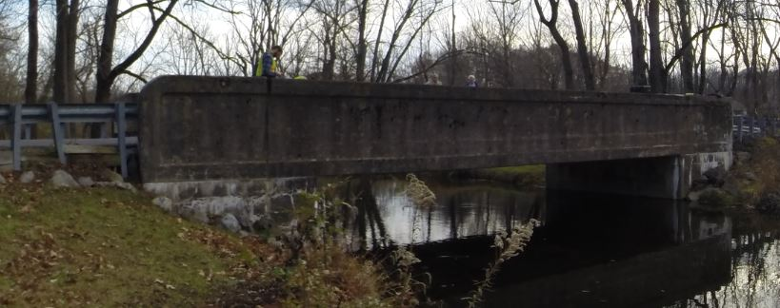Northampton County Bridge 076 was evaluated on November 4, 2014 using forced vibration testing methods and the dynamic properties (natural frequencies and mode shapes) were extracted for finite element model calibration.

Figure 1. Northampton County Bridge 076

A self-contained modal impact trailer equipped with a falling mass impact system and local sensor array was used to execute the vibration tests. The superstructure was excited via a 25 kip impulse force at multiple, spatially distributed locations which resulted in up to 4 g’s of bridge deck acceleration. Acceleration responses were measured via a local sensor array of six accelerometers and multiple spatially distributed stationary global references secured to the bridge deck via glue adhesive prior to testing. Local modal parameter estimation was performed utilizing the Complex Mode Indicator Function (CMIF) and integrated into a final global modal parameter set. Three natural frequencies and mode shapes were identified in the frequency band of 0-55 Hz (Figure 2 & Table 1).

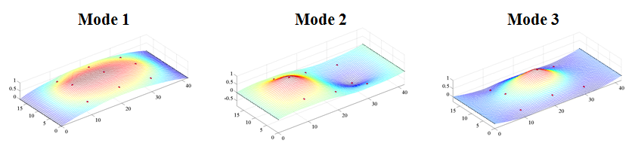

Figure 2. THMPR Results – Overview of Global Mode Shapes

Table 1. THMPR Results – Identified Natural Frequencies

|  |  |
| --- | --- |
| **Mode** | **Span 1**  **Frequency [Hz]** |
| 1 | 13.38 |
| 2 | 17.48 |
| 3 | 20.18 |

## Load Rating Analysis Summary

The structure was modeled using finite element analysis and computational software. An initial finite element (FE) model was created in Strand7 for Northampton County Bridge 076 using the RAMPS software package developed at Drexel University as part of a National Institute of Standards and Technology Innovation Program (NIST-TIP) and the National Cooperative Highway Research Program Project 12-103 (NCHRP 12-103). Conservative material properties, section properties, continuity conditions and boundary conditions were assumed for an initial model. The 3D geometric model (Figure 3) utilizes beam elements for the concrete encased girders and transverse floor beams. Shell elements are used to model the deck and concrete curb. Rigid links as well as beam elements with variable stiffness are used to enforce compatibility of the displacements between the various structural elements.

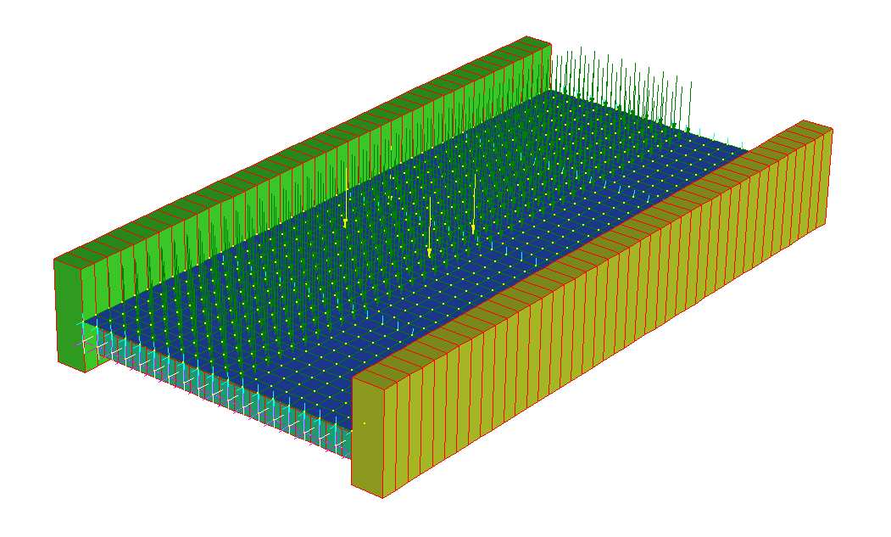

Y

X

Z

Figure 3. *A Priori* FE Model of single span of Bridge 076.

The model used for rating exhibited lower natural frequencies than the experimental results, indicating that the global stiffness of the actual structure is higher than that of the model and that the model is a conservative estimate of global behavior in response to static loads.

Due to the lack of design details for the girder or any reinforcement, concrete stress under wearing surface dead load and AASHTO HL-93 live load were simulated. This analysis assumes that the unknown steel within the structure safely carries the dead load due to steel and concrete while the concrete carries the entirety of wearing surface dead load and live load. Concrete stress in the model was compared to a conservative cracking limit of 300 psi and was found to be under this limit.

## Appendix C-1 – Bridge Description

Northampton County Bridge 076 is a concrete encased girder bridge with unknown reinforcement. It carries East Aluta Mill Road over Bushkill Creek. The bridge is approximate 41 feet long with a roadway with of 16.5 feet. The concrete encased through-girders are 73 inches high and 24 inches wide at mid-span. The bridge has a concrete deck of approximately 9 inches thick with a 1-5 inch thick asphalt overlay. Three transverse floor beams that are approximately 18 inches high and 13 inches wide run under the deck.

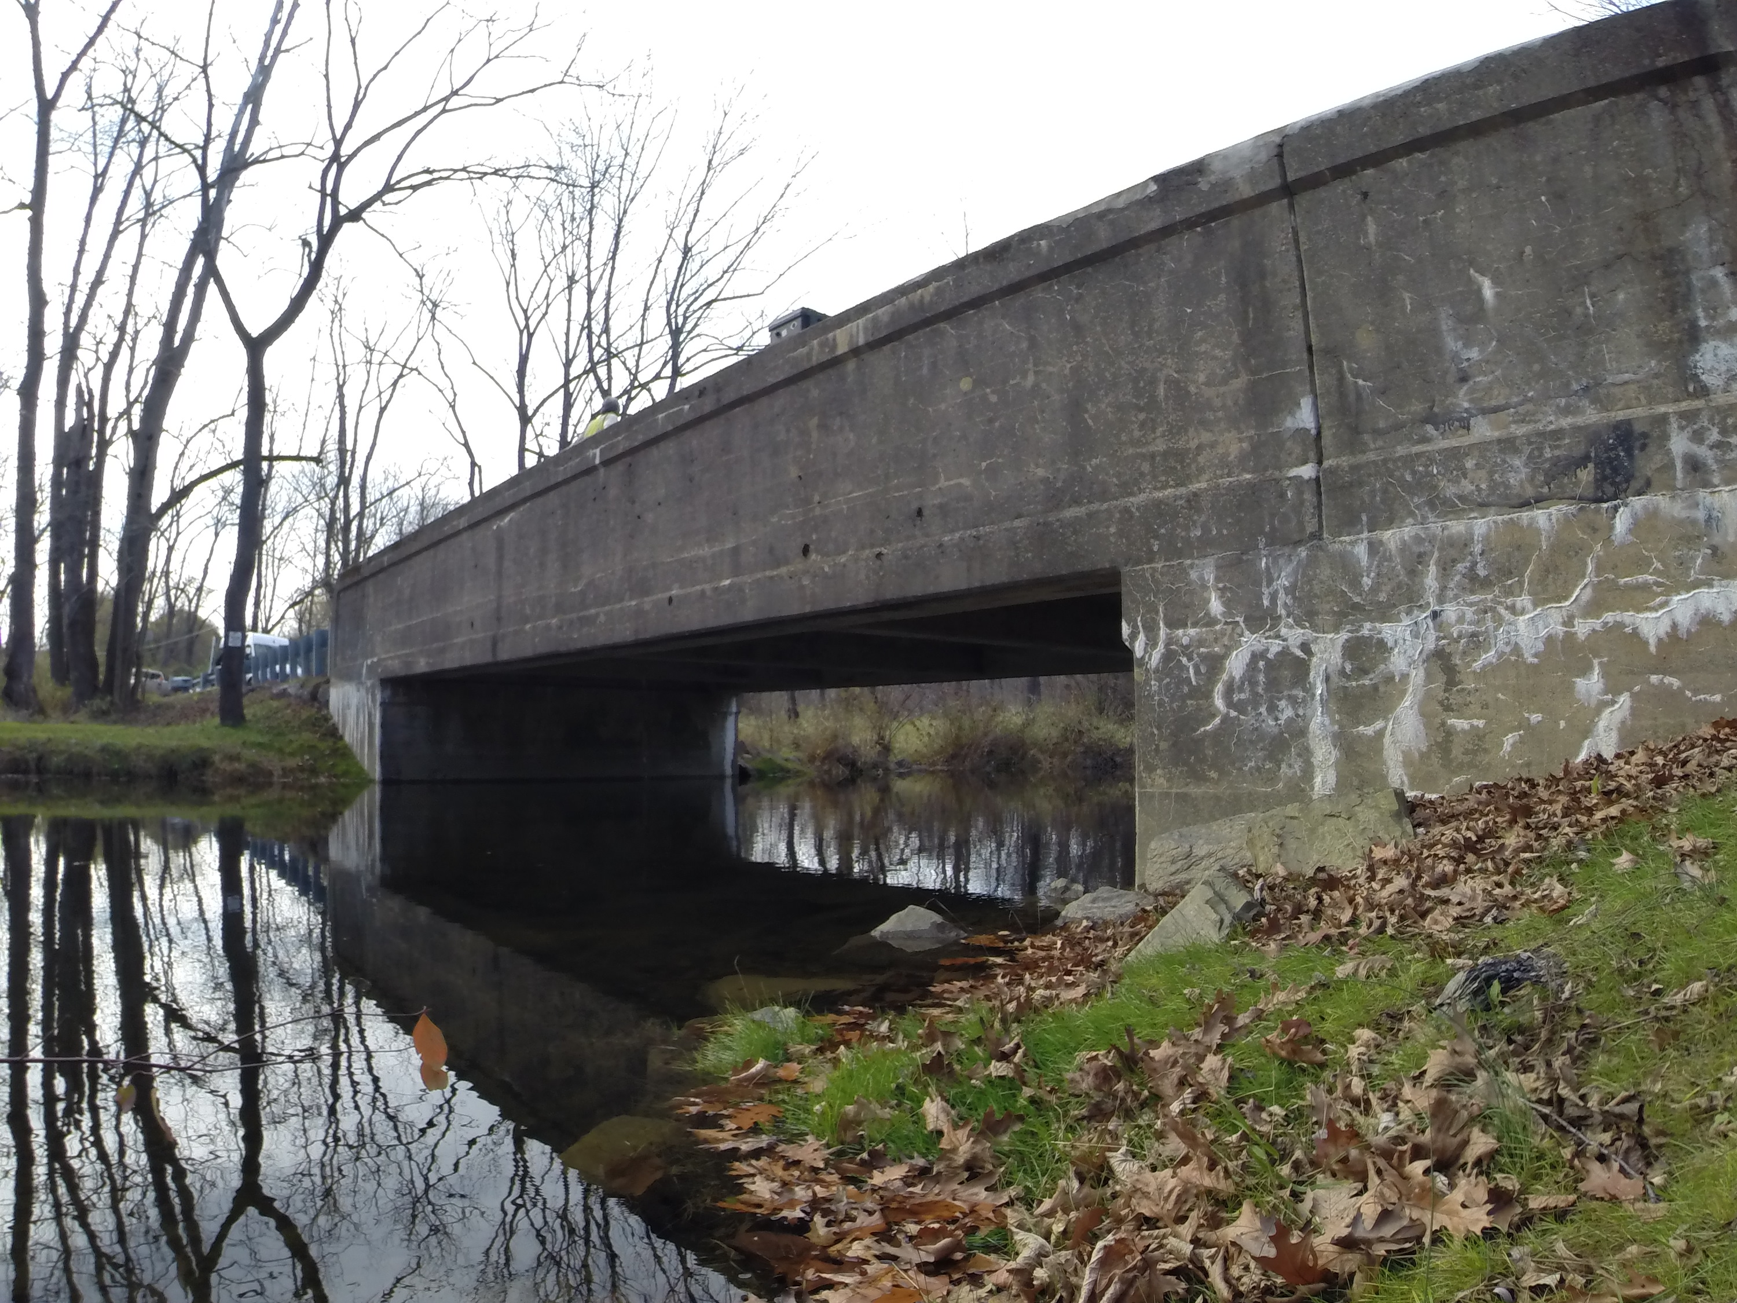

Figure 4. Northampton County Bridge 076

## Appendix C-2 – Experimental Evaluation

Northampton County Bridge 076 was evaluated using vibration testing methods. The bridge was dynamically excited at several locations on the deck surface using a broad band impact force, and its corresponding vibration responses were measured using accelerometers that were also located on the deck. The combined input-output vibration measurements were subsequently analyzed to extract the dynamic properties of the structure which were then used to calibrate a finite element model of the bridge. Details of the experimental setup, the test execution and the data analysis methods employed for the bridge are provided in the following sections.

### Description of Test Equipment - THMPR System

The Targeted Hits to Measure Performance Responses (THMPR) system is a self-contained rapid modal testing trailer and streamlined data processing software which extracts modal parameters, such as frequencies and mode shapes, of a structure. The extracted modal parameters may then be used to determine anomalous behavior as well as provide experimental data for finite element model calibration. The system, shown in Figure 5, is comprised of a physical test device which utilizes a significantly reconfigured Falling Weight Deflectometer trailer with modifications to (1) provide a single, large (~30 kip) broadband impact source, and (2) collect the resulting free-decay response of the bridge’s surface in a spatially distributed manner (and in-turn be able to capture local mode shapes). The local sensor array is shown in Figure 6. The trailer is towed along the bridge deck and single-input-multiple-output (SIMO) impact testing is performed at targeted locations. The data is wirelessly acquired at each location and passed to semi-automated modal processing software which performs (1) data quality checks, (2) frequency response function development and (3) modal parameter estimation. The local mode shapes are then linearly combined into a final global modal parameter set utilizing selected stationary references previously secured along an available sidewalk and cabled to an independent, GPS synchronized data acquisition.



Figure 5. THMPR System - Primary Components



Figure 6. THMPR Local Sensor Array

### Instrumentation

The typical instrumentation plan for a single span is shown in Figure 7. A total of six stationary reference accelerometers were temporarily attached to the bridge deck using glue adhesive at the quarter span, mid span, and three-quarter span locations along each sidewalk. The reference accelerometers remained at the same locations on the deck throughout the vibration testing and were used to link together the vibrations measured by THMPR’s local sensor array of six accelerometers (Figure 6). The reference accelerometers were cabled to GPS synchronized data acquisition systems along each shoulder and out of the way of traffic.

A total of three impact locations were selected at the quarter span, mid span, and three-quarter span lengths along center lane of the superstructureFigure . The impact locations were chosen so that the measured vibration responses would have a dense spatial resolution and to vary the spatial characteristics of the input excitation. The former consideration is important for resolving different mode shapes from the vibration measurements, while the latter is important for exciting different vibration modes. Note, due to the short length of the span and limited lane access, only a single input/output measurement was required at each location for the analysis.

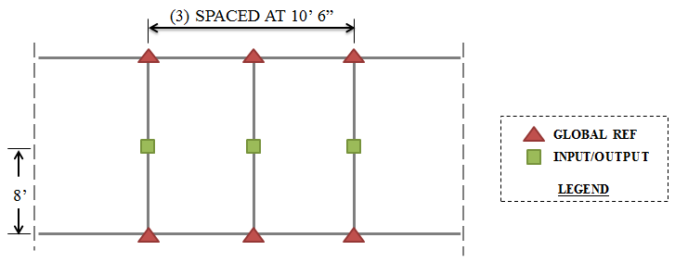

Figure 7 Typical Instrumentation Plan

### Test Execution

THMPR system testing was conducted on November 4, 2014. THMPR’s impact head was centered above a selected impact location on the deck and the GPS synchronized accelerometer array attached to THMPR was remotely deployed. This lowered the six accelerometer housings onto the bridge deck and compressed them against the surface. The impact force and bridge vibration measurements were recorded at a rate of 3,200 samples per second (Hz) in order to precisely define the shape of the impulse signal and for a duration of 10 seconds to ensure the complete capture of the structure’s post-impact free vibration decay response. A total of three separate impacts were recorded for averaging and noise reduction purposes at each of the nine locations.

### Data Quality

Typical impact forces of up to 25,000 lbs. were observed (Figure 8A) with an approximate usable frequency range of 0-55 Hz (Figure 8B). The impact forces produced by THMPR also resulted in bridge acceleration magnitudes of up to 4 g’s (Figure 9A). Frequency content of the structural response (Figure 9B) shows clearly defined, smooth peaks of resonance which indicates linearity, adequate frequency resolution, and good excitation of all fundamental modes of interest. The relatively large structural response and the acquisition of ten second time windows provided a frequency resolution of 0.09 Hz which resulted in good characterization of closely spaced modes.

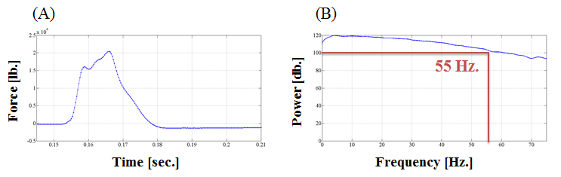

Figure 8. (A) Typical Force Time History & (B) Typical Force Frequency Content

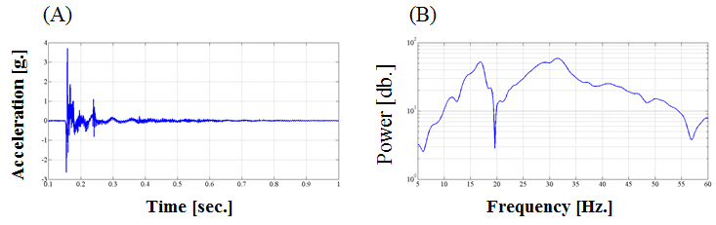

Figure 9. (A) Typical Response Time History & (B) Typical Response Frequency Content

### Modal Parameter Identification

The modal parameters for the structure were identified from the vibration measurements onsite after completion of the testing to provide immediate feedback on the data quality, structural response of the bridge, and operating condition of the test equipment to the on-site engineers. The modal parameters include the natural frequencies and the modal vectors (mode shapes) for each mode. These parameters are directly related to the in-situ mass and stiffness characteristics of the bridge, and are used for calibrating the FE model of the structure.

The modal parameter identification process starts with the computation of frequency response functions for each input-output measurement pair. A frequency response function is essentially the frequency domain transform of measured acceleration response at each sensor location divided by the measured impact force for each test location. The Complex Mode Indicator Function (CMIF) was then calculated for each test location (Figure 10) using the frequency response functions created in the previous step. The CMIF is computed by singular value decomposition of the matrix of frequency response functions for each test location. The largest singular values are plotted against frequency to create the CMIF plot. Each peak in the CMIF plot represents a location of a vibration mode for the structure and the amplitude of the singular value is directly related to the dominance of the corresponding modal vector at that test location. The singular values for each independent impact location are super imposed to compare areas of resonance and ultimately select global modal parameters. A total of three global vibration modes (global poles) identified from the CMIF plots as shown in Figure 10.

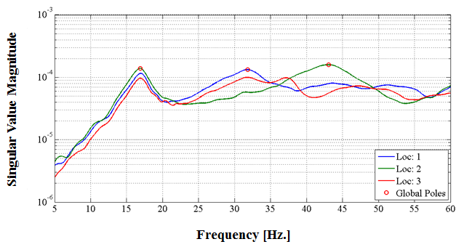

Figure 10. Complex Mode Indicator Function (CMIF)

Local mode shapes for each impact location were extracted at each global pole and combined into a global parameter set. Master mode shapes were selected for each mode based on the relative amplitude of the CMIF singular value for each impact location. The impact location associated with the largest CMIF amplitude for a specific vibration mode contains the highest signal to noise ratio and the corresponding mode shape was designated the master shape for that vibration mode. For each global pole, the modal amplitudes of the stationary references were compared between the local master mode shape and the remaining local mode shapes. A scaling coefficient was developed via a least squares approximation and used to linearly integrate the independent local mode shapes into the local master mode shape and form a global parameter set. Local mode shapes extracted from impact locations which coincided with a point of zero displacement (nodal point) for a particular mode were discarded and not included within the global modal parameter set. Additionally, a combination of the stationary references for each master local mode shape was chosen on an individual mode basis to avoid using reference sensors in locations of low modal amplitude for a particular mode. Global mode shapes and frequencies are shown in Figure 11 and Table 2, respectively. It should be noted that the interstitial areas between the discrete experimental degrees-of-freedom for the mode shapes were interpolated using a fourth order equation to aid in the visualization of these shapes.

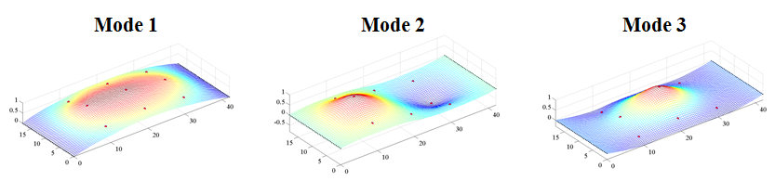

Figure 11. Span 1 – THMPR Results - Global Mode Shapes

Table 2. Span 1 – THMPR Results – Identified Natural Frequencies

|  |  |  |  |
| --- | --- | --- | --- |
| **Mode** | **Frequency [Hz]** | **Master**  **Location** | **Included Locations** |
| 1 | 16.89 | 2 | 1 2 3 |
| 2 | 31.84 | 1 | 1 3 |
| 3 | 43.07 | 2 | 1 2 |

# Appendix D – Bridge 138 Performance Evaluation and Load Rating Analysis

**Northampton County Bridge 138**

|  |  |
| --- | --- |
| **BMS No:** | 48 721 0564 9138 |
| **Feature Carried:** | Club Road |
| **Feature Intersected:** | Hokendauqua Creek |
| **Structure Type:** | Simply Supported Concrete Encased Steel I-Beam |
|  |  |
| **Test Date:** | 09/08/2014 |
| **Test Type:** | Dynamic Test |
| **Analysis and Rating Method:** | AASHTO LRFR |

**Experimental Evaluation Summary:**

Northampton County Bridge 138 was evaluated using forced vibration testing methods and the dynamic properties (natural frequencies and mode shapes) were extracted for finite element model calibration. A self-contained modal impact trailer equipped with a falling mass impact system and local sensor array was roved along the deck. The superstructure was excited via a 25 kip impulse force at four locations. Acceleration responses were measured via a local sensor array of six accelerometers and six stationary global references secured to the bridge deck via glue adhesive prior to testing. Local modal parameter estimation was performed and integrated into a final global modal parameter set. The structure's first eight natural frequencies and mode shapes were identified in the frequency band of 0-60 Hz.

**Load Rating Analysis Summary:**

Northampton County Bridge 138 was modeled using finite element analysis and the computational software. Conservative material properties, section properties, continuity conditions and boundary conditions were assumed for an initial model. The initial model was rated for AASHTO Load and Resistance Factor Strength I and Service II limit states for an HL-93 truck. The initial model was then calibrated to the natural frequencies and mode shapes developed through experimentation. A set of calibrated models were used to perform live load ratings. The initial model had a controlling inventory Strength I rating of 2.35 and Service II model rating of 1.33, or 85 and 48 tons, respectively. **The final updated model had a controlling inventory Strength I rating of 6.37 and Service II model rating of 4.64, or 230 and 167 tons, respectively.**

|  |  |  |  |  |  |  |  |  |  |  |
| --- | --- | --- | --- | --- | --- | --- | --- | --- | --- | --- |
|  | **Strength I** | **Inventory** | **Tons** | **Operating** | **Tons** | **Service II** | **Inventory** | **Tons** | **Operating** | **Tons** |
| ***Pre-Test Rating*** |  |  |  |  |  |  |  |  |
| Single Line* | 0.6 | 22 | 1.0 | 38 | - | - | - | - |
| *A Priori* Model | 2.4 | 85 | 2.0 | 72 | 1.33 | 48 | 0.8 | 29 |
| ***Post-Test Conservative Model Rating*** |  |  |  |  |  |  |  |  |
| **Span 1** | **6.4** | **230** | **8.3** | **332** | **4.6** | **167** | **6.0** | **240** |

Table 1. Single Line, *A Priori*, and Final Calibrated Models for all three spans of Bridge 138.  
*Single line rating for ML80 loading, from 2012 report provided by STV Inc.

## Appendix D-1 Bridge Description

Northampton County Bridge 138 is a simple span concrete-encased I-girder bridge and currently has a load posting of 20 tons (Figure 1 & Figure 2). The structure was built in 1946 and carries Club Road over Hokendauqua Creek in Northampton County, Pennsylvania. The bridge has an ADT of 150, a Deck Condition Rating of 6, a Superstructure Condition Rating of 5, and a Substructure Condition Rating of 5. The Sufficiency Rating is 36.4. The structure is not considered Structurally Deficient; however, it is Functionally Obsolete.

Bridge #138 is 49 feet long, has a roadway width of 20 feet, an out-to-out width of 21.33 feet, and a clear distance between barriers of 17.92 feet. It carries Type-2 strong post guiderails over 16 inch wide, 7 inch high curbs. The structure consists of seven concrete-encased I-sections spaced at 3.33 feet, a 10 inch deck slab, and integral abutment bearings. The bridge has no skew or deck overlay.

No original plans exist for the bridge; however STV Inc. produced a Load Rating Summary performed in 2013 that details the structure cross-section. In their load rating, STV noted that Northampton County produced approximate beam dimensions after taking cores of the structure.

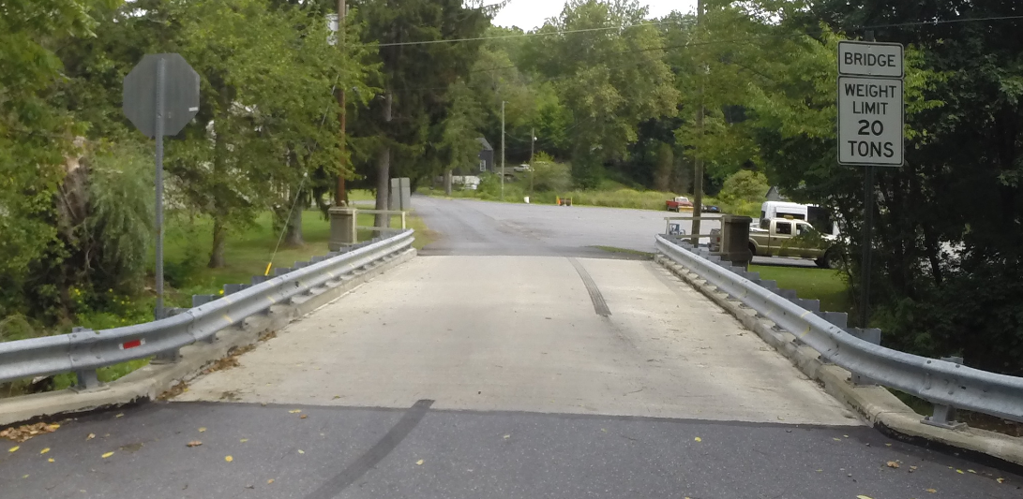

Figure 1. Northampton County Bridge 138

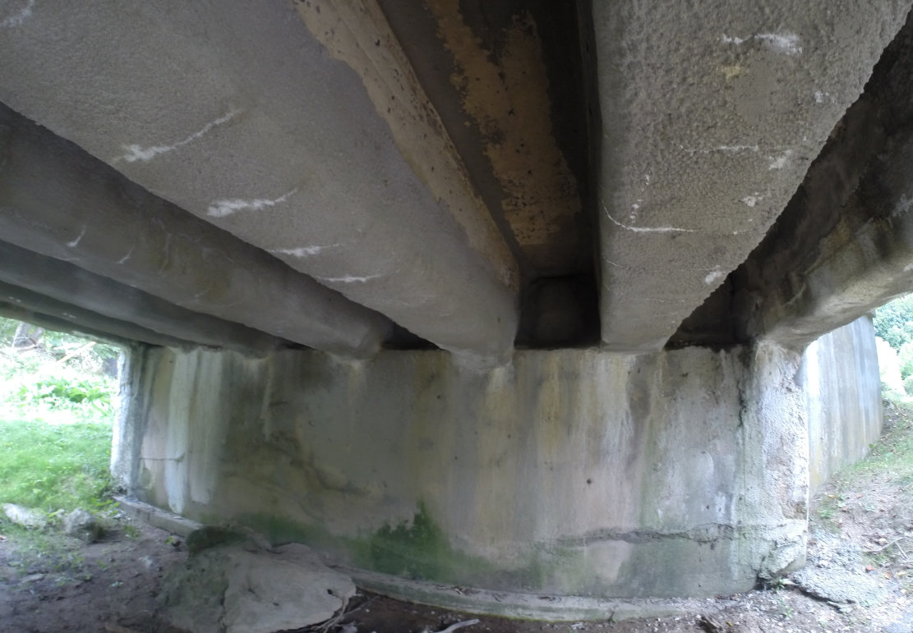

Figure 2. Underside view of the structure

## Appendix D-2 Experimental Evaluation

Northampton County Bridge 138 was evaluated using vibration testing methods. The bridge was dynamically excited at several locations on the deck surface using a broad band impact force, and its corresponding vibration responses were measured using accelerometers that were also located on the deck. The combined input-output vibration measurements were subsequently analyzed to extract the dynamic properties of the structure which were then used to calibrate a finite element model of the bridge. Details of the experimental setup, the test execution and the data analysis methods employed for the bridge are provided in the following sections.

**THMPR System Overview**

The Targeted Hits to Measure Performance Responses (THMPR) system (Figure 3) is a self-contained rapid modal testing trailer and streamlined data processing software which extracts modal parameters, such as frequencies and mode shapes, of a structure. The extracted modal parameters may then be used to determine anomalous behavior as well as provide experimental data for finite element model calibration. The system, shown in Figure 3, is comprised of a physical test device which utilizes a significantly reconfigured Falling Weight Deflectometer trailer with modifications to (1) provide a single, large (~30 kip) broadband impact source, and (2) collect the resulting free-decay response of the bridge’s surface in a spatially distributed manner (and in-turn be able to capture local mode shapes). The trailer is towed along the bridge deck and local single-input-multiple-output (SIMO) impact testing is performed at targeted locations. The data is wirelessly acquired at each location and passed to semi-automated modal processing software which performs (1) data quality checks, (2) frequency response function development and (3) modal parameter estimation. The local mode shapes are then linearly combined into a final global modal parameter set utilizing selected stationary references previously secured along an available sidewalk and cabled to an independent, GPS synchronized data acquisition.



Figure 3. THMPR System - Primary Components

### Instrumentation

The instrumentation plan is shown in Figure 4. A total of six stationary reference accelerometers (three in each shoulder) were temporarily attached to the bridge deck using glue adhesive at the quarter span, mid span, and three-quarter span locations. The reference accelerometers remained at the same locations on the deck throughout the vibration testing and were used to link together the vibrations measured by THMPR’s local sensor array of six accelerometers (Figure 5). The reference accelerometers were cabled to a local GPS synchronized data acquisition system along the shoulder and out of the way of traffic.

A total of four impact locations were selected for the test: (1) at quarter span in the right lane, (2) at mid span in the right lane, (3) at three-quarter span in the left lane and (4) at mid span in the left lane. The impact locations were chosen so that the measured vibration responses would have a dense spatial resolution and to vary the spatial characteristics of the input excitation. The former consideration is important for resolving different mode shapes from the vibration measurements, while the latter is important for exciting different vibration modes.

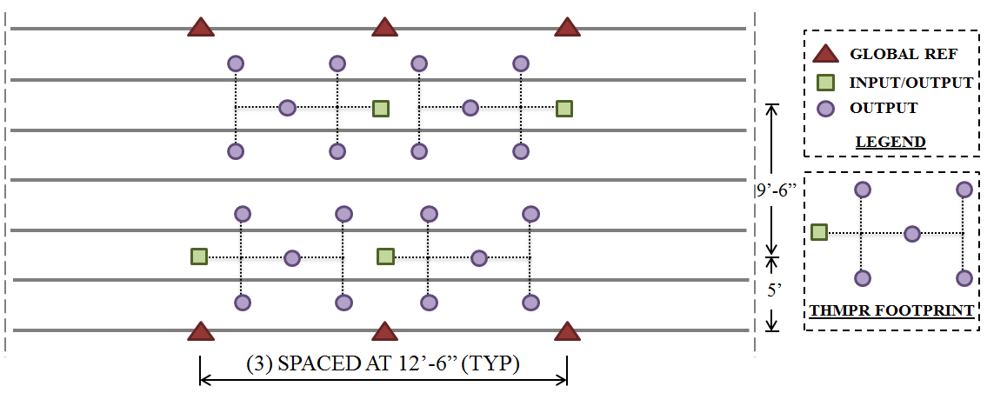

Figure 4. THMPR Instrumentation Plan



Figure 5. THMPR Local Sensor Array

### Test Execution

The THMPR system was roved onto the span at approximately 2:10 PM on September 8, 2014. THMPR’s impact head was centered above a selected impact location on the deck and the GPS synchronized accelerometer array attached to THMPR was remotely deployed. This lowered the six accelerometer housings onto the bridge deck and compressed them against the surface (Figure 6). The impact force and bridge vibration measurements were recorded at a rate of 3,200 samples per second (Hz) in order to precisely define the shape of the impulse signal and for a duration of 10 seconds to ensure the complete capture of the structure’s post-impact free vibration decay response. A total of three separate impacts were recorded at each of the four locations for averaging and noise reduction purposes. The total time required to complete the vibration testing of the bridge was about 20 minutes with the final impact location being completed at 2:30 PM.

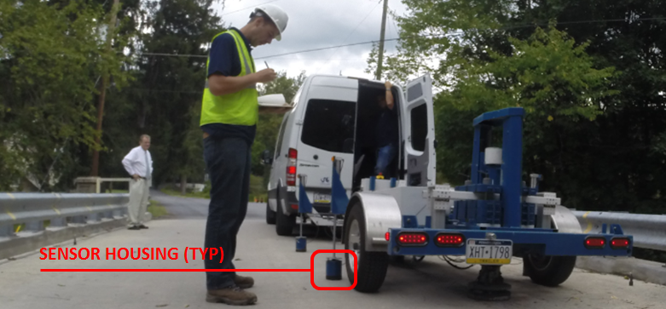

Figure 6. THMPR System Test Execution

### Data Quality

Typical impact forces of up to 25,000 lbs. were observed (Figure 7A) with an approximate usable frequency range of 0-60 Hz (Figure 7B). The impact forces produced by THMPR also resulted in bridge acceleration magnitudes of up to 2 g’s (Figure 8A). Frequency content of the structural response (Figure 8B) shows clearly defined, smooth peaks of resonance which indicates linearity, adequate frequency resolution, and good excitation of all fundamental modes of interest. The relatively large structural response and the acquisition of ten second time windows provided a frequency resolution of 0.09 Hz which resulted in good characterization of closely spaced modes.

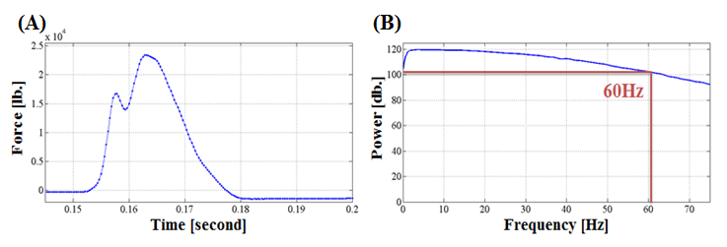

Figure 7. (A) Typical Force Time History & (B) Typical Force Frequency Content

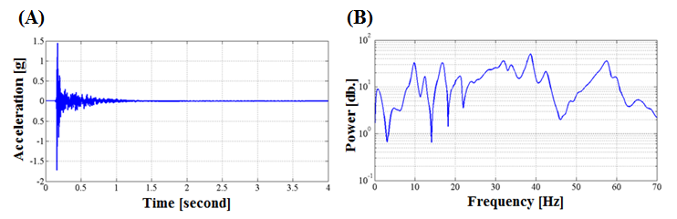

Figure 8. (A) Typical Response Time History & (B) Typical Response Frequency Content

### Modal Parameter Identification

The modal parameters for the structure were identified from the vibration measurements onsite after completion of the testing to provide immediate feedback on the data quality, structural response of the bridge, and operating condition of the test equipment to the on-site engineers. The modal parameters include the natural frequencies and the modal vectors (mode shapes) for each mode. These parameters are directly related to the in-situ mass and stiffness characteristics of the bridge, and are used for calibrating the FE model of the structure.

The modal parameter identification process starts with the computation of frequency response functions for each input-output measurement pair. A frequency response function is essentially the frequency domain transform of measured acceleration response at each sensor location divided by the measured impact force for each test location. The Complex Mode Indicator Function (CMIF) was then calculated for each test location (Figure 9) using the frequency response functions created in the previous step. The CMIF is computed by singular value decomposition of the matrix of frequency response functions for each test location. The largest singular values are plotted against frequency to create the CMIF plot. Each peak in the CMIF plot represents a location of a vibration mode for the structure and the amplitude of the singular value is directly related to the dominance of the corresponding modal vector at that test location. The singular values for each independent impact location are super imposed to compare areas of resonance and ultimately select global modal parameters. A total of eight global vibration modes (global poles) were identified from the CMIF plot as shown in Figure 9.

Additionally, dynamic characteristics are dependent on the mass and stiffness of the structure and careful consideration must be exercised during experimentation so as to not influence the measured dynamic properties of the test specimen. For example, adding a substantial amount of mass to a structure may artificially decrease the frequency of identified system poles and may also distort the extracted modal vectors. Due to the short span of the structure, the mass loading differed between each impact location and allowed for the mass loading effects of the THMPR system trailer and the tow vehicle to be investigated. The quarter span impact locations required the trailer and tow vehicle to be present on the superstructure while the mid span impact locations required only the trailer to be present on the superstructure. Despite these different mass loading configurations, consistent system poles are observed throughout each of the impact locations which indicates the additional mass of the THMPR system and towing vehicle had a negligible effect on the identified global poles and modal vectors of the structure.

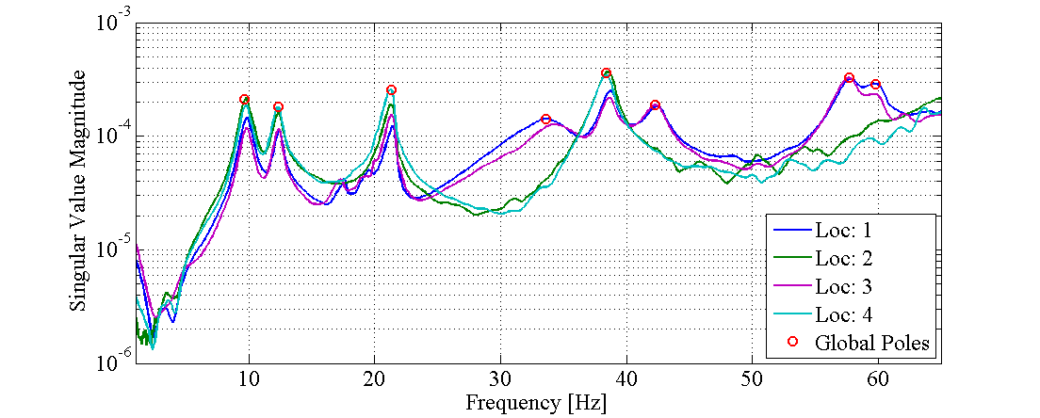

Figure 9. Complex Mode Indicator Function (CMIF)

Local mode shapes for each impact location were extracted at each global pole and combined into a global parameter set. Master mode shapes were selected for each mode based on the relative amplitude of the CMIF singular value for each impact location. The impact location associated with the largest CMIF amplitude for a specific vibration mode contains the highest signal to noise ratio and the corresponding mode shape was designated the master shape for that vibration mode. For each global pole, the modal amplitudes of the stationary references were compared between the local master mode shape and the remaining local mode shapes. A scaling coefficient was developed via a least squares approximation and used to linearly integrate the independent local mode shapes into the local master mode shape and form a global parameter set. Local mode shapes extracted from impact locations which coincided with a point of zero displacement (nodal point) for a particular mode were discarded and not included within the global modal parameter set. Additionally, a combination of the stationary references for each master local mode shape was chosen on an individual mode basis to avoid using reference sensors in locations of low modal amplitude for a particular mode. The first eight fundamental global mode shapes and corresponding frequencies occur within the frequency band of 0-60 Hz and are shown in Figure 10 and Table 8, respectively. It should be noted that the interstitial areas between the discrete experimental degrees-of-freedom for the mode shapes shown in Figure 10 were interpolated using a fourth order equation to aid in the visualization of these shapes.

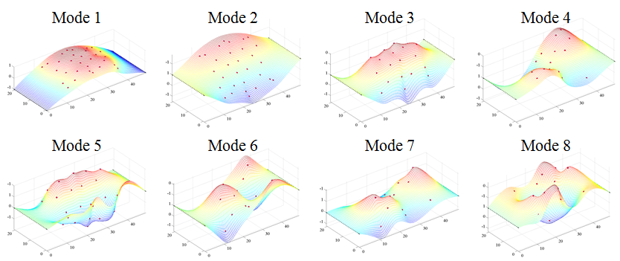

Figure 3 THMPR Results - Global Mode Shapes

Table 8. THMPR Results – Identified Natural Frequencies

|  |  |  |  |
| --- | --- | --- | --- |
| **Mode** | **Frequency [Hz]** | **Master**  **Location** | **Included Locations** |
| 1 | 9.67 | 2 | 1 2 3 4 |
| 2 | 12.3 | 4 | 1 2 3 4 |
| 3 | 21.29 | 4 | 1 2 3 4 |
| 4 | 33.59 | 1 | 1 3 |
| 5 | 38.38 | 2 | 1 2 3 4 |
| 6 | 42.29 | 3 | 1 3 |
| 7 | 57.71 | 3 | 1 3 |
| 8 | 59.77 | 1 | 1 3 |

## Appendix D-3 - Finite Element (FE) Model Development and Rating

### FE Model Creation

An initial finite element (FE) model was created in Strand7 of Northampton County Bridge 138 using the RAMPS software package developed at Drexel University as part of a National Institute of Standards and Technology Innovation Program (NIST-TIP) and the National Cooperative Highway Research Program Project 12-103 (NCHRP 12-103). The 3D geometric model (Figure 11) utilizes beam elements for the steel I-section and concrete encasement. Shell elements are used to model the deck and concrete curb. Rigid links as well as beam elements with variable stiffness are used to enforce compatibility of the displacements between the various structural elements. The following section describes the initial FE model creation and the error screening process employed for the model.

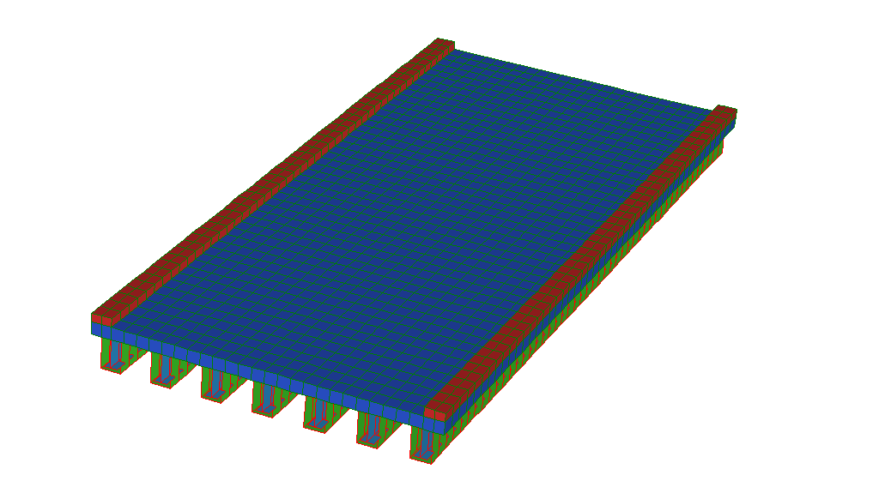

Z

X

Y

Figure 11. *A Priori* FE Bridge Model - Bridge 138

Geometry

Structure dimensions entered into RAMPS software FE Model Creation Module (RAMPS-MCM). These dimensions were verified by field measurements during a site visit by the Drexel University THMPR Team on September 8, 2014:

Table 9. Structure Geometry

|  |  |  |
| --- | --- | --- |
| **Dimension** | **Value** | **Notes** |
| Spans | 1 | *None* |
| Length [in] | 588 | *None* |
| Roadway Width [in] | 240 | *None* |
| Skew [in] | 0 | *None* |
| Sidewalk Width [in] | 16 | Curb modeled as sidewalk in RAMPS |
| Sidewalk Height [in] | 7 | *None* |
| Barrier Width [in] | 0 | Type-2 Guiderails not included in FE model analysis |
| Barrier Height [in] | 0 | Type-2 Guiderails not included in FE model analysis |

Material Properties

Material properties entered into RAMPS-MCM.

Table 10. Material Properties

|  |  |  |
| --- | --- | --- |
| **Property** | **Value** | **Notes** |
| Deck *f’c* [psi] | 2500 | Per *AASHTO MBE 2011* 6A.5.2.1-1 (Highway et al. 2011) |
| Sidewalk *f’c* [psi] | 2500 | Per *AASHTO MBE 2011* 6A.5.2.1-1 (Highway et al. 2011) |
| Barrier *f’c* [psi] | N/A | No barriers |
| Steel *fy* [psi] | 33000 | Per *AASHTO MBE 2011* 6A.6.2.1-1 (Highway et al. 2011) |

Diaphragms

There are no diaphragms on the structure.

Girder Dimensions

Girder dimensions entered into RAMPS-MCM.

Table 11. Girder Dimensions

|  |  |  |
| --- | --- | --- |
| **Property** | **Value** | **Notes** |
| Number of Girders | 7 | *None* |
| Girder Spacing [in] | 40 | *None* |
| Girder *D* [in] | 26.25 | Per STV Report (STV 2013) |
| Girder *bf* [in] | 10.25 | Per STV Report (STV 2013) |
| Girder *tw* [in] | 0.75 | Per STV Report (STV 2013) |
| Girder *tf* [in] | 0.75 | Per STV Report (STV 2013) |

Boundary Conditions

Boundary conditions entered into RAMPS-MCM.

Table 12. Boundary Conditions

|  |  |  |  |  |
| --- | --- | --- | --- | --- |
| **FIXED Bearing** | | | | |
| **DOF** | **Fix** | **Spring** | **Spring Value** | **Notes** |
| U1 | Yes | *No* | - | *Displacement prevented in x-direction* |
| U2 | Yes | *No* | *-* | *Displacement prevented in y-direction* |
| U3 | Yes | *No* | - | *Displacement prevented in z-direction* |
| R1 | Yes | *No* | - | *Rotation prevented about x-axis* |
| R2 | No | *No* | - | *Rotation allowed about y-axis* |
| R3 | No | *No* | - | *Rotation allowed about z-axis* |

|  |  |  |  |  |
| --- | --- | --- | --- | --- |
| **EXPANSION Bearing** | | | | |
| **DOF** | **Fix** | **Spring** | **Spring Value** | **Notes** |
| U1 | No | *No* | *-* | *Displacement allowed in x-direction* |
| U2 | Yes | *No* | *-* | *Displacement prevented in y-direction* |
| U3 | Yes | No | - | *Displacement prevented in z-direction* |
| R1 | Yes | No | - | *Rotation prevented about x-axis* |
| R2 | No | No | - | *Rotation allowed about y-axis* |
| R3 | No | No | - | *Rotation allowed about z-axis* |

|  |  |  |
| --- | --- | --- |
| **BC Line** | **Type** | **Notes** |
| 1 | FIX | *None* |
| 2 | EXP | *None* |

RAMPS Model Modification Notes for *A Priori* Model

1. Created Concrete Encasement property for model updating
2. End diaphragms removed from model
3. Concrete beam offset from steel girder line, moved by 3.125 inches (–Z direction)
4. All girders and girder centerline nodes moved to 14.375 inches (-Z direction)
5. Boundary nodes moved to 30 inches (-Z direction)
6. Beam top surface nodes moved to 5 inches (-Z direction)
7. Beam bottom surface nodes moved to 27.5 inches (-Z direction)
8. Creation of rigid links to enforce composite action between the steel beam and concrete encasement

### Error Screening for *A Priori* Model

Natural Frequency Analysis

Mode shapes and natural frequencies were extracted from modal analysis of the initial, or *a priori,* FE model. Natural frequencies were within the range expected from experimental results (Table 7). No discontinuities or rigid body modes were observed. No “Warnings” or “Errors” were noted in the Strand7 analysis log other than a note about mass participation factors possibly being incorrect. Mass participation factors are not used in the model updating procedure and this warning was ignored for error screening. The structure was initially considered to behave non-compositely (both beam-deck and beam-encasement) for the sake of error screening. The stiffness contribution of the concrete encasement was neglected by setting the FE model parameter associated with encasement concrete modulus to an arbitrarily small number determined by sensitivity analysis. The degree of composite action was set to an arbitrarily small number determined with sensitivity analysis. The level of the composite action simulated, like all other parameters in this model, may be later adjusted or “tuned” in response to model/experiment correlation or other reasons.

Table 13. Modal Error Screening

|  |  |  |
| --- | --- | --- |
| **Mode** | **Analytical Freq [Hz]** | **Experimental Freq [Hz]** |
| *1* | 3.47 | 9.67 |
| *2* | 4.81 | 12.30 |
| *3* | 12.03 | 21.29 |
| *4* | 14.74 | 33.59 |

|  |  |
| --- | --- |
| Figure 44. Mode 1 | Figure 55. Mode 2 |
| Figure 66. Mode 3 | Figure17. Mode 4 |

Dead Load Reaction Check

The reaction forces obtained from the FE model for a dead load analysis were evaluated to determine the total weight of the structure. The total weight of the structure computed from the FE model was compared to a manual calculation of the structure’s weight. The total weight of the structure was calculated using the following material densities:

Concrete = 0.08671 lb/in3

Steel = 0.2836 lb/in3

Total volumes of concrete and steel were calculated to be the following:

Deck Concrete = 1,599,360 in3

Sidewalk Concrete = 131,712 in3

Encasement Concrete = 1,646,400 in3

Steel = 139,686.75 in3

The total weight of the concrete and steel components of the bridge and the overall weight of the structure were calculated to be the following:

Total WeightCONCRETE = 292.86 kips

Total WeightSTEEL = 39.615 kips

Total Weight of Bridge= 332.48 kips

The total weight of the bridge determined from the dead load analysis of the FE model was 332.41 kips. The percent difference between manual and FE model calculations of the total bridge weight was 0.0211 %, indicating that the FE model very accurately simulates the total weight of the bridge.

### *A Priori* FE Model Rating

Bridge 138 was rated using an initial (known as *a priori*) FE model using the RAMPS Automated Load Rating Module (RAMPS-ALRM). Unknown parameters were investigated using sensitivity analysis for both dynamic property effects as well as effects on LRFD load rating values. The unknown parameter values were set at what were judged to be the most conservative values given the sensitivity analysis and engineering judgment. The parameters used in the model should not be taken as the true physical values of the materials or sections in the actual structure. These parameter values are used, instead, to simulate observable phenomena and predict likely global behavior. A natural frequency analysis of the FE model was performed and the dynamic properties of the analytical structure were compared to the experimental results developed with the THMPR system. A semi-automated deck mass redistribution algorithm was used to determine model fitness and dynamic properties of the mass-adjusted FE model were compared to the *in situ* results. The *a priori* model was then rated for an AASHTO LRFD HL-93 truck load for Strength I and Service II limit states.

### Unknown Parameter Selection

Composite Action

According to *AASHTO MBE 2011* Section 6A.6.9.4 – “Encased I Sections,” (Highway et al. 2011) encased I-sections may be assumed to act as composite for service and fatigue limit states if there is no sign of cracking, rust, or separation along the steel-concrete interface. If sufficient shear transfer between the steel I-section and concrete can be verified by calculation, the section may be considered composite for strength limit states. Encased I-sections constructed without shear connectors may act compositely with the concrete deck; however, this degree of this composite action may take on any value.

For the RAMPS *a priori* model load rating, the conservative case was assumed that the concrete encasement was *not* acting compositely with the steel I-sections. Likewise, it was conservatively assumed that the deck and steel I-sections are non-composite.

According to the STV Load Rating Summary (STV 2013) regarding concrete core testing, the top flange of the beams were “fully in contact with the deck and no sign of cracking, rust, or separation along the steel-concrete interface is present [was] present.” For RAMPS load rating the top flange is considered continuously braced per *AASHTO MBE 2011* 6A.6.9.3 (Highway et al. 2011).

Boundary Conditions

Boundary conditions were modeled as a “Pin-Roller” system. These boundary conditions are the most conservative conditions for the flexural limit states of interest. Since the structure is symmetric, no special consideration was made to choosing the “Pin” or “Roller” side of the model.

### Initial Natural Frequency Analysis Comparison

Natural frequencies and mode shapes were extracted from the FE model and compared to the test results developed with the THMPR system. The individual vibration modes of the bridge identified from the analytical model (FE model) and experiment were matched using Modal Assurance Criterion (MAC) values. The MAC value is a correlation coefficient that describes the level of agreement between two mode shape vectors. MAC values may range from zero (indicating that two mode shape vectors are completely different) to 1.0 indicating the two mode shape vectors are exactly alike. Percent error in the FE model frequencies and MAC values for each mode pairing are presented in Table 14. A qualitative comparison of paired mode shapes is provided in Table 15.

Table 14. *A Priori* Model Natural Frequency Comparison

|  |  |  |  |  |
| --- | --- | --- | --- | --- |
| **MAC** | **Natural Frequency** | | | **Analytical Mode** |
| *Experimental [Hz]* | *Analytical [Hz]* | *% Difference* |
| 0.9900 | 9.67 | 3.47 | -64.07 | 1 |
| 0.9918 | 12.30 | 4.81 | -60.92 | 2 |
| 0.9544 | 21.29 | 12.03 | -43.49 | 3 |
| 0.8608 | 33.59 | 14.74 | -56.12 | 5 |
| 0.9180 | 38.38 | 27.03 | -29.58 | 9 |
| 0.9511 | 42.29 | 20.54 | -51.43 | 7 |
| 0.9021 | 57.71 | 33.16 | -42.55 | 12 |

The higher frequency experimental modes are paired with high number analytical modes. Due to model FE construction there are many rigid body modes that may be safely ignored. It is highly unlikely during an updating process that these rigid body modes will be paired in any updating process.

Table 15. Paired Mode Shape Comparison

|  |  |
| --- | --- |
| ***Experimental Mode Shape*** | ***Paired Analytical Mode Shape*** |
| **Mode 1** | **Mode 1** |
| **Mode 2** | **Mode 2** |
| **Mode 3** | **Mode 3** |
| **Mode 4** | **Mode 5** |
| **Mode 5** | **Mode 9** |
| **Mode 6** | **Mode 7** |
| **Mode 7** | **Mode 12** |
| **Mode 8** | **Mode 21** |

MAC values are all above 0.86 while six out of eight paired modes have a MAC value over 0.90. The first two modes have MAC values over 0.99. These values provide evidence that the relative spatial distribution of stiffness in the FE model is close to that of the structure. A global increase in stiffness would not significantly affect the mode shapes and MAC values; however, it would affect the frequency values. Frequency error for all modes is negative and between 20 and 60 percent, indicating that that the global stiffness of the FE model is significantly lower than that of the *in situ* structure. It is likely that load ratings computed using the *a priori* FE model will be lower than the load capacity of the actual structure.

### *A Priori* FE Model Load Rating

The same values for the unknown material properties that were employed by STV Inc. in their BAR7 load rating analysis were also used for the initial RAMPS load rating. Other unknown properties were set to what would produce the most conservative load rating. In total, every assumption that was made in the *a priori* model creation and load rating was to assure the most conservative estimate of performance. Using these conservative assumptions, the bridge rates for AASHTO LRFR Inventory loads under HL-93 for both Strength I and Service II limit states. Further, the encasement cracking shown in Figure 2 indicates that the encasement is likely acting compositely with the steel I-section and may contribute to increased structural capacity. This composite relationship may be manifested in the significantly lower frequencies in the FE model when compared to experimental data. Likewise, the deck and steel I-sections are expected to act compositely due to the 3.75 inch embedment of the beam flange in the deck. This would also contribute to the low frequencies in the FE model when compared to experimental results.

Strength I Rating Factors – LRFR - HL93

Inventory Rating:

* RF: 2.37
* 85 Tons
* Girder 3 (3rd interior)

Operating Rating:

* RF: 3.08
* 110 Tons
* Girder 3 (3rd Interior)

Service II Rating Factors – LRFR - HL93

Inventory Rating:

* RF: 1.35
* 48 Tons
* Girder 3 (3rd Interior)

Operating Rating:

* RF: 1.76
* 62 Tons
* Girder 3 (3rd Interior)

## Appendix D-4 - Model Experiment Correlation and Updated Model Rating

### Initial Values

The *a priori* model was updated five separate times using different initial values for the FE model unknown parameters. The first update used the same parameters values as the initial model used for load rating. Updates two through five used the highest possible values available to the updating algorithm for a single parameter while keeping all other parameters at the same value as the *a priori* model. Table 16 and Table 17 show thee starting parameter values. Table 16 indicates the structural phenomena each starting parameter value represents while Table 17 indicates whether this parameter value is at the upper bound (high) or lower bound (low, as well as *a priori*). Table 18 shows the physical values used in the FE model for upper and lower bounds; **note that many of these parameter values should not be taken as the *actual* physical measurement found in the *in situ* structure.**

Table 16. Initial Values for Five Model Updating Trials

|  |  |  |  |  |  |
| --- | --- | --- | --- | --- | --- |
|  | ***Update 1*** | ***Update 2*** | ***Update 3*** | ***Update 4*** | ***Update 5*** |
| ***Deck f’c [psi]*** | 2500 | 6000 | 2500 | 2500 | 2500 |
| ***Encasement*** | Non-composite | Non-composite | Composite | Non-composite | Non-composite |
| ***Composite Action*** | Non-composite | Non-composite | Non-composite | Composite | Non-composite |
| ***Near and Far Bearing*** | Pin/Roller | Pin/Roller | Pin/Roller | Pin/Roller | Fixed/Fixed |

Table 17. Initial Values for Five Model Updating Trials

|  |  |  |  |  |  |
| --- | --- | --- | --- | --- | --- |
|  | ***Update 1*** | ***Update 2*** | ***Update 3*** | ***Update 4*** | ***Update 5*** |
| ***Deck*** | Low | **High** | Low | Low | Low |
| ***Encasement*** | Low | Low | **High** | Low | Low |
| ***Composite Action*** | Low | Low | Low | **High** | Low |
| ***Near and Far Bearing*** | Low | Low | Low | Low | **High** |

The lower bound for the deck *f’c* was set to be 20% less than half of the *a priori* parameter value. The upper bound was set to be 20% more than half of the *a priori* value. The bounds for degree of encasement composite action (simulated by adjusting the encasement *f’c),* deck/girder composite action, and rotational stiffness at the supports were bounded by looking at the sensitivity of the FE model’s natural frequencies and mode shapes as well as the FE model-derived Strength I and Service II LRFR.

Table 18. Physical Parameter Values Used in Model Updating

|  |  |  |  |
| --- | --- | --- | --- |
|  | ***A Priori*** | ***Lower*** | ***Upper*** |
| ***Deck f’c [psi]*** | 2500 | 1000 | 6000 |
| ***Encasement f’c [psi]*** | 0.80 | 0.80 | 6000 |
| ***Composite Action Ix [in4]*** | 3.00 x 10-4 | 3.00 x 10-4 | 200 |
| ***Near and Far Bearing Kr [in-ft]*** | 2.75 x 106 | 2.75 x 106 | 1.10 x 1012 |

### Updating Process

Model parameters were updated using a gradient-based non-linear least squares minimization algorithm that seeks to minimize the objective function, S.

|  |  |  |
| --- | --- | --- |
|  | $$S= \sum_{i=1}^{n}{\sqrt{{\left(1-MAC_{i}\right)}^{2}+{\left(1-∆_{f_{i}}\right)}^{2}}}$$ | Eqn. 1 |

Where:

|  |  |  |
| --- | --- | --- |
|  | $$∆_{f_{i}}= \left(\frac{f_{\exp_{i}}-f_{{ana}_{i}}}{f_{\exp_{i}}}\right)$$ | Eqn. 2 |

|  |  |  |
| --- | --- | --- |
|  |  | Eqn. 3 |

And:

$f_{{ana}_{i}}$: Analytical frequency for mode *i*

$f_{\exp_{i}}$: Exerpimental frequency for mode *i*

$\{{Φ_{A}}_{i}\}$: Analytical mode shape vector for mode *i*

$\{{Φ_{E}}_{j}\}$: Experimental mode shape vector for mode *j*

### Final Values

Final values for the model updating trials are shown in Table 22 and Table 23. Both deck and encasement parameters ended at their upper bounds, however raising these bounds in subsequent trials, while likely resulting in a reduced objective function, would provide less conservative rating factors. In four out of five updating trials, deck/girder composite action resulted at a value at the lower-middle range of the most sensitive area for that parameter. Similarly, bearing rotational stiffness ended at a value squarely in the middle of the sensitive region in four out of five updating trials. The parameters for deck/girder composite action and bearing stiffness “swapped” final stiffness values for update 3. The maximum global stiffness in the model was not significantly changed, however there were more local effects. For example: due to an increased bearing stiffness, the points of inflection in the first bending mode shape were shifted towards mid-span in update 3 when compared to all other update trials.

Table 22. Final Values for Five Model Updating Trials

|  |  |  |  |  |  |
| --- | --- | --- | --- | --- | --- |
|  | ***Update 1*** | ***Update 2*** | ***Update 3*** | ***Update 4*** | ***Update 5*** |
| ***Deck f’c [psi]*** | 6000 | 6000 | 6000 | 6000 | 6000 |
| ***Encasement f’c [psi]*** | 6000 | 6000 | 6000 | 6000 | 6000 |
| ***Composite Action Ix [in4]*** | 0.0132 | 0.0131 | 3.00 x 10-4 | 0.0133 | 0.0133 |
| ***Near and Far Bearing Kr [in-ft]*** | 1.90 x 1009 | 1.77 x 1009 | 3.55 x 1010 | 1.88 x 1009 | 1.93 x 1009 |

Table 23. Final Values for Five Model Updating Trials

|  |  |  |  |  |  |
| --- | --- | --- | --- | --- | --- |
|  | ***Update 1*** | ***Update 2*** | ***Update 3*** | ***Update 4*** | ***Update 5*** |
| ***Deck f’c***  ***[psi]*** | High | High | High | High | High |
| ***Encasement*** | High | High | High | High | High |
| ***Composite Action*** | Mid-Low | Mid-Low | Low | Mid-Low | Mid-Low |
| ***Near and Far Bearing*** | Mid | Mid | Mid-High | Mid | Mid |

### Updated Model Fitness

The fitness of the updated models for load rating was investigated by comparing the final objective function results for each trial to the objective function values of the *a priori* model. Table 24 shows the percent reduction of the MAC and frequency residuals in the updated models from the *a priori* model. Updated models 1, 2, 4, and 5 all exhibited similar changes in their residuals. Updated model 3 exhibited a greater MAC residual reduction and lesser frequency residual reduction than the other updated models, however every updated model had a total residual reduction of over 80 percent.

Table 24. Objective Function Residual Comparison

|  |  |  |  |  |  |  |  |  |  |  |  |
| --- | --- | --- | --- | --- | --- | --- | --- | --- | --- | --- | --- |
|  | | **Residuals** | | | | | | | | | |
| **Experimental Mode** | | ***Update 1*** | | ***Update 2*** | | ***Update 3*** | | ***Update 4*** | | ***Update 5*** | |
| *MAC* | *Freq* | *MAC* | *Freq* | *MAC* | *Freq* | *MAC* | *Freq* | *MAC* | *Freq* |
| *1* | | 0.10 | -94.31 | 0.09 | -94.10 | -0.34 | -87.19 | 0.10 | -94.27 | 0.11 | -94.31 |
| *2* | | -0.14 | -96.20 | -0.15 | -96.08 | -0.64 | -99.74 | -0.14 | -96.21 | -0.14 | -96.26 |
| *3* | | -1.16 | -99.09 | -1.17 | -98.90 | -1.40 | -94.28 | -1.16 | -99.11 | -1.16 | -99.15 |
| *4* | | 2.44 | -90.50 | 2.50 | -90.56 | 2.09 | -84.19 | 2.44 | -90.56 | 2.42 | -90.51 |
| *5* | | -3.98 | -86.81 | -3.93 | -86.92 | -1.53 | -95.47 | -3.99 | -86.78 | -3.99 | -86.77 |
| *6* | | -2.93 | -92.49 | -3.02 | -92.41 | -2.17 | -85.72 | -2.94 | -92.54 | -2.91 | -92.53 |
| *7* | | 5.71 | -93.46 | 5.73 | -93.41 | 4.33 | -90.93 | 5.71 | -93.49 | 5.71 | -93.48 |
| *MAC Only* | *Freq Only* | -1.08 | -93.16 | -1.20 | -93.11 | -5.43 | -88.93 | -1.04 | -93.18 | -1.04 | -93.17 |
| **Total Residual** | | **-83.94** | | **-83.93** | | **-82.28** | | **-83.94** | | **-83.94** | |

Table 25 through Table 30 show the natural frequency analysis results for the *a priori* and updated models. MAC values in the updated models were all over 0.88 and many of the lower order modes were above 0.99. Frequency differences in four out of five updated models were less than 5.5% and in one other model were less than 8.5%. These results very good global stiffness and load sharing agreement between the updated FE models and *in situ* structure. Updated model 3 had a much less accurate prediction of the first bending mode – a significant indicator of global stiffness – and a generally less accurate prediction of all natural frequencies, and will not be utilized for load rating.

Table 25. *A Priori* Final Dynamic Property Values

|  |  |  |  |  |
| --- | --- | --- | --- | --- |
| **MAC** | **Natural Frequency** | | | **Analytical Mode** |
| *Experimental [Hz]* | *Analytical [Hz]* | *% Difference* |
| 0.9900 | 9.67 | 3.47 | -64.07 | 1 |
| 0.9918 | 12.30 | 4.81 | -60.92 | 2 |
| 0.9544 | 21.29 | 12.03 | -43.49 | 3 |
| 0.8608 | 33.59 | 14.74 | -56.12 | 5 |
| 0.9180 | 38.38 | 27.03 | -29.58 | 9 |
| 0.9511 | 42.29 | 20.54 | -51.43 | 7 |
| 0.9021 | 57.71 | 33.16 | -42.55 | 12 |

Table 26. Updated Model 1 Dynamic Property Values

|  |  |  |  |  |
| --- | --- | --- | --- | --- |
| **MAC** | **Natural Frequency** | | | **Analytical Mode** |
| *Experimental [Hz]* | *Analytical [Hz]* | *% Difference* |
| 0.9910 | 9.67 | 10.02 | 3.65 | 1 |
| 0.9904 | 12.30 | 12.02 | -2.31 | 2 |
| 0.9433 | 21.29 | 21.20 | -0.40 | 3 |
| 0.8818 | 33.59 | 31.80 | -5.33 | 5 |
| 0.8815 | 38.38 | 39.88 | 3.90 | 7 |
| 0.9232 | 42.29 | 40.65 | -3.86 | 8 |
| 0.9536 | 57.71 | 56.11 | -2.78 | 10 |

Table 27. Updated Model 2 Dynamic Property Values

|  |  |  |  |  |
| --- | --- | --- | --- | --- |
| **MAC** | **Natural Frequency** | | | **Analytical Mode** |
| *Experimental [Hz]* | *Analytical [Hz]* | *% Difference* |
| 0.9909 | 9.67 | 10.03 | 3.78 | 1 |
| 0.9903 | 12.30 | 12.01 | -2.39 | 2 |
| 0.9432 | 21.29 | 21.19 | -0.48 | 3 |
| 0.8823 | 33.59 | 31.81 | -5.30 | 5 |
| 0.8819 | 38.38 | 39.86 | 3.87 | 7 |
| 0.9224 | 42.29 | 40.63 | -3.90 | 8 |
| 0.9538 | 57.71 | 56.10 | -2.80 | 10 |

Table 28. Updated Model 3 Dynamic Property Values

|  |  |  |  |  |
| --- | --- | --- | --- | --- |
| **MAC** | **Natural Frequency** | | | **Analytical Mode** |
| *Experimental [Hz]* | *Analytical [Hz]* | *% Difference* |
| 0.9866 | 9.67 | 10.46 | 8.21 | 1 |
| 0.9855 | 12.30 | 12.32 | 0.16 | 2 |
| 0.9410 | 21.29 | 20.76 | -2.49 | 3 |
| 0.8788 | 33.59 | 30.61 | -8.87 | 6 |
| 0.9040 | 38.38 | 38.89 | 1.34 | 8 |
| 0.9305 | 42.29 | 39.18 | -7.34 | 9 |
| 0.9412 | 57.71 | 55.49 | -3.86 | 11 |

Table 29. Updated Model 4 Dynamic Property Values

|  |  |  |  |  |
| --- | --- | --- | --- | --- |
| **MAC** | **Natural Frequency** | | | **Analytical Mode** |
| *Experimental [Hz]* | *Analytical [Hz]* | *% Difference* |
| 0.9910 | 9.67 | 10.02 | 3.67 | 1 |
| 0.9904 | 12.30 | 12.02 | -2.31 | 2 |
| 0.9433 | 21.29 | 21.21 | -0.39 | 3 |
| 0.8818 | 33.59 | 31.81 | -5.30 | 5 |
| 0.8814 | 38.38 | 39.88 | 3.91 | 7 |
| 0.9231 | 42.29 | 40.66 | -3.83 | 8 |
| 0.9536 | 57.71 | 56.12 | -2.77 | 10 |

Table 30. Updated Model 5 Dynamic Property Values

|  |  |  |  |  |
| --- | --- | --- | --- | --- |
| **MAC** | **Natural Frequency** | | | **Analytical Mode** |
| *Experimental [Hz]* | *Analytical [Hz]* | *% Difference* |
| 0.9911 | 9.67 | 10.02 | 3.65 | 1 |
| 0.9904 | 12.30 | 12.02 | -2.28 | 2 |
| 0.9433 | 21.29 | 21.21 | -0.37 | 3 |
| 0.8816 | 33.59 | 31.81 | -5.32 | 5 |
| 0.8814 | 38.38 | 39.88 | 3.91 | 7 |
| 0.9234 | 42.29 | 40.66 | -3.84 | 8 |
| 0.9536 | 57.71 | 56.11 | -2.77 | 10 |

Table 31 shows the experimental mode shapes and their paired modes from the updated FE models. The paired modes from updated model 3 have a different order than those found in the other updated models, however their shapes are the same.

Figure 31. Experimental and Analytical Mode Shape Comparison

|  |  |
| --- | --- |
| ***Experimental Mode Shape*** | ***Paired Analytical Mode Shape*** |
| **Mode 1** | **Mode 1** |
| **Mode 2** | **Mode 2** |
| **Mode 3** | **Mode 3** |
| **Mode 4** | **Mode 5** |
| **Mode 5** | **Mode 7** |
| **Mode 6** | **Mode 8** |
| **Mode 7** | **Mode 10** |

### Rating

The four updated models with strong objective function and final parameter agreement were rated using the RAMPs software. In order to assure the most conservative load rating estimate while utilizing an updated FE model, stiffness contributions from the concrete encasement were ignored in a second set of ratings for the same four updated models. It was necessary to allow the updating algorithm to increase encasement stiffness in the model in response to differences between frequencies and mode shapes. We may, however, neglect this stiffness contribution after updating. All other parameters from the updated models were carried over into the rating.

Table 32 and Table 33 show the Strength I and Service II limit state LRFR, percent increase in rating factor from the *a priori* model, and controlling girder for each updated model. **The controlling Strength I limit state rating factors for the model with concrete encasement contribution was 16.18/20.97 (Op/Inv) and without concrete encasement was 6.37/8.26. The Strength II rating factors with concrete encasement were 10.05/13.07 and without were 4.64/6.03.**

Table 32. Facting Factors for Updated Models with Concrete Encasement Contribution

|  |  |  |  |  |  |  |  |  |  |
| --- | --- | --- | --- | --- | --- | --- | --- | --- | --- |
|  | | **Updated Models With Concrete Encasement Contribution** | | | | | | | |
| ***Strength I*** | | | | ***Service II*** | | | |
| *Inv* | *Ctrl. Gir.* | *Op* | *Ctrl. Gir.* | *Inv* | *Ctrl. Gir.* | *Op* | *Ctrl. Gir.* |
| ***A Priori*** | **RF** | 2.35 | 3 | 3.05 | 3 | 1.33 | 3 | 1.73 | 3 |
| **Tons** | 84.60 | 109.80 | 47.88 | 62.28 |
| **Update 1** | **RF** | 16.18 | 4 | 20.97 | 4 | 10.05 | 5 | 13.07 | 5 |
| **Tons** | 582.48 | 754.92 | 361.80 | 470.52 |
| **% Δ** | 85.48 | 85.46 | 86.77 | 86.76 |
| **Update 2** | **RF** | 16.22 | 4 | 21.02 | 4 | 10.07 | 5 | 13.09 | 5 |
| **Tons** | 583.92 | 756.72 | 362.52 | 471.24 |
| **% Δ** | 85.51 | 85.49 | 86.79 | 86.78 |
| **Update 4** | **RF** | 16.18 | 4 | 20.97 | 4 | 10.05 | 5 | 13.07 | 5 |
| **Tons** | 582.48 | 754.92 | 361.80 | 470.52 |
| **% Δ** | 85.48 | 85.46 | 86.77 | 86.76 |
| **Update 5** | **RF** | 16.18 | 4 | 20.97 | 4 | 10.05 | 5 | 13.07 | 5 |
| **Tons** | 582.48 | 754.92 | 361.80 | 470.52 |
| **% Δ** | 85.48 | 85.46 | 86.77 | 86.76 |

Table 33. Rating Factors for Updated Models without Concrete Encasement Contribution

|  |  |  |  |  |  |  |  |  |  |
| --- | --- | --- | --- | --- | --- | --- | --- | --- | --- |
|  | | **Updated Models Without Concrete Encasement Contribution** | | | | | | | |
| ***Strength I*** | | | | ***Service II*** | | | |
| Inv | Ctrl. Gir. | Op | Ctrl. Gir. | Inv | Ctrl. Gir. | Op | Ctrl. Gir. |
| ***A Priori*** | **RF** | 2.35 | 3 | 3.05 | 3 | 1.33 | 3 | 1.73 | 3 |
| **Tons** | 84.60 | 109.80 | 47.88 | 62.28 |
| **Update 1** | **RF** | 6.38 | 5 | 8.27 | 5 | 4.64 | 5 | 6.04 | 5 |
| **Tons** | 229.68 | 297.72 | 167.04 | 217.44 |
| **% Δ** | 63.17 | 63.12 | 71.34 | 71.36 |
| **Update 2** | **RF** | 6.37 | 5 | 8.26 | 5 | 4.64 | 5 | 6.03 | 5 |
| **Tons** | 229.32 | 297.36 | 167.04 | 217.08 |
| **% Δ** | 63.11 | 63.08 | 71.34 | 71.31 |
| **Update 4** | **RF** | 6.38 | 5 | 8.26 | 5 | 4.64 | 5 | 6.04 | 5 |
| **Tons** | 229.68 | 297.36 | 167.04 | 217.44 |
| **% Δ** | 63.17 | 63.08 | 71.34 | 71.36 |
| **Update 5** | **RF** | 6.38 | 5 | 8.27 | 5 | 4.65 | 5 | 6.04 | 5 |
| **Tons** | 229.68 | 297.72 | 167.40 | 217.44 |
| **% Δ** | 63.17 | 63.12 | 71.40 | 71.36 |

# Appendix E – Bridge 200 Performance Evaluation and Load Rating Analysis

**Northampton County Bridge 200**

|  |  |
| --- | --- |
| **BMS No:** | 48 7413 0000 9200 |
| **Feature Carried:** | Columba Ave. |
| **Feature Intersected:** | Roseto Creek |
| **Structure Type:** | Concrete Encased Multi-Girder |
|  |  |
| **Test Date:** | 11/05/2014 |
| **Test Type:** | Dynamic Test |
| **Analysis and Rating Method:** | AASHTO LRFR |

|  |  |  |  |  |  |
| --- | --- | --- | --- | --- | --- |
|  | **Strength I** | **Inventory** | **Tons** | **Operating** | **Tons** |
| ***Pre-Test Rating*** |  |  |  |  |
| *A Priori* Model | 4.6 | 166 | 6.0 | 216 |
| ***Post-Test Conservative Model Rating*** |  |  |  |  |
| **Span 1 Final** | **2.7** | **95** | **3.4** | **124** |

Table 1. *A Priori*, Calibrated, and Final Model AAHSTO HL-93 load rating for Bridge 200.

No plans were provided for this structure. The geometry of the bridge and its components were investigated during the test. The structure was evaluated using forced vibration testing methods and the dynamic properties (natural frequencies and mode shapes) were extracted for finite element model calibration.

Strand7 FE Modelling Software was used in conjunction with computational software to perform a live load rating analysis for the bridge. An initial finite element (FE) model was created in Strand7 of the bridge. Conservative material properties, section properties, continuity conditions and boundary conditions were assumed for an initial model. A likely girder section was assumed for the structure using the girder sizing software developed by Drexel University. This girder section was designed using AASHTO *Standard Specifications* Allowable Stress Design for an H-15 truck. Girder placement within concrete encasement, girder sizing, and other design details were estimated by referring to bridge designs by the same engineering firm for Northampton Country during the same time period (mid 1920’s). The initial model was rated for AASHTO Load and Resistance Factor Strength I limit states for an HL-93 truck. Service II limit state was not considered due to lack of information about girder proportioning and inherent stability due to structurally active concrete encasement. The initial model was then calibrated to the natural frequencies and mode shapes developed through experimentation. A set of calibrated models were used to perform live load ratings for each span with and without concrete encasement stiffness contribution. Controlling ratings for the initial and calibrated models are summarized in the above table.

## Experimental Evaluation Summary

 Northampton County Bridge 200 was evaluated on November 5, 2014 using forced vibration testing methods and the dynamic properties (natural frequencies and mode shapes) were extracted for finite element model calibration.

Figure 1. THMPR System

A self-contained modal impact trailer equipped with a falling mass impact system and local sensor array was used to execute the vibration tests. The superstructure was excited via a 25 kip impulse force at multiple, spatially distributed locations which resulted in up to 3 g’s of bridge deck acceleration. Acceleration responses were measured via a local sensor array of six accelerometers and multiple spatially distributed stationary global references secured to the bridge deck via glue adhesive prior to testing. Local modal parameter estimation was performed utilizing the Complex Mode Indicator Function (CMIF) and integrated into a final global modal parameter set. Six natural frequencies and mode shapes were identified for span 1 and five natural frequencies and mode shapes were identified for span 2 in the frequency band of 0-65 Hz (Figure 2 & Table 2).

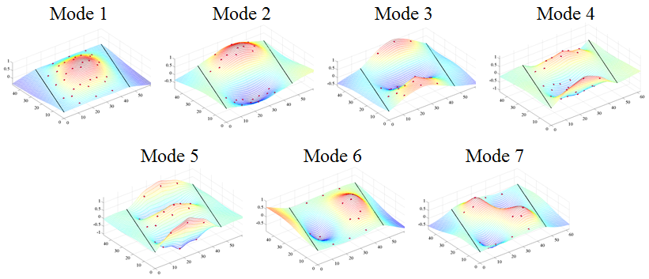

Figure 2. THMPR Results – Overview of Global Mode Shapes

Table 2. THMPR Results – Identified Natural Frequencies

|  |  |
| --- | --- |
| **Mode** | **Span 1**  **Frequency [Hz]** |
| 1 | 13.38 |
| 2 | 17.48 |
| 3 | 20.18 |
| 4 | 23.34 |
| 5 | 28.03 |
| 6 | 39.16 |
| 7 | 43.95 |

## Load Rating Analysis Summary

The structure was modeled using finite element analysis and computational software. An initial finite element (FE) model was created in Strand7 for both spans of Northampton County Bridge 041 using the RAMPS software package developed at Drexel University as part of a National Institute of Standards and Technology Innovation Program (NIST-TIP) and the National Cooperative Highway Research Program Project 12-103 (NCHRP 12-103).Conservative material properties, section properties, continuity conditions and boundary conditions were assumed for an initial model. The 3D geometric model (Figure 3) utilizes beam elements for the steel I-section and concrete encasement. Shell elements are used to model the deck and concrete curb. Rigid links as well as beam elements with variable stiffness are used to enforce compatibility of the displacements between the various structural elements.

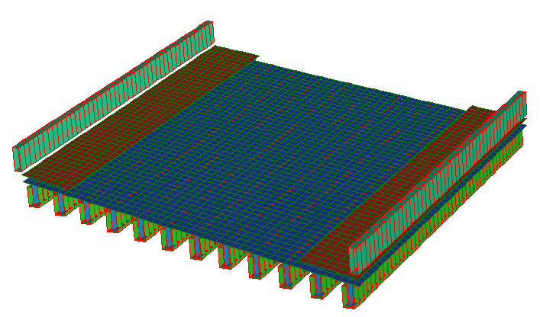

Y

X

Z

Figure 3. *A Priori* FE Model of single span of Bridge 041.

The initial model was rated for AASHTO Load and Resistance Factor Strength I limit state for an HL-93 truck. It was then calibrated to the natural frequencies and mode shapes developed through experimentation. A set of calibrated models were used to perform live load ratings. The eight calibrated models with strong objective function and final parameter agreement were rated using the RAMPs software. In order to assure the most conservative load rating estimate while utilizing an updated FE model, stiffness contributions from the concrete encasement were ignored in a second set of ratings for the same six updated models. It was necessary to allow the updating algorithm to increase encasement stiffness in the model in response to differences between frequencies and mode shapes. Conservatively, we neglected the stiffness contribution of the concrete encasement after updating. The final reported ratings are based on the updated models without stiffness contribution of the concrete encasement. All other parameters from the updated models were carried over into this rating.

**The controlling Strength I limit state rating factors for the model with and without concrete encasement stiffness contribution is summarized in the following table.**

Table 3. Controlling Strength I and Service II Limit state rating factors.

|  |  |
| --- | --- |
| **(Inventory/Operating)** | **Strength I** |
| **With Concrete Encasement** | **7.47/9.68** |
| **Concrete Encasement Neglected** | **2.67/3.43** |

## Appendix E-1 – Bridge Description

Northampton County Bridge 041 is a simply supported, concrete encased multi-girder structure with a 18⁰ skew. The steel encased within the concrete beams is of unknown type and design. The bridge carries Columbus Ave. in Roseto Borough over Roseto Creek, has an ADT of 400, and has a current posted weight limit of 30 tons. With a sufficiency rating of 81.1, the bridge is evaluated as “Not Structurally Deficient.” The span was measured with a length of 45’-10” and a roadway width of 32’-7”. The span carriers a 76” wide, 10” high sidewalk and 33” high, 10” wide concrete barriers (Figure 4). The overall deck thickness was measured to be approximately 9” with a 3” overlay. Each span has twelve (12) concrete encased beams with unknown reinforcement spaced at 4’-0” with overall dimensions of 27.5”x15”. Each girder has what appears to be 1-2” of shotcrete applied to the surface of the original concrete encasement at a time unknown to the engineer. The presence of shotcrete over the original concrete encasement may imply that some deterioration of the encasement was present.

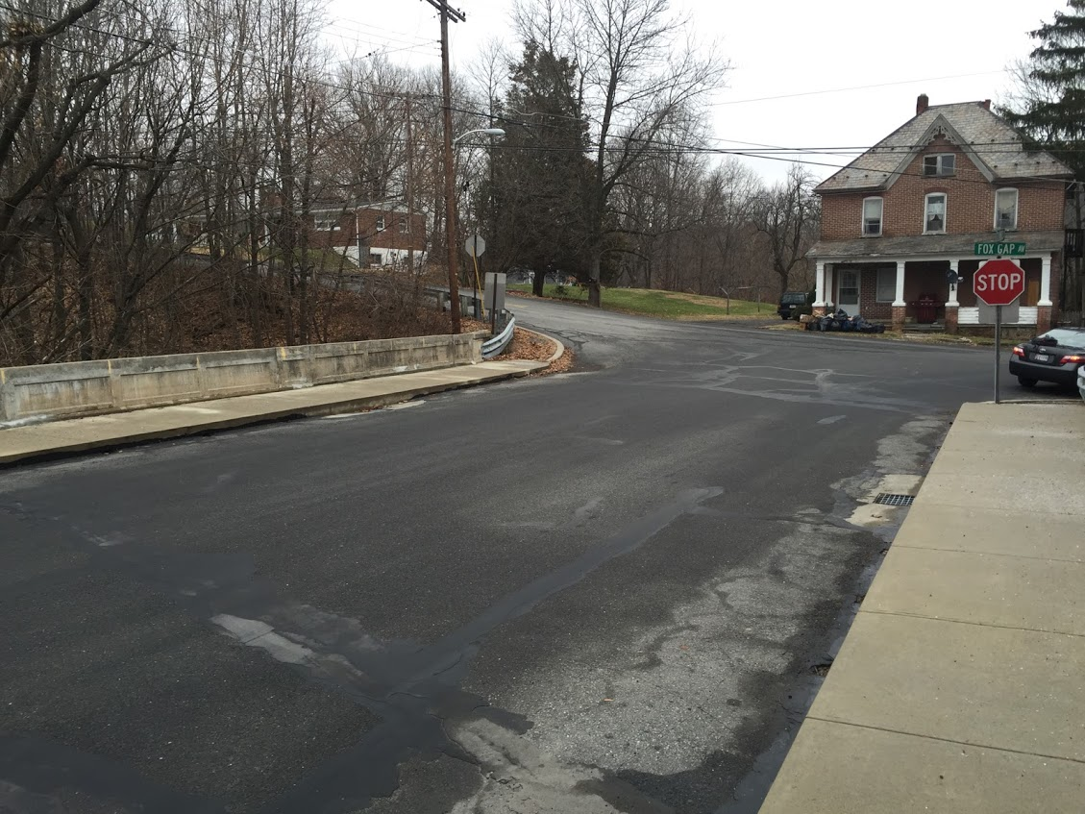

Figure 4. Northampton County Bridge 063

## Appendix E-2 – Experimental Evaluation

Northampton County Bridge 063 was evaluated using vibration testing methods. The bridge was dynamically excited at several locations on the deck surface using a broad band impact force, and its corresponding vibration responses were measured using accelerometers that were also located on the deck. The combined input-output vibration measurements were subsequently analyzed to extract the dynamic properties of the structure which were then used to calibrate a finite element model of the bridge. Details of the experimental setup, the test execution and the data analysis methods employed for the bridge are provided in the following sections.

### Description of Test Equipment - THMPR System

The Targeted Hits to Measure Performance Responses (THMPR) system is a self-contained rapid modal testing trailer and streamlined data processing software which extracts modal parameters, such as frequencies and mode shapes, of a structure. The extracted modal parameters may then be used to determine anomalous behavior as well as provide experimental data for finite element model calibration. The system, shown in Figure 5, is comprised of a physical test device which utilizes a significantly reconfigured Falling Weight Deflectometer trailer with modifications to (1) provide a single, large (~30 kip) broadband impact source, and (2) collect the resulting free-decay response of the bridge’s surface in a spatially distributed manner (and in-turn be able to capture local mode shapes). The local sensor array is shown in Figure 6. The trailer is towed along the bridge deck and single-input-multiple-output (SIMO) impact testing is performed at targeted locations. The data is wirelessly acquired at each location and passed to semi-automated modal processing software which performs (1) data quality checks, (2) frequency response function development and (3) modal parameter estimation. The local mode shapes are then linearly combined into a final global modal parameter set utilizing selected stationary references previously secured along an available sidewalk and cabled to an independent, GPS synchronized data acquisition.



Figure 5. THMPR System - Primary Components



Figure 6. THMPR Local Sensor Array

### Instrumentation

The typical instrumentation plan for a single span is shown in Figure 7. A total of six stationary reference accelerometers were temporarily attached to the bridge deck using glue adhesive at the quarter span, mid span, and three-quarter span locations along each sidewalk. The reference accelerometers remained at the same locations on the deck throughout the vibration testing and were used to link together the vibrations measured by THMPR’s local sensor array of six accelerometers (Figure 6). The reference accelerometers were cabled to GPS synchronized data acquisition systems along each shoulder and out of the way of traffic.

A total of nine impact locations were selected at the quarter span, mid span, and three-quarter span lengths along the right lane, left lane, and mid width lane of the superstructure. The impact locations were chosen so that the measured vibration responses would have a dense spatial resolution and to vary the spatial characteristics of the input excitation. The former consideration is important for resolving different mode shapes from the vibration measurements, while the latter is important for exciting different vibration modes. Note, only three of the six local output sensors were required for data analysis.

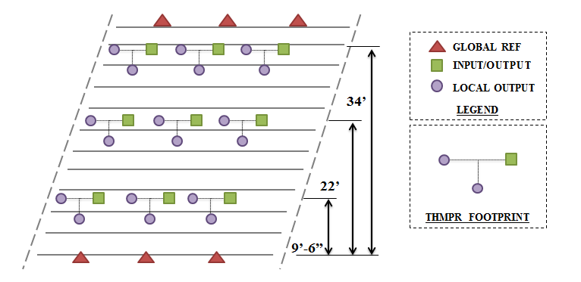

Figure 7. Typical Instrumentation Plan

### Test Execution

THMPR system testing was conducted on November 5, 2014. THMPR’s impact head was centered above a selected impact location on the deck and the GPS synchronized accelerometer array attached to THMPR was remotely deployed. This lowered the six accelerometer housings onto the bridge deck and compressed them against the surface. The impact force and bridge vibration measurements were recorded at a rate of 3,200 samples per second (Hz) in order to precisely define the shape of the impulse signal and for a duration of 10 seconds to ensure the complete capture of the structure’s post-impact free vibration decay response. A total of three separate impacts were recorded for averaging and noise reduction purposes at each of the nine locations.

### Data Quality

Typical impact forces of up to 25,000 lbs. were observed (Figure 8A) with an approximate usable frequency range of 0-55 Hz (Figure 8B). The impact forces produced by THMPR also resulted in bridge acceleration magnitudes of up to 4 g’s (Figure 9A). Frequency content of the structural response (Figure 9B) shows clearly defined, smooth peaks of resonance which indicates linearity, adequate frequency resolution, and good excitation of all fundamental modes of interest. The relatively large structural response and the acquisition of ten second time windows provided a frequency resolution of 0.09 Hz which resulted in good characterization of closely spaced modes.

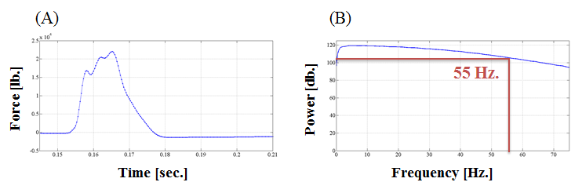

Figure 8. (A) Typical Force Time History & (B) Typical Force Frequency Content

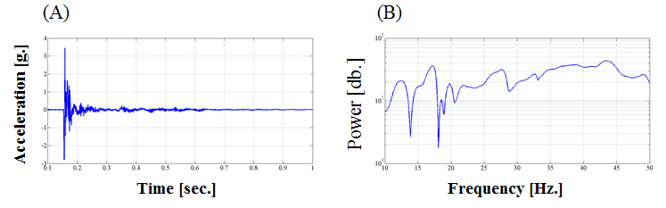

Figure 9. (A) Typical Response Time History & (B) Typical Response Frequency Content

### Modal Parameter Identification

The modal parameters for the structure were identified from the vibration measurements onsite after completion of the testing to provide immediate feedback on the data quality, structural response of the bridge, and operating condition of the test equipment to the on-site engineers. The modal parameters include the natural frequencies and the modal vectors (mode shapes) for each mode. These parameters are directly related to the in-situ mass and stiffness characteristics of the bridge, and are used for calibrating the FE model of the structure.

The modal parameter identification process starts with the computation of frequency response functions for each input-output measurement pair. A frequency response function is essentially the frequency domain transform of measured acceleration response at each sensor location divided by the measured impact force for each test location. The Complex Mode Indicator Function (CMIF) was then calculated for each test location (Figure 10) using the frequency response functions created in the previous step. The CMIF is computed by singular value decomposition of the matrix of frequency response functions for each test location. The largest singular values are plotted against frequency to create the CMIF plot. Each peak in the CMIF plot represents a location of a vibration mode for the structure and the amplitude of the singular value is directly related to the dominance of the corresponding modal vector at that test location. The singular values for each independent impact location are super imposed to compare areas of resonance and ultimately select global modal parameters. A total of seven global vibration modes (global poles) identified from the CMIF plots as shown in Figure 10.

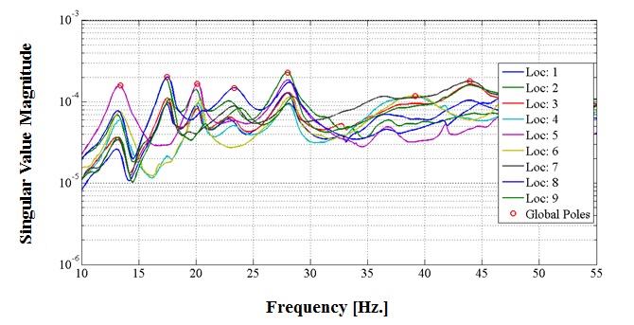

Figure 10. Span 1 – Complex Mode Indicator Function (CMIF)

Local mode shapes for each impact location were extracted at each global pole and combined into a global parameter set. Master mode shapes were selected for each mode based on the relative amplitude of the CMIF singular value for each impact location. The impact location associated with the largest CMIF amplitude for a specific vibration mode contains the highest signal to noise ratio and the corresponding mode shape was designated the master shape for that vibration mode. For each global pole, the modal amplitudes of the stationary references were compared between the local master mode shape and the remaining local mode shapes. A scaling coefficient was developed via a least squares approximation and used to linearly integrate the independent local mode shapes into the local master mode shape and form a global parameter set. Local mode shapes extracted from impact locations which coincided with a point of zero displacement (nodal point) for a particular mode were discarded and not included within the global modal parameter set. Additionally, a combination of the stationary references for each master local mode shape was chosen on an individual mode basis to avoid using reference sensors in locations of low modal amplitude for a particular mode. Global mode shapes and frequencies are shown in Figure 11 and Table 4, respectively. It should be noted that the interstitial areas between the discrete experimental degrees-of-freedom for the mode shapes were interpolated using a fourth order equation to aid in the visualization of these shapes.

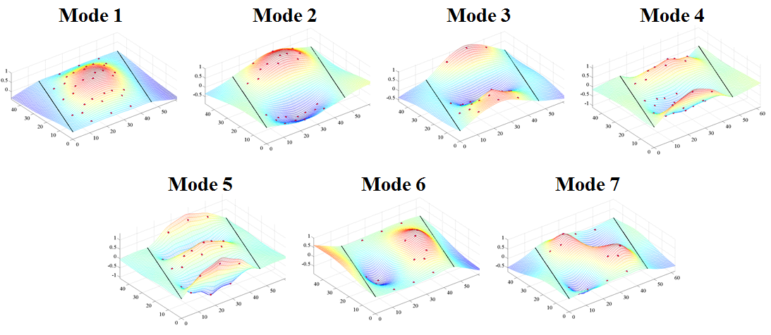

Figure 11. Span 1 – THMPR Results - Global Mode Shapes

Table 4. Span 1 – THMPR Results – Identified Natural Frequencies

|  |  |  |  |
| --- | --- | --- | --- |
| **Mode** | **Frequency [Hz]** | **Master**  **Location** | **Included Locations** |
| 1 | 13.38 | 6 | 1 2 3 4 5 6 7 8 9 |
| 2 | 17.48 | 8 | 1 2 3 7 8 9 |
| 3 | 20.18 | 5 | 1 2 3 4 5 6 |
| 4 | 23.34 | 8 | 1 2 3 4 5 7 8 9 |
| 5 | 28.03 | 2 | 1 2 3 4 5 6 7 8 9 |
| 6 | 39.16 | 6 | 3 4 6 |
| 7 | 43.95 | 7 | 1 3 7 9 |

## Appendix E-3 – Model Updating

The *a priori* model was updated for each span using a multi-start method with 8 updating trials starting from different combinations of initial parameter values:

|  |  |  |  |  |  |  |
| --- | --- | --- | --- | --- | --- | --- |
|  | **Start Point** | | | | | |
| **Update** | *Deck* | *Steel* | *Encasement* | *Sidewalks* | *Composite Action* | *R2* |
| *1* | Min | Min | Min | Min | Min | Min |
| *2* | Max | Min | Min | Min | Min | Min |
| *3* | Min | Max | Min | Min | Min | Min |
| *4* | Min | Min | Max | Min | Min | Min |
| *5* | Min | Min | Min | Max | Min | Min |
| *6* | Min | Min | Min | Min | Max | Min |
| *7* | Min | Min | Min | Min | Min | Max |
| *8* | Max | Max | Max | Max | Max | Max |

Presented in Table 5 are the analytical mode shapes paired with the experimental results. The *a priori* model exhibited natural frequencies lower than that of the actual structure, indicating a lack of global stiffness. The MAC comparison between experiment and *a priori* model indicate reasonable local stiffness distribution. All updated models showed moderate negative differences in frequency from the experiment for all but the first mode, indicating conservative values for global stiffness; meanwhile the MAC values remained high for every mode. The first mode of the updated models had positive frequency differences of about 15%, indicating a higher stiffness than the actual structure, however the MAC value remained high. This indicates a global excess of stiffness in the model, as opposed to a local error, such as boundary conditions. Because of this, the stiffness contribution of the concrete encasement will be neglected for load rating.

Table 5. Typical Mode Shapes

|  |  |  |  |
| --- | --- | --- | --- |
| A-Priori Shapes | Mode  Number | Typical Updated Model Shapes | Mode Number |
|  | **2** |  | **1** |
|  | **3** |  | **2** |
|  | **4** |  | **3** |
|  | **5** |  | **4** |
|  | **6** |  | **5** |
|  | **9** |  | **7** |
|  | **10** |  | **9** |

Table 6. Comparison of A-Priori and Experimental Mode Frequencies

|  |  |  |  |  |
| --- | --- | --- | --- | --- |
| **MAC** | **Natural Frequency** | | | **Analytical Mode** |
| *Experimental [Hz]* | *Analytical [Hz]* | *% Difference* |
| 0.9464 | 13.3789 | 7.5307 | -43.7121 | 2 |
| 0.9263 | 17.4805 | 8.8361 | -49.4517 | 3 |
| 0.7803 | 20.1172 | 11.9401 | -40.6473 | 4 |
| 0.9076 | 23.3398 | 15.038 | -35.5696 | 5 |
| 0.9384 | 28.0273 | 19.516 | -30.3681 | 6 |
| 0.9533 | 39.1602 | 25.9208 | -33.8082 | 9 |

Table 7. Comparison of Update 1 and Experimental Mode Frequencies

|  |  |  |  |  |
| --- | --- | --- | --- | --- |
| **MAC** | **Natural Frequency** | | | **Analytical Mode** |
| *Experimental [Hz]* | *Analytical [Hz]* | *% Difference* |
| 0.9777 | 13.3789 | 15.2794 | 14.2055 | 1 |
| 0.9464 | 17.4805 | 16.5053 | -5.5786 | 2 |
| 0.8647 | 20.1172 | 17.721 | -11.9111 | 3 |
| 0.9278 | 23.3398 | 20.5235 | -12.0668 | 4 |
| 0.9364 | 28.0273 | 25.1423 | -10.2935 | 5 |
| 0.9817 | 39.1602 | 39.1144 | -0.1169 | 7 |
| 0.9452 | 43.9453 | 41.8882 | -4.681 | 9 |

Table 8. Comparison of Update 2 and Experimental Mode Frequencies

|  |  |  |  |  |
| --- | --- | --- | --- | --- |
| **MAC** | **Natural Frequency** | | | **Analytical Mode** |
| *Experimental [Hz]* | *Analytical [Hz]* | *% Difference* |
| 0.9776 | 13.3789 | 15.3262 | 14.5548 | 1 |
| 0.9461 | 17.4805 | 16.5435 | -5.3601 | 2 |
| 0.8641 | 20.1172 | 17.7535 | -11.7494 | 3 |
| 0.9277 | 23.3398 | 20.5507 | -11.9503 | 4 |
| 0.9363 | 28.0273 | 25.1621 | -10.2229 | 5 |
| 0.9817 | 39.1602 | 39.2268 | 0.1701 | 7 |
| 0.945 | 43.9453 | 41.9869 | -4.4566 | 9 |

Table 9. Comparison of Update 3 and Experimental Mode Frequencies

|  |  |  |  |  |
| --- | --- | --- | --- | --- |
| **MAC** | **Natural Frequency** | | | **Analytical Mode** |
| *Experimental [Hz]* | *Analytical [Hz]* | *% Difference* |
| 0.9795 | 13.3789 | 15.4078 | 15.1651 | 1 |
| 0.9493 | 17.4805 | 16.6264 | -4.8857 | 2 |
| 0.8736 | 20.1172 | 17.7907 | -11.5649 | 3 |
| 0.9274 | 23.3398 | 20.4552 | -12.3594 | 4 |
| 0.9356 | 28.0273 | 24.8986 | -11.1631 | 5 |
| 0.9811 | 39.1602 | 39.3735 | 0.5447 | 7 |
| 0.9444 | 43.9453 | 42.0744 | -4.2575 | 9 |

Table 10. Comparison of Update 4 and Experimental Mode Frequencies

|  |  |  |  |  |
| --- | --- | --- | --- | --- |
| **MAC** | **Natural Frequency** | | | **Analytical Mode** |
| *Experimental [Hz]* | *Analytical [Hz]* | *% Difference* |
| 0.9779 | 13.3789 | 15.2985 | 14.3483 | 1 |
| 0.9467 | 17.4805 | 16.5225 | -5.48 | 2 |
| 0.8655 | 20.1172 | 17.7322 | -11.8555 | 3 |
| 0.9277 | 23.3398 | 20.52 | -12.0816 | 4 |
| 0.9363 | 28.0273 | 25.1198 | -10.3739 | 5 |
| 0.9816 | 39.1602 | 39.1556 | -0.0116 | 7 |
| 0.9451 | 43.9453 | 41.9202 | -4.6083 | 9 |

Table 11. Comparison of Update 5 and Experimental Mode Frequencies

|  |  |  |  |  |
| --- | --- | --- | --- | --- |
| **MAC** | **Natural Frequency** | | | **Analytical Mode** |
| *Experimental [Hz]* | *Analytical [Hz]* | *% Difference* |
| 0.9778 | 13.3789 | 15.2965 | 14.3333 | 1 |
| 0.9464 | 17.4805 | 16.5265 | -5.4576 | 2 |
| 0.8646 | 20.1172 | 17.7461 | -11.7865 | 3 |
| 0.9277 | 23.3398 | 20.5543 | -11.9347 | 4 |
| 0.9364 | 28.0273 | 25.1845 | -10.1431 | 5 |
| 0.9817 | 39.1602 | 39.1478 | -0.0316 | 7 |
| 0.9453 | 43.9453 | 41.9253 | -4.5967 | 9 |

Table 12. Comparison of Update 6 and Experimental Mode Frequencies

|  |  |  |  |  |
| --- | --- | --- | --- | --- |
| **MAC** | **Natural Frequency** | | | **Analytical Mode** |
| *Experimental [Hz]* | *Analytical [Hz]* | *% Difference* |
| 0.9792 | 13.3789 | 15.2934 | 14.3101 | 1 |
| 0.9488 | 17.4805 | 16.5281 | -5.4482 | 2 |
| 0.8715 | 20.1172 | 17.7188 | -11.922 | 3 |
| 0.9277 | 23.3398 | 20.4398 | -12.4253 | 4 |
| 0.936 | 28.0273 | 24.9561 | -10.958 | 5 |
| 0.9814 | 39.1602 | 39.1161 | -0.1125 | 7 |
| 0.9451 | 43.9453 | 41.8631 | -4.7383 | 9 |

Table 13. Comparison of Update 7 and Experimental Mode Frequencies

|  |  |  |  |  |
| --- | --- | --- | --- | --- |
| **MAC** | **Natural Frequency** | | | **Analytical Mode** |
| *Experimental [Hz]* | *Analytical [Hz]* | *% Difference* |
| 0.9777 | 13.3789 | 15.2828 | 14.2302 | 1 |
| 0.9464 | 17.4805 | 16.5074 | -5.5667 | 2 |
| 0.8646 | 20.1172 | 17.7223 | -11.9047 | 3 |
| 0.9278 | 23.3398 | 20.5241 | -12.0643 | 4 |
| 0.9364 | 28.0273 | 25.142 | -10.2949 | 5 |
| 0.9817 | 39.1602 | 39.1216 | -0.0986 | 7 |
| 0.9452 | 43.9453 | 41.8933 | -4.6695 | 9 |

Table 14. Comparison of Update 7 and Experimental Mode Frequencies

|  |  |  |  |  |
| --- | --- | --- | --- | --- |
| **MAC** | **Natural Frequency** | | | **Analytical Mode** |
| *Experimental [Hz]* | *Analytical [Hz]* | *% Difference* |
| 0.9776 | 13.3789 | 15.3489 | 14.7245 | 1 |
| 0.9461 | 17.4805 | 16.5633 | -5.2467 | 2 |
| 0.8645 | 20.1172 | 17.7683 | -11.6761 | 3 |
| 0.9276 | 23.3398 | 20.5548 | -11.9327 | 4 |
| 0.9363 | 28.0273 | 25.1525 | -10.2572 | 5 |
| 0.9816 | 39.1602 | 39.2788 | 0.3029 | 7 |
| 0.9449 | 43.9453 | 42.0301 | -4.3582 | 9 |

## Appendix E-4 – Updated Model Ratings

Table 15. Updated models with concrete encasement contribution.

|  |  |  |  |  |  |
| --- | --- | --- | --- | --- | --- |
|  | | **Updated Models With Concrete Encasement Contribution** | | | |
| ***Strength I*** | | | |
| *Inv* | *Ctrl. Gir.* | *Op* | *Ctrl. Gir.* |
| ***A Priori*** | **RF** | 4.62 | 6 | 6.00 | 6 |
| **Tons** | 166.32 | 216.00 |
| **Update 1** | **RF** | 7.95 | 6 | 10.31 | 6 |
| **Tons** | 286.20 | 371.16 |
| **% Δ** | 41.89 | 41.80 |
| **Update 2** | **RF** | 7.60 | 6 | 9.85 | 6 |
| **Tons** | 273.60 | 354.60 |
| **% Δ** | 39.21 | 39.09 |
| **Update 3** | **RF** | 7.92 | 6 | 10.27 | 6 |
| **Tons** | 285.12 | 369.72 |
| **% Δ** | 41.67 | 41.58 |
| **Update 4** | **RF** | 7.55 | 6 | 9.79 | 6 |
| **Tons** | 271.80 | 352.44 |
| **% Δ** | 38.81 | 38.71 |
| **Update 5** | **RF** | 7.47 | 6 | 9.68 | 6 |
| **Tons** | 268.92 | 348.48 |
| **% Δ** | 38.15 | 38.02 |
| **Update 6** | **RF** | 7.64 | 6 | 9.90 | 6 |
| **Tons** | 275.04 | 356.40 |
| **% Δ** | 39.53 | 39.39 |
| **Update 7** | **RF** | 7.50 | 6 | 9.72 | 6 |
| **Tons** | 270.00 | 349.92 |
| **% Δ** | 38.40 | 38.27 |
| **Update 8** | **RF** | 7.66 | 6 | 9.93 | 6 |
| **Tons** | 275.76 | 357.48 |
| **% Δ** | 39.69 | 39.58 |

Table 16. Updated models without concrete encasement contribution.

|  |  |  |  |  |  |
| --- | --- | --- | --- | --- | --- |
|  | | **Updated Models Without Concrete Encasement Contribution** | | | |
| ***Strength I*** | | | |
| Inv | Ctrl. Gir. | Op | Ctrl. Gir. |
| **Update 1** | **RF** | 2.67 | 6 | 3.47 | 6 |
| **Tons** | 96.12 | 124.92 |
| **Update 2** | **RF** | 2.75 | 6 | 3.57 | 6 |
| **Tons** | 6.37 | 8.26 |
| **Update 3** | **RF** | 3.04 | 6 | 3.94 | 6 |
| **Tons** | 6.38 | 8.26 |
| **Update 4** | **RF** | 2.73 | 6 | 3.53 | 6 |
| **Tons** | 6.38 | 8.27 |
| **Update 5** | **RF** | 2.65 | 6 | 3.43 | 6 |
| **Tons** | 6.38 | 8.27 |
| **Update 6** | **RF** | 2.81 | 6 | 3.64 | 6 |
| **Tons** | 6.38 | 8.27 |
| **Update 7** | **RF** | 2.68 | 6 | 3.48 | 6 |
| **Tons** | 6.38 | 8.27 |
| **Update 8** | **RF** | 2.80 | 6 | 3.63 | 6 |
| **Tons** | 6.38 | 8.27 |